SK1632

16-bit or 32-bit PIC Start-Up Kit

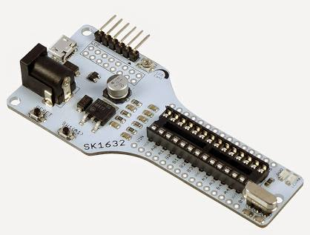
User's Manual

V1.2

Oct 2015

Information contained in this publication regarding device applications and the like is intended through suggestion only and may be superseded by updates. It is your responsibility to ensure that your application meets with your specifications. No representation or warranty is given and no liability is assumed by Cytron Technologies Incorporated with respect to the accuracy or use of such information or infringement of patents or other intellectual property rights arising from such use or otherwise. Use of Cytron Technologies’s products as critical components in life support systems is not authorized except with express written approval by Cytron Technologies. No licenses are conveyed, implicitly or otherwise, under any intellectual property rights.

INDEX

- Introduction/Overview 3

- Packing List 5

- Product Specification And Limitations 6

- Dimension 7

- Board Layout 8
- Hardware 12

- Software 13

- Getting Started 15

- Warranty 18

1. INTRODUCTION/OVERVIEW

SK1632 is new starter kit designed for 28 pin PIC which support all 5V operate 16-bit and 32-bit PDIP PIC microcontroller. This board comes with basic electronic components for user to begin project development. It offer plug and use features:

- Industrial grade PCB
- Every board is being tested before is shipped to customer
- Compact platform
- DC Adapter socket, 7-15V DC input
- Reset button ready
- Power indicator LED ready
- Suitable for student, researchers, trainer, hobbyists and amateurs
- Save development and soldering time
- No extra components required for PIC to function
- All I/O pins nicely labeled to avoid mis-connection by users
- Mini USB socket on board
- 1 x Programmable switch
- 1 x Programmable LED indicator
- 1x turn pin for crystal and changeable crystal
- Ready pad for 2x8 parallel LCD display (soldering and extra header socket is required)
- This Starter Kit supported both 16 bits and 32 bits PIC in 28 pin which listed at Product Specification and Limitation

PICkit pin ready for loading program via ICSP, using PICkit 3

This kit comes WITHOUT PIC microcontroller to provide the freedom for user to choose PIC type.

2. PACKING LIST

Please check the parts and components according to the packing list. If there are any parts missing, please contact us at sales@cytron.com.my immediately.

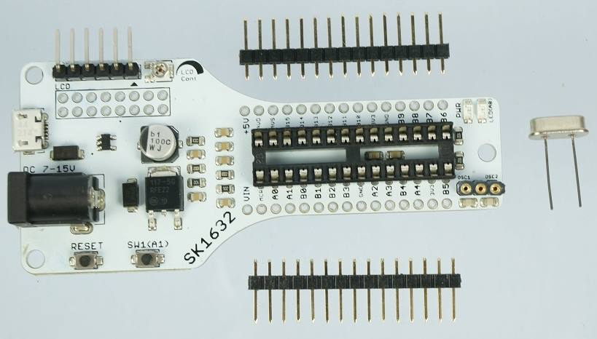

- 1 x SK1632 board
- 1 x 8MHz Crystal
- 2 x header pin 15 ways

3. PRODUCT SPECIFICATION AND LIMITATIONS

Absolute Maximum Rating
Symbol | Parameter | Min | Max | Unit
Vin | Input Voltage via DC Power Adaptor Socket | 7.0 | 15.0 | V
Imax | Maximum output current from on-board 5V Voltage regulator |  | 1.0 | A

Supported PIC - (70 PIC Model Supported)

PIC16-bits 28 Pins
PIC24FJ16MC102 | dsPIC33FJ16GP102 | dsPIC33FJ06GS102A | dsPIC33FJ32GP302
PIC24FJ32MC102 | dsPIC33FJ32GP102 | dsPIC33FJ06GS202A | dsPIC33FJ128MC802
PIC24EP32GP202 | dsPIC33FJ16MC102 | dsPIC33FJ09GS302 | dsPIC33FJ128MC202
PIC24EP64GP202 | dsPIC33FJ32MC102 | dsPIC33FJ12GP202 | dsPIC33FJ64MC802
PIC24EP128GP202 | dsPIC33EP32GP502 | dsPIC33FJ12MC202 | dsPIC33FJ64MC202
PIC24EP256GP202 | dsPIC33EP64GP502 | dsPIC33FJ06GS102 | dsPIC33FJ32MC302
PIC24EP512GP202 | dsPIC33EP128GP502 | dsPIC33FJ06GS202
PIC24EP32MC202 | dsPIC33EP256GP502 | dsPIC33FJ16GS402 | Support USB
PIC24EP64MC202 | dsPIC33EP512GP502 | dsPIC33FJ16GS502 | PIC24FJ32GB002
PIC24EP128MC202 | dsPIC33EP32MC202 | dsPIC33FJ06GS102*** | PIC24FJ64GB002
PIC24EP256MC202 | dsPIC33EP64MC202 | dsPIC33FJ06GS202*** | PIC24FJ64GB202
PIC24EP512MC202 | dsPIC33EP128MC202 | dsPIC33FJ16GS402*** | PIC24FJ128GB202
PIC24HJ12GP202 | dsPIC33EP256MC202 | dsPIC33FJ16GS502***
PIC24HJ32GP202 | dsPIC33EP512MC202 | dsPIC33FJ32GP202
PIC24HJ128GP502 | dsPIC33EP32MC502 | dsPIC33FJ32MC202
PIC24HJ128GP202 | dsPIC33EP64MC502 | dsPIC33FJ128GP802
PIC24HJ64GP502 | dsPIC33EP128MC502 | dsPIC33FJ64GP802
PIC24HJ64GP202 | dsPIC33EP256MC502 | dsPIC33FJ128GP202
PIC24HJ32GP302 | dsPIC33EP512MC502 | dsPIC33FJ64GP202
*** PIC with some of the pin name is different from others.
PIC 32-bits - 28 Pins
PIC32MX110F016B | Support USB
PIC32MX170F256B | PIC32MX250F128B
PIC32MX120F032B | PIC32MX270F256B
PIC32MX130F064B | PIC32MX230F064B
PIC32MX150F128B | PIC32MX210F016B
 | PIC32MX220F032B

*** SK1632 was tested with PIC32MX250F128B and dsPIC33fj64GP802 only. The rest of the PIC listed on the table above may work with SK1632 as the power pin is match.

LCD Pins - 4-bits mode

LCD | PIC Pin | Pinguino Pin Name
RS | RB2 | 10
RW | GND
EN | RB3 | 9
DB0 | GND
DB1 | GND
DB2 | GND
DB3 | GND
DB4 | RB4 | 8
DB5 | RB7 | 6
DB6 | RB13 | 2
DB7 | RB14 | 1

Programmable Push Button

Name | Pin function | Connection
SW | Digital Input Pin | RA1 pin of PIC MCU

4. DIMENSION

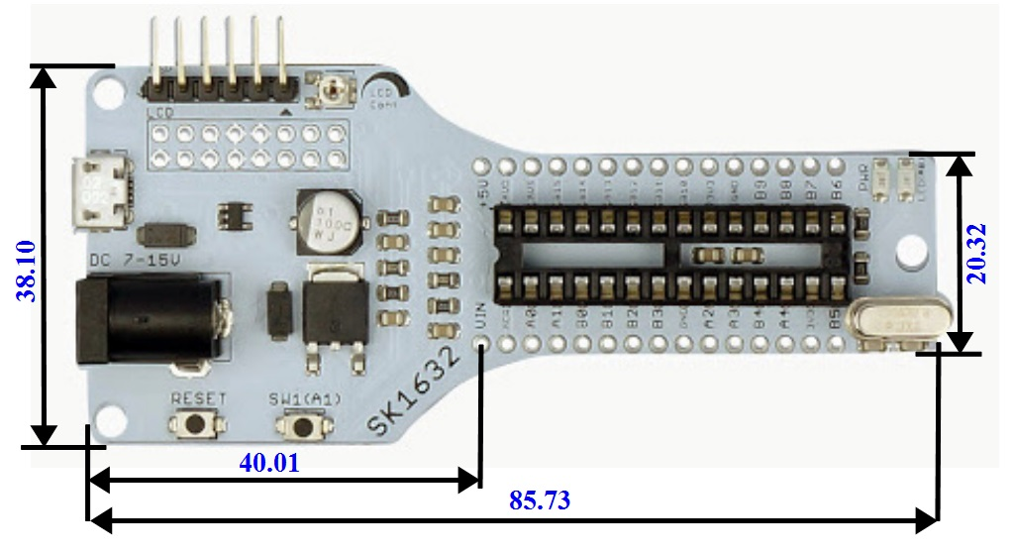

5. BOARD LAYOUT

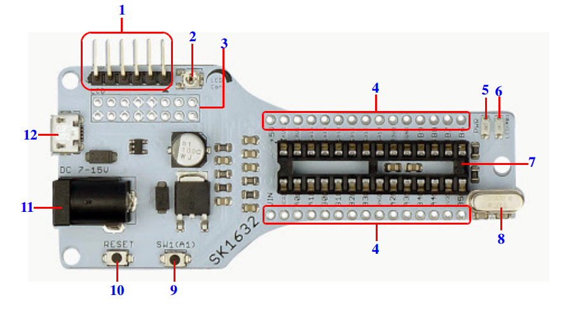
Top View of SK1632

1. PICkit pin for loading program via ICSP
User may directly use PICkit (PICkit 2 or PICkit 3) to load program or use UIC00B programmer with UIC-A to load program..
2. LCD contrast control potentiometer
5K of trimmer to adjust LCD’s contrast.

3. Reserved for 2x8 Parallel LCD
2x5 female header and Straight Pin Header is needed. This is optional to user.

4. Header pin, extension from PIC microcontroller pin
PIC Microcontroller pins extension and is reserved for header pin. User may extend SK1632 to breadboard or donut board with header pins provided.

5. Power Indicator LED
It will light ON as long as the input power is correctly connected.

6. Programmable LED Indicator
Active High output LED for PIC MCU. This LED is controllable from PIC MCU and it is connected to RB1.

7. 28 pin IC socket
28pin IC socket for user to plug in any 28 pin PDIP PIC MCU (16-bits and 32-bits). Please ensure the first pin is at the top right side.

8. Turn pin for crystal
Provided for external crystal. 8MHz is default crystal provided is SK1632. However, the 8MHz crystal can be removed and replace with other crystal. Just remove the crystal and put other crystal on turn pin without soldering.

9. Programmable Push Button
A push button is connected to RA1 of PIC Microcontroller. This is extra input button for user. It can be programmed as input switch.

10. Reset Button
A push button with function of Reset for PIC MCU.

11. DC Power Adaptor Socket
DC power adaptor socket for user to plug in DC adaptor. The input voltage should be ranged from 7 to 15VDC.

12. Micro USB connector
Using for connection using USB cable between SK1632 to a USB host controller (usually personal computer). This function is only valid for certain model of PIC microcontroller. Please refer PIC supported for 16-bits and 32-bits.

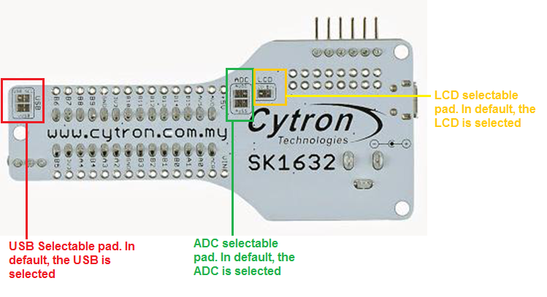
Bottom view of SK1632

USB Selectable pad
In default, the USB is selected. To use USB function, user must ensure this USB selected.

ADC Selectable pad
In default, the ADC is selected. To use Analog pin, user must ensure this ADC pin is selected.

LCD Selectable pad
By default, the LCD backlight is selected. If user don't want to use LCD backlight (B/L), user may simply cut through the wire connection for LCD.

6. HARDWARE

SK1632 comes with PICkit pin to offer simple way for downloading program via ICSP. Downloading program into PIC is either using PICkit programmer or other compatible ICSP programmer. Unfortunately, UIC00B does not support most of the new 16-bit and 32-bit PIC.

6.1 Loading program using PICkit Programmer

After plug in 28 pin PIC MCU (make sure the orientation is correct), SK1632 should be powered either from DC adaptor, Battery or USB’s power . To load program, one must have the hex code. Hex code sometime called machine code. It is result after compilation.

- Connect PICkit programmer shown as figure below. Figure below is using PICkit 3 from Microchip to load program into SK1632. Make sure the arrow at PICkit pin of SK1632 is same side with arrow at PICkit 3 programmer.

Note: SK1632 cannot be powered from pickit/ICSP pin as the VDD is not connected. It must be power from either the on board USB micro B receptor or from DC jack as shown in the picture.

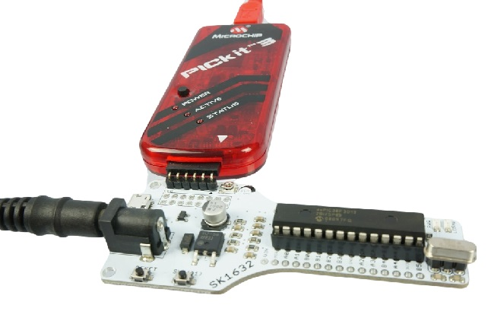

6.2 2x8 LCD

The 2x8 character LCD offer character display for embedded system. It can be used to display numerical information, text message and also special symbol. 2x8 LCD, female header and header pin are not included in SK1632 packing list. User need to get it separately.

- To use LCD, cut Straight Pin Header (Male) 2x40 Ways to 2x8 ways. Solder the header pin to the LCD shown as figure below.

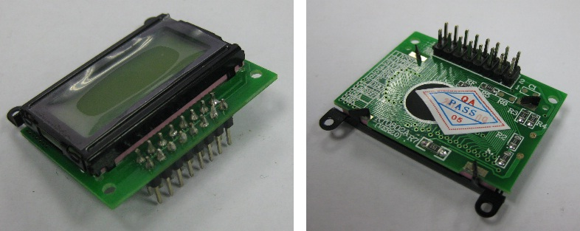

- Cut Straight Female Header 2x10 Ways to 2x8 ways. The female header also must soldered at LCD area, and plug in the 2x8 LCD when it is ready.

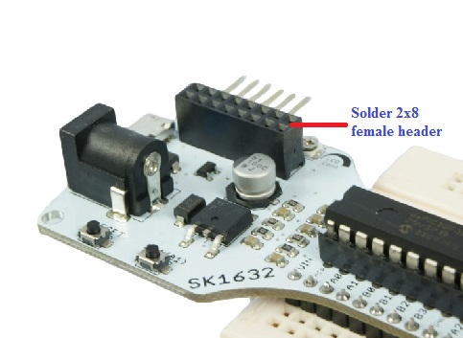

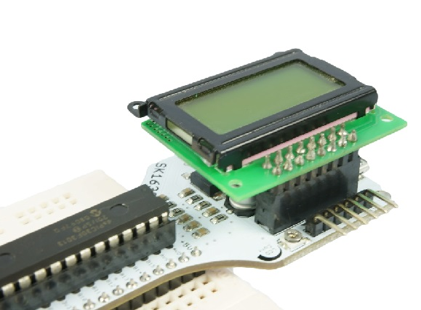
- Preset/Potentiometer is used to adjust the contrast of LCD display. Turn left or right to adjust the contrast.

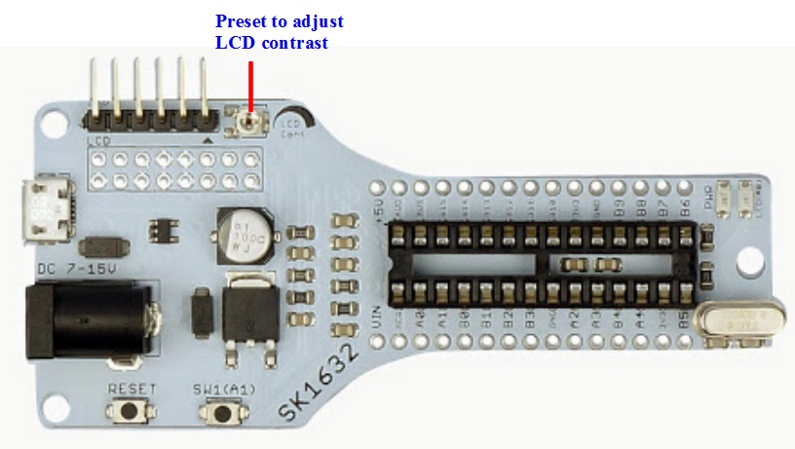

6.4 Using SK1632 IO pins

The I/O pin of PIC microcontroller on SK1632 can be extended onto donut board/breadboard with header pin soldered at the left and right SK1632 board. Figure below shows example SK1632 with header pin and it is extend to breadboard.

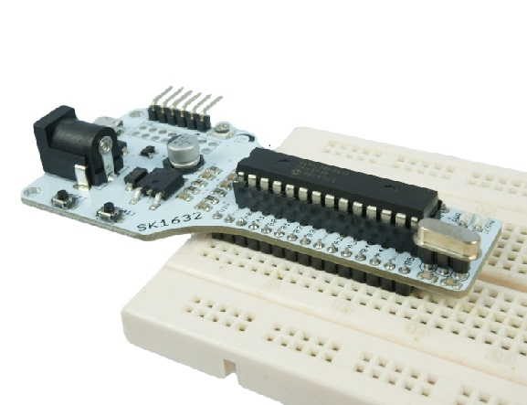

6.5 USB Interface

USB is one of possible serial communication between microcontroller and computer offered on SK1632. Again this is optional to user.

USB data pins (pin 22 (D-) and pin 21(D+)) are connected to a micro USB socket on SK1632 for USB development usage. Microchip has 4 USB 16-bit microcontrollers in 28-pin PDIP package (as the time this manual is written) which include PIC24FJ32GB002, PIC24FJ64GB002, PIC24FJ64GB202 and PIC24FJ128GB202. For 32-bits microcontroller 28-pin PDIP package, Microchip has 5 PIC USB supported which are PIC32MX250F128B, PIC32MX270F256B, PIC32MX230F064B, PIC32MX210F016B and PIC32MX220F032B

7. SOFTWARE

To get started with SK1632, users may use MPLAB X or Pinguino IDE software. Download MPLAB X IDE installer and Pinguino IDE software from SK1632 Product Page or the latest version software from Microchip for MPLAB X.

8. GETTING STARTED

Burn Pinguino Bootloader into PIC32MX250F128B
- Download the “HIDBoot_MX250.hex” from Github.
- Open MPLAB X and create a new project then choose “Prebuilt(HEX, Loadable Image) Project” and choose PIC32MX250F128B.
- Once done, right click on “Prebuilt Files” and choose “Add Existing Item”.
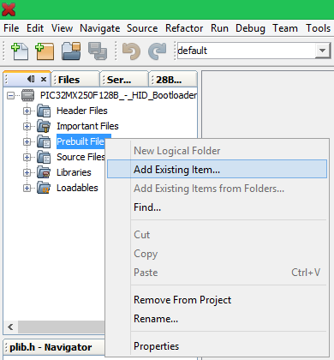

- Enter the “HIDBoot_MX250.hex”
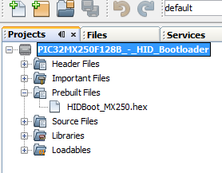
- Click “Make and Program Device Project” . Make sure this project hex file is burn using PICKit3.
- In case of error appear, go to “Project Properties” > “PicKit3” > “Power” and tick the box.
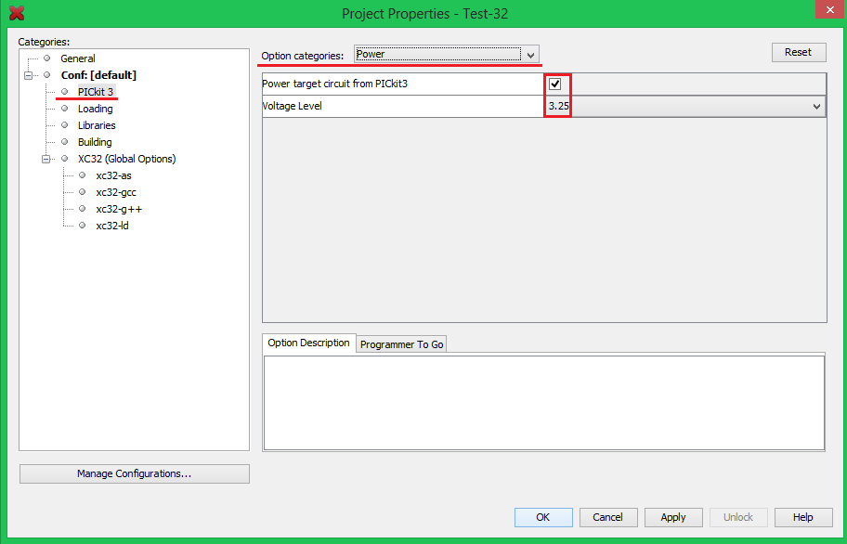

Note: SK1632 cannot be powered from pickit/ICSP pin as the VDD is not connected. It must be powered from either the on board USB micro B receptor or from DC jack.

Get Started with Pinguino IDE for LED Blinking

- Open the “pinguino.exe” in the Pinguino IDE folder.
(** Pinguino IDE below is using vx.4. Tested with new Pinguino IDE v11 beta-3 is compatible.)

- Before start programming, click on the “Select the board” (in square).
- Select the Architecture to ‘32-bit’, Programming Mode to ‘USB Bootloader’ and lastly, Devices to ‘Pinguino 32MX250’.

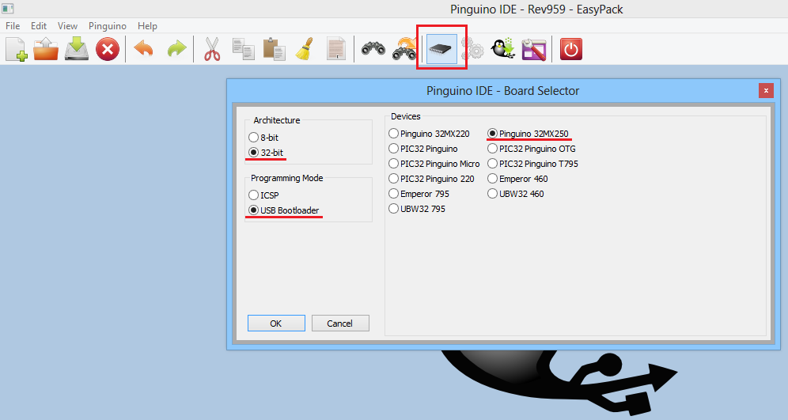

- Click on the “New File” icon, go to Basic > Blink > Blink.pde.
- Once done, click “Compile” and upload to SK1632. Upload the code using USB cable.

NOTE: In order to upload program, make sure the PIC is in bootloader mode.LED will blink rapidly when it already enter bootloader mode

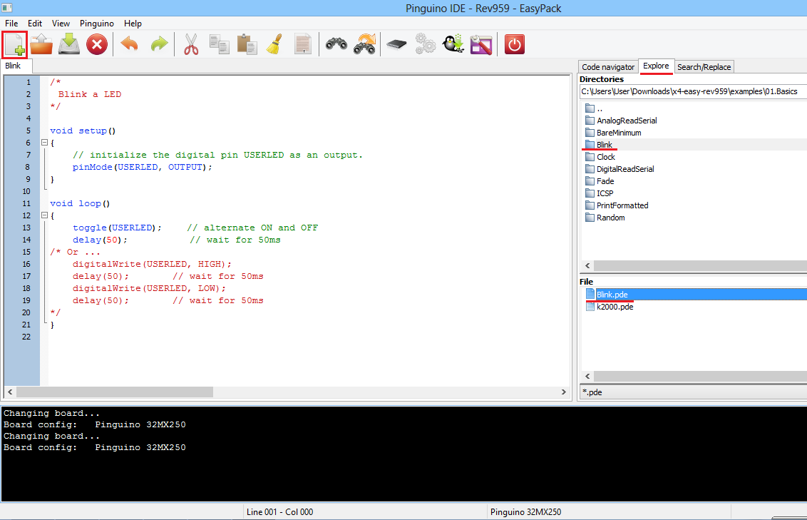

Steps to Enter Bootloader Mode

STEP | RESET | SW1(A1)
1 | Press and Hold | Release
2 | Press and Hold | Press and Hold
3 | Release | Press and Hold
4 | Release | Release

9. WARRANTY

- Product warranty is valid for 12 months.
- Warranty only applies to manufacturing defect.
- Damaged caused by misuse is not covered under warranty
- Warranty does not cover freight cost for both ways.

Prepared by
Cytron Technologies Sdn. Bhd.
No. 16, Jalan Industri Ringan Permatang Tinggi 2,
Kawasan Industri Ringan Permatang Tinggi,
14100 Simpang Ampat,
Penang, Malaysia.

Tel: +604 - 504 1878
Fax: +604 - 504 0138

URL: www.cytron.com.my
Email: support@cytron.com.my
sales@cytron.com.my

