IG45 - Planetary DC Geared Motor Technical Data

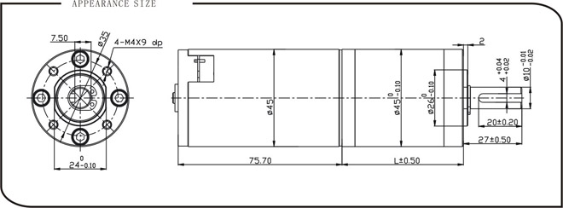

Model | Gear Ratio | Rated Torque(N.m) | Rated Speed (RPM) | Rated Power (W) | Gear Length, L (mm) | Weight(g)
IG45-04K | 3.7 | 0.3592 | 1216 | 49.5 | 33.6 | 590
IG45-14K | 13.7 | 1.1768 | 328 | 49.5 | 44.9 | 650
IG45-33K | 32.5 | 2.7916 | 138 | 49.5 | 44.9 | 680

Motor Data
Voltage | 24V
Rated Torque(mN.m) | 107.87
Rated Speed (RPM) | 4500
Rated Current (mA) | 3500
No Load Speed (RPM) | 6000
No Load Current (mA) | 350

