GD02 Rev2.0
G15 Driver

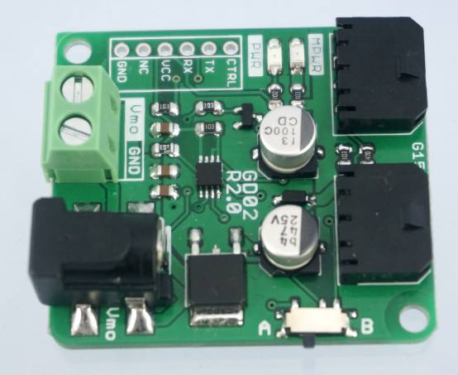

User's Manual

V2.1

June 2015

Information contained in this publication regarding device applications and the like is intended through suggestion only and may be superseded by updates. It is your responsibility to ensure that your application meets with your specifications. No representation or warranty is given and no liability is assumed by Cytron Technologies Incorporated with respect to the accuracy or use of such information or infringement of patents or other intellectual property rights arising from such use or otherwise. Use of Cytron Technologies’s products as critical components in life support systems is not authorized except with express written approval by Cytron Technologies. No licenses are conveyed, implicitly or otherwise, under any intellectual property rights.

Index

- Introduction 3

- Packing List 4

- Product Specification and Limitation 5

- Board or Product Layout 6

- Dimension 7

- Half Duplex Serial Communication 8

- Hardware Installation 10

- Warranty 11

1.0 INTRODUCTION

G15 Driver (GD02) is used to drive G15 Cube Servo. It is a Full to Half Duplex Communication Converter board. It converts UART duplex communication to half-duplex single line communication which is required by G15 Cube Servo. GD02 has two ports for the Cube Servo. G15 Cube servo is a serial servo which can be daisy chained for more servos thus more than two Cube Servos can be connected serially to GD02. G02 has a separated port connector for motor’s power supply. GD02 makes simple and easy way for user to control G15 Cube Servo with UART communication from any microcontroller board for example Cytron’s SKPIC32, SK40C, SK28, SK18 and Arduino’s Main Board.

Features:
- New! GD02 Rev2.0 (G15 Driver) comes with:
- Polarity Protection for input power
- Compatible control signal port with UC00A
- DC Socket adapter included
- Compatible with Arduino-G15 Shield logic. (Which mean it also can run the same logic as Arduino G15 shield)
- 2 x G15 Cube Servo ports (can be daisy chained for more servos)
- External power port for Cube Servo.
- 2 LEDs as logic power and servo power indicators.
- 3.3V and 5V signals compatible.

2.0 PACKING LIST

Please check the parts and components according to the packing lists. If there are any parts missing, please contact us at sales@cytron.com.my immediately.

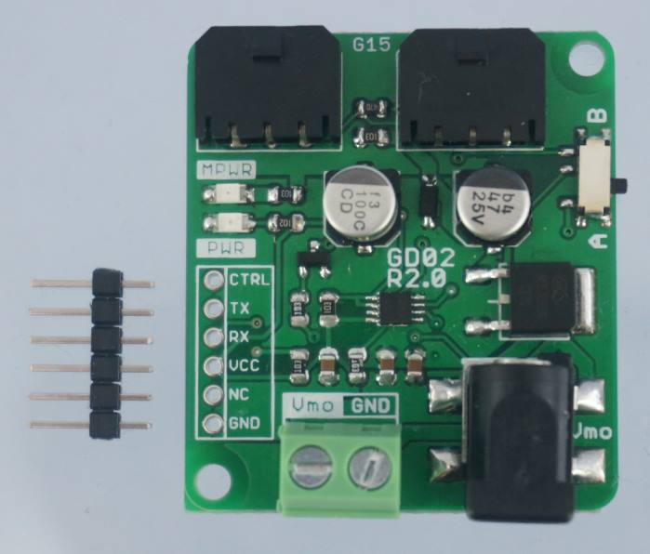

- 1 x G15 Driver

- 1 x 6 ways header pins

3.0 PRODUCT SPECIFICATION AND LIMITATIONS

Maximum Ratings
Parameter | Min | Typical | Max | Unit
Logic Voltage | 3.3 | 5 | 5 | V
Servo Motor’s Voltage | 7 | 12 | 15 | V
Servo Motor’s Current | - | - | 8 | A

4.0 BOARD OR PRODUCT LAYOUT

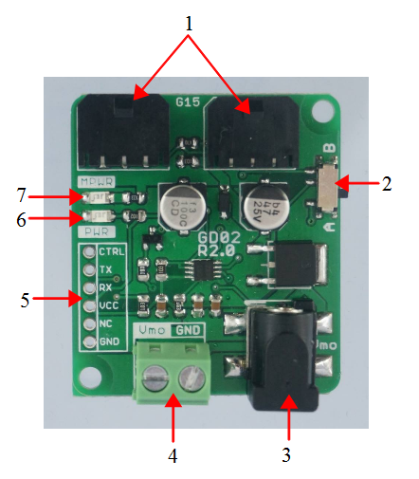

1. G15 Servo port
2 port connectors for G15 servo motor.

2. Mode Switch
Mode switch is used to enter different modes which is mode A or mode B.

3. DC Socket for Motor Power
This DC socket is power connector for the servo motor. User need to supply external power for servo motor. User may use DC socket or terminal block for Motor power supply.

4. Motor Power Terminal block
This terminal block is power connector for the servo motor. User need to supply external power for servo motor. User may use DC socket or terminal block for Motor power supply.

5. Control pins
JP3 is control signals pin to control G15 servo motor. JP3 includes the signal of 5V, GND, TX, RX and CTRL.

6. Power LED
Power indicator LED for logic power. The LED will turn on when 3.3 or 5V power is supplied to this board.

7. Motor Power LED
Power indicator LED for motor power. The LED will turn on when power for motor is supplied through the Motor Power Connector.
5.0 DIMENSION

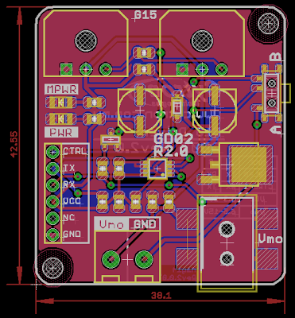

6.0 HALF DUPLEX SERIAL COMMUNICATION

G15 Cube Servo is using half duplex serial communication. The communication is standard UART with 8 bit data, 1 stop bit and no parity. There is only one data pin for the half duplex communication instead of 2 pins of normal UART communication. Thus, the main controller as the master will need to have one control pin to switch between transmit and receive mode as shown by the figure below. Besides the TX and RX pin, main controller will need one digital output pin as the control pin. The implementation is as shown by the logic circuit below. TX and RX bus is merged into one single data bus. On G15 driver the control pin is labelled as CTRL.

GD02 Rev2 has 2 modes which are mode A and mode B. For mode A, if control pin (CTRL) is 0 then it is in transmit mode (transmit data to G15) else if control pin is 1 then it is receive mode (main controller receive data from G15). For mode B, if control pin (CTRL) is 0 then it is in receive mode (main controller receive data from G15) else if control pin is 1 then it is transmit mode (transmit data to G15).

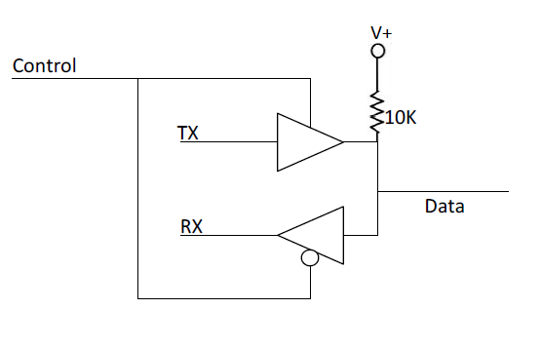

G15 Control Logic
Mode | A | B
CTRL = 0 | TX | RX
CTRL = 1 | RX | TX
** TX --> Data transfer from G15 to Main Controller.
** RX --> Data transfer from Main Controller to G15.
** Main Controller --> eg: Microcontroller, PC or others.

The following flowchart shows the communication flow for G15 Cube Servo. CTRL is a digital pin of main controller which is connected to general purpose input output pin. For the communication protocol, please refer to G15 Cube Servo’s user manual.

Flow Chart

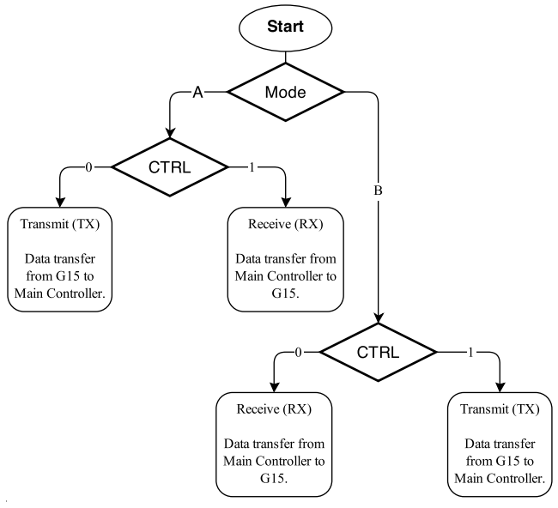

GD02 Half Duplex Communication Flow

Comparison Btw GD02 and GD02 Rev2.0
 | GD02 | GD02 Rev2.0
Power Input Option | Terminal Block Only | Terminal Block + DC Jack
Control Signal Logic | Only support 1 logic level | Option to switch logic level
Polarity Protection | No | Yes
Compatible Control Signal Port | No | Compatible to UC00A

7.0 HARDWARE INTERFACE

The Figure below is sample hardware interface between GD02 and main controller. External power is needed to supply power for G15 cube servo. The TX and RX connection between Master (microcontroller) to GD02 Rev2 Driver are slightly different from GD02 (ver1).

In this version, the Rx pin of microcontroller is connected to Tx pin of GD02 Rev2 and Tx pin of microcontroller is connected to Rx pin of GD02 Rev2. Compared to GD02 (ver1), Tx and Rx pin of GD02 is connect to TX and RX pin of microcontroller respectively. CTRL pin of GD02 is connect to any GPIO pin for example RC5 as a control pin.

Signal Connections:

Main Controller (master) | GD02 (as buffer) | GD02 Rev2 (slave)
5V or 3.3V | V+ | V+
GND | GND | GND
UART-TX | TX | RX
UART-RX | RX | TX
GPIO | CTRL | CTRL

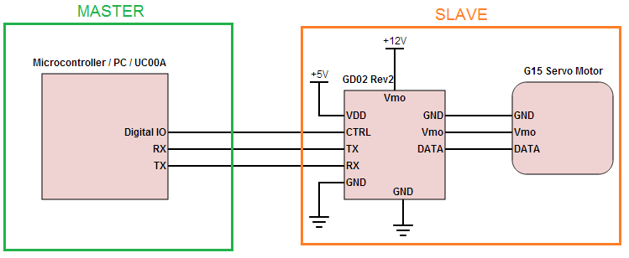

8.0 WARRANTY

- Product warranty is valid for 12 months.
- Warranty only applies to manufacturing defect.
- Damaged caused by misuse is not covered under warranty
- Warranty does not cover freight cost for both ways.

Prepared by:
Cytron Technologies Sdn. Bhd.
No. 16, Jalan Industri Ringan Permatang Tinggi 2,
Kawasan Industri Ringan Permatang Tinggi,
14100 Simpang Ampat,
Penang, Malaysia.

Tel: +604 - 504 1878
Fax: +604 - 504 0138

URL: www.cytron.com.my
Email: support@cytron.com.my
sales@cytron.com.my

