SP1848-27145 150 Degree Temperature
Resistant Thermal Power Generator
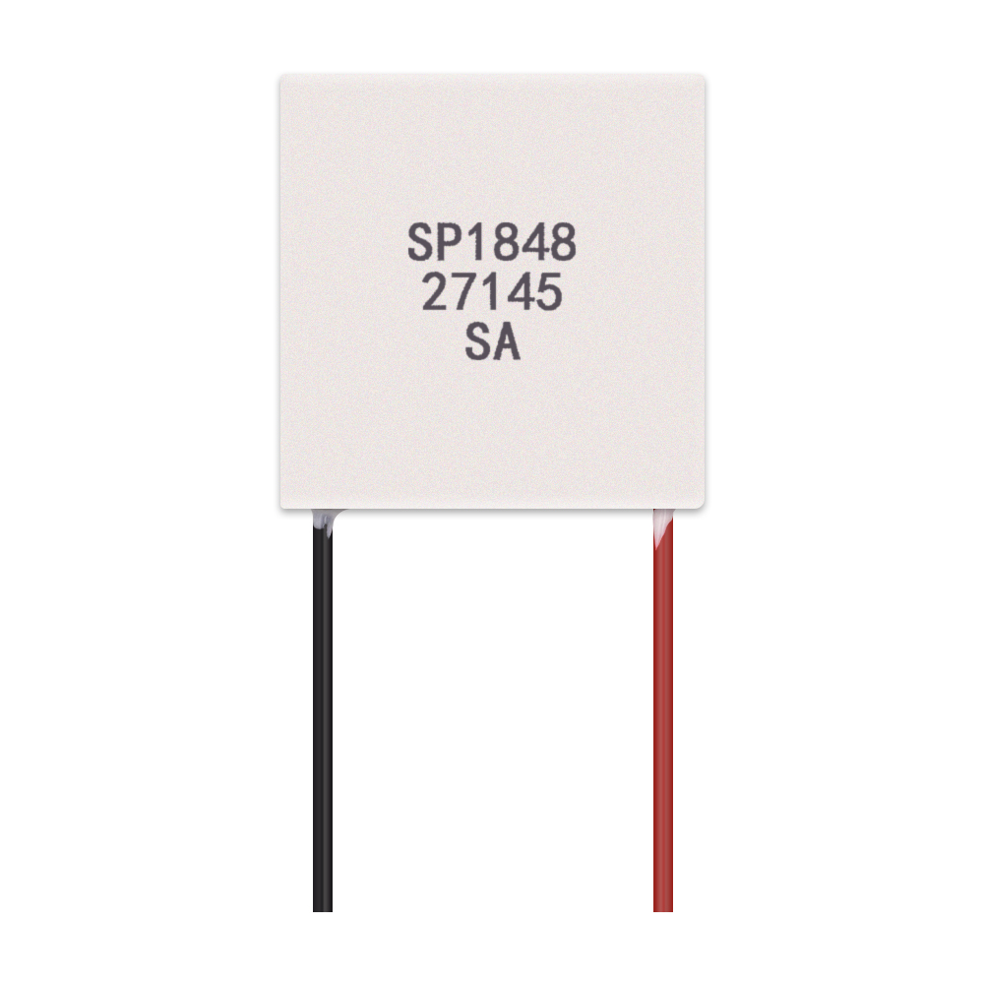
dimension
Lead wire length: about 30CM
Generator size: 40MM (long)* 40MM (wide)* 3.4MM(thick)

Method of use
The side with the lettering is close to the heat sink (cold side).
The non-lettered side is attached to the heat-absorbing side (hot side).
The red wire is connected to the positive terminal and the black wire is connected to the negative terminal to generate electricity when there is a temperature difference.

SP1848-27145 Parameters
The above values are for reference only, in the actual use of wiring, and booster board, the current will be lost.

