Hexapod Robot Installation Tutorial

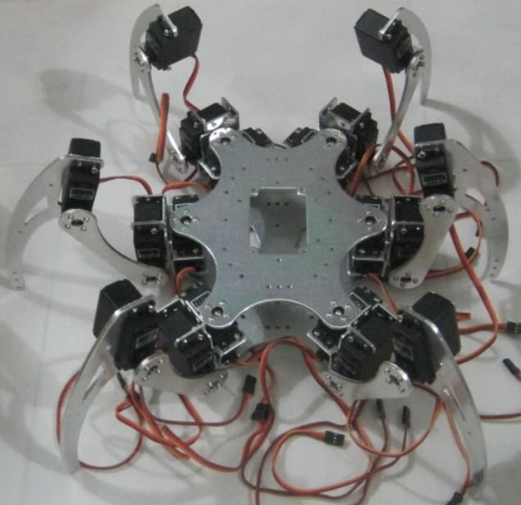

First you need all of the following parts:

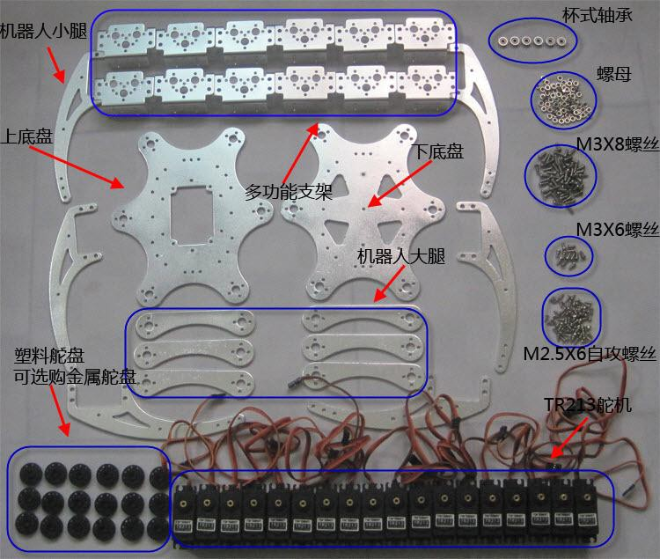
12PCS Multi-function bracket
6PCS Upper chassis, lower chassis, 1 robotic calf,
6PCS Robot thigh
18PCS TR213 high torque high precision robot and steering gear
18PCS Plastic steering wheels (TR213 steering gear with plastic steering wheel inside)
60PCS M3X8 screw
12PCS M3X6 screw
72PCS M2.5X5 self-tapping screws
54PCS M3 nut

First install 18 steering wheels
One thigh requires two steering wheels, for a total of six thighs, as shown below:
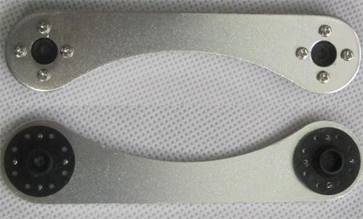
The robot's upper chassis requires six steering wheels, as shown below:
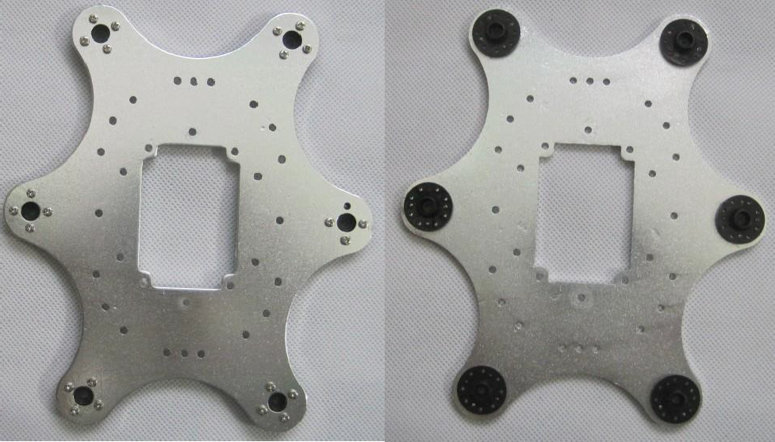
At this point, the self-tapping screws and the steering wheel are all used up.
Start installing the calf, a total of 6 calves, the legs of this set of hexapod robots are
Symmetrically distributed, so there are 3 and 3 other calves are symmetrical.
As shown below:

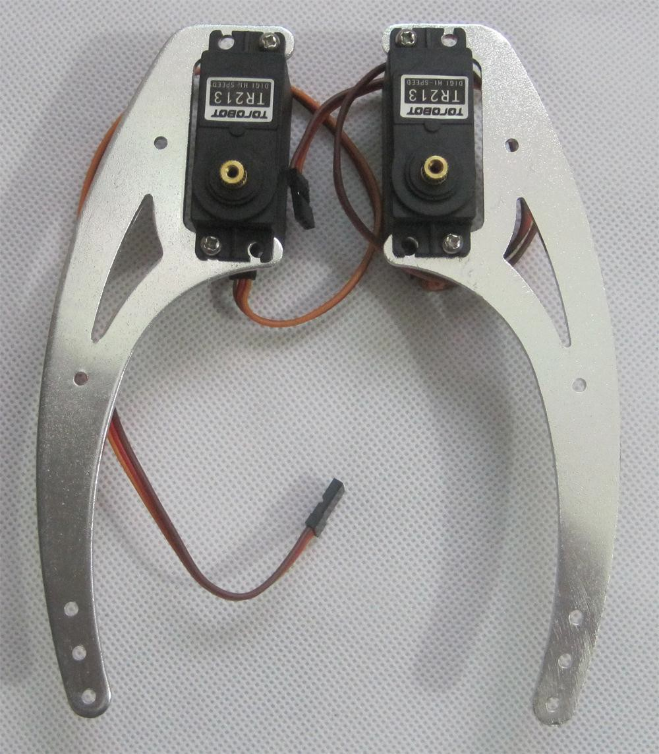
PS: Only one M3X8 screw is required for each servo.

Next is to install the multi-function bracket on the lower chassis, first install the bearing, as shown below:
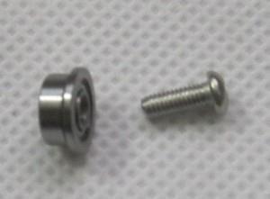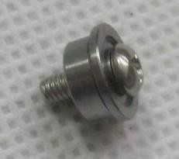

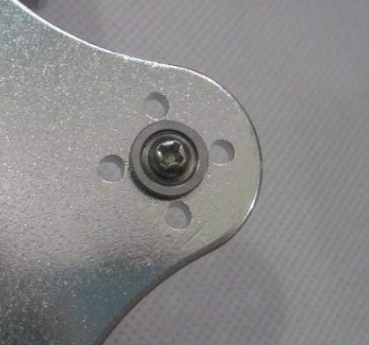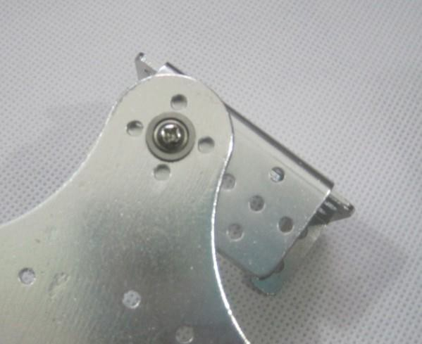
PS: The bearing is buckled inside, that is, the wide side of the cup bearing is outside.
Install 6 multi-functional brackets first, and the left side is not symmetrically distributed on the right side, as shown below: 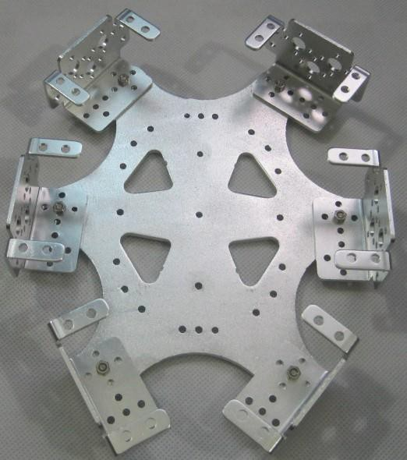

The next step is to follow the other 6 multi-functional brackets, as shown:
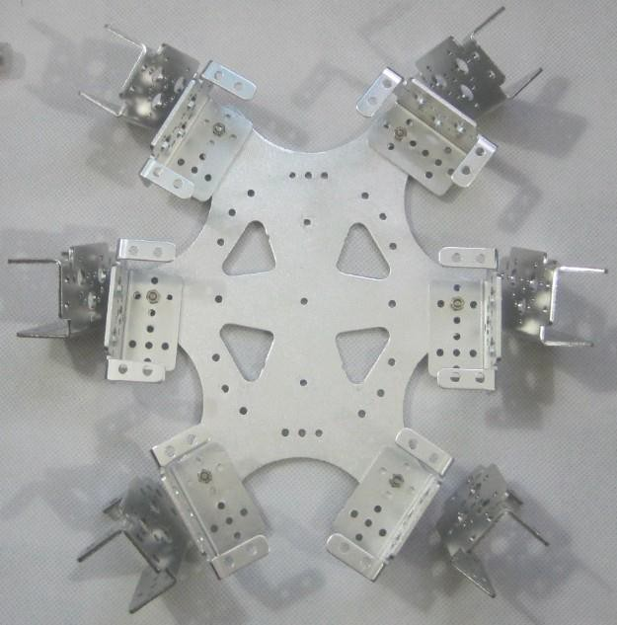
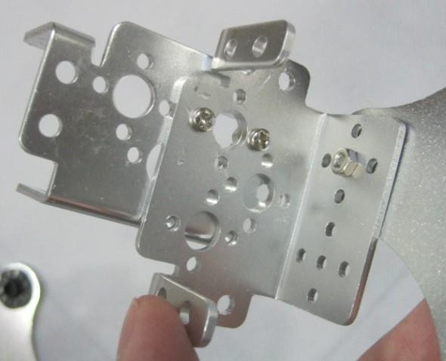
PS: In order to facilitate the installation of the steering gear, it is recommended to install the above three screws in one line (one line, not T type)
Pay attention to the direction, and the mounting hole position, the screw head is inside, the nut is outside, as shown.
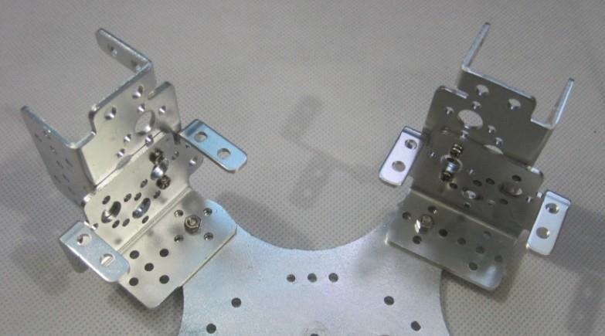
The multi-functional bracket is installed, as shown below:
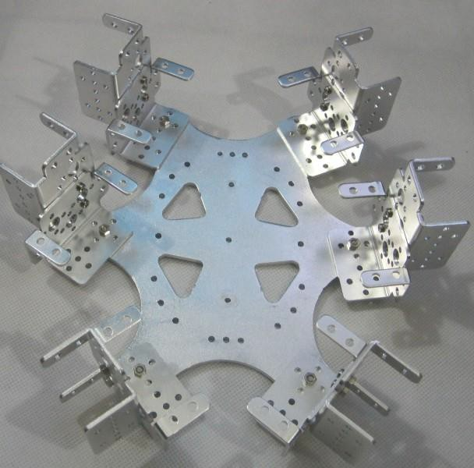

Next is to install the servo, as shown.
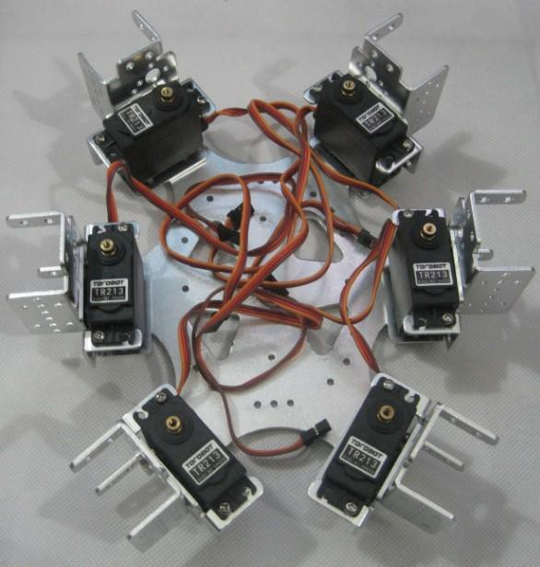

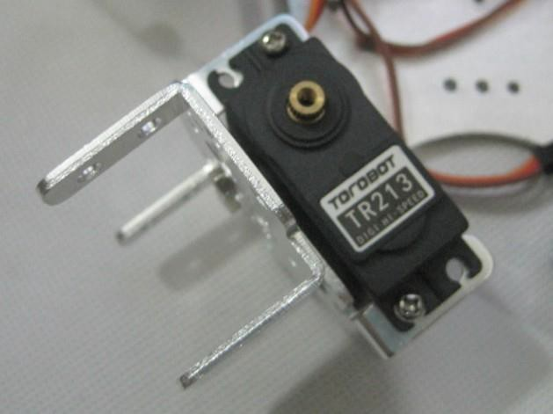

Install another 6 servos as shown.
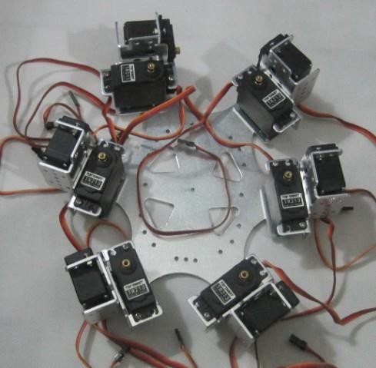
PS: The servo shaft is below.

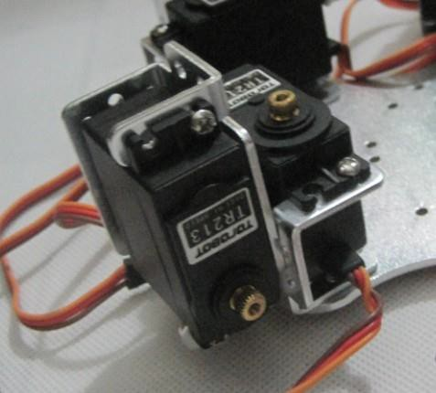

Install the upper chassis of the robot, as shown.

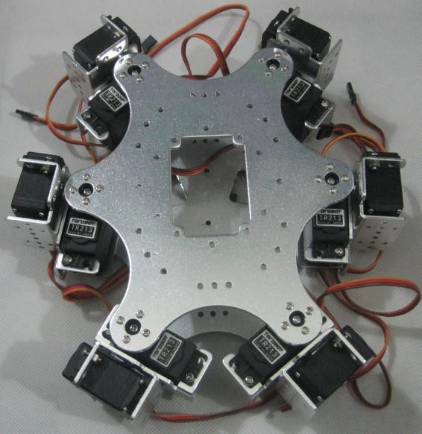
PS: It is recommended to adjust the initial position of the servo before this step. It is recommended to adjust the position to the middle to facilitate the rotation of the joint in the left and right direction.

Next, install the thighs, symmetrical, and the radius of the arc is on, as shown.

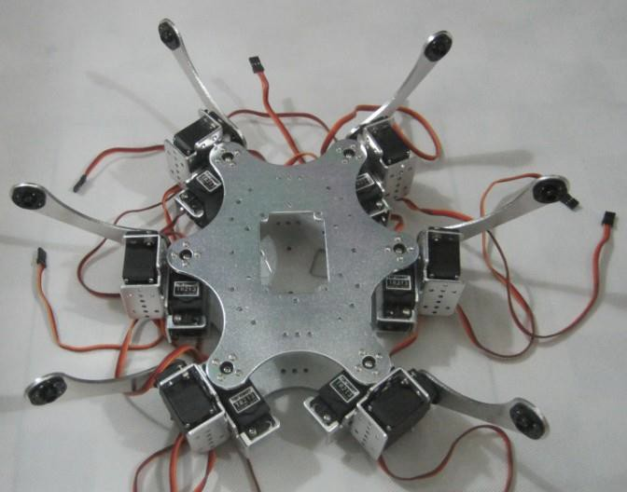
PS: Before this step, it is recommended to adjust the initial position of the steering gear as needed to facilitate joint movement.

The last step is to install the calf, symmetrical, and the radius of the arc is below, as shown.

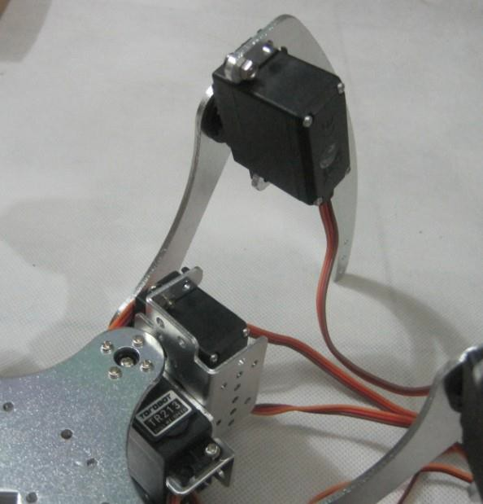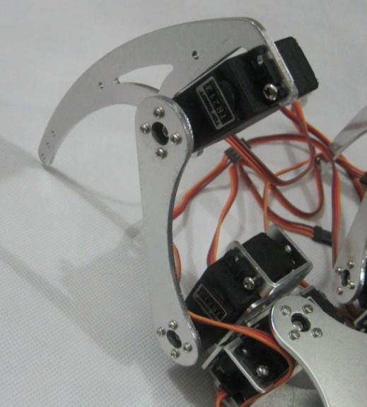

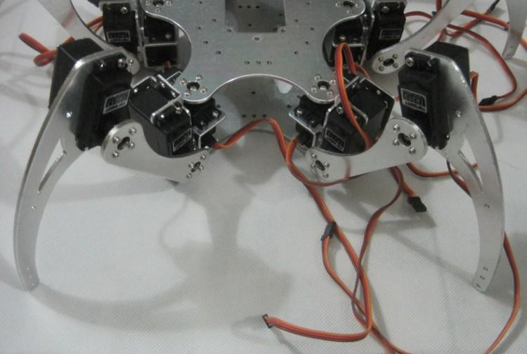
At this moment, the robot installation is complete, thank you for your support!

http://6zu.org

http://www.torobot.com

