1.3" Inch SPI OLED LCD Module
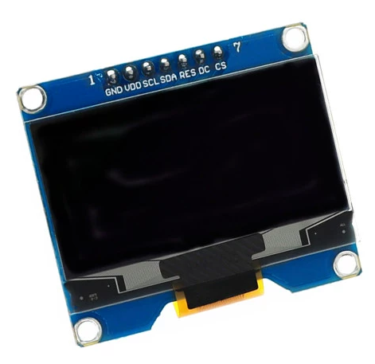

Product Parameter
Driver Chip | SH1106
Support interface | SPI
Resolution | 128×64
Display size | 1.3 inch
Display color | blue
Dimension | 35.5X33.7X1.2(mm)
Glass Size | 34.5X23X1.45(mm)
Display Area | 29.42X14.7(mm)
Tolerance | 0.2mm
Number of needles | 7 needles
Viewing angle | >160°
Operating Temperature | -40℃~80℃
Storage Temperature | -45℃~85℃
Operating Voltage | 3.3V / 5V

Pin Description
PIN | SYMBOL | Descriptions
1 | GND | Logic Circuit Grounding
2 | VDD | Logic Power Supply
3 | SCK | Serial Clock Input
4 | SDA | Serial Data Input
5 | RST | This pin is the reset signal input. When the pin is low, the initialization chip executes. Keep the pin pulled high during normal operation.
6 | DC | This pin is the data/command control pin. When the big pin is pulled high to select the serial interface mode, data will be interpreted at SDIN. When it is pulled low, the data in SDIN will drop to be transferred to the command register. In I2C mode, this pin acts as for slave address selection.
7 | CS | The chip is selected. Chip is selected when CS0 = " L".

Dimension Drawing
