 [Translated from Chinese (Simplified) to English - www.onlinedoctranslator.com](https://www.onlinedoctranslator.com/en/?utm_source=onlinedoctranslator&utm_medium=docx&utm_campaign=attribution)

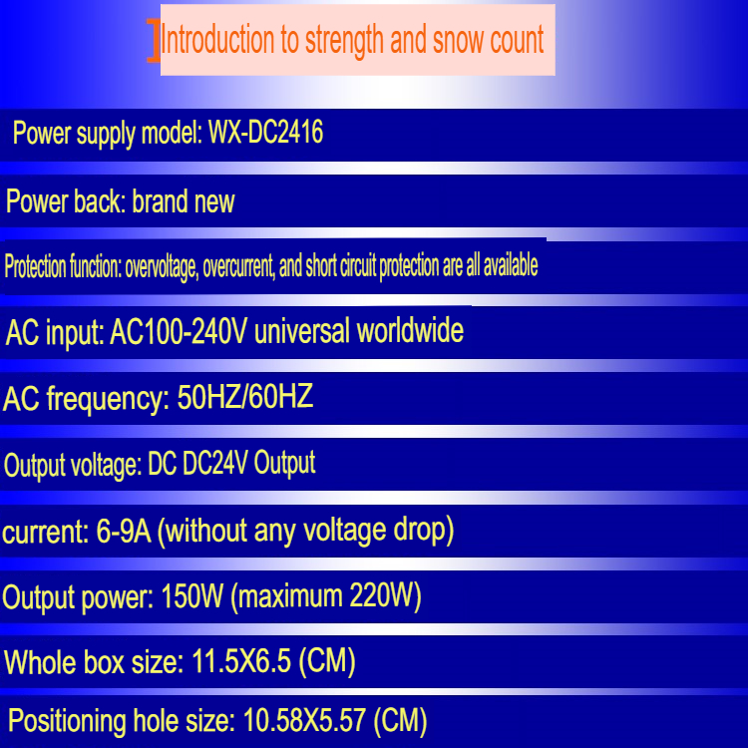

**Output ripple: <150MV**

**Height: 3.5cm**

