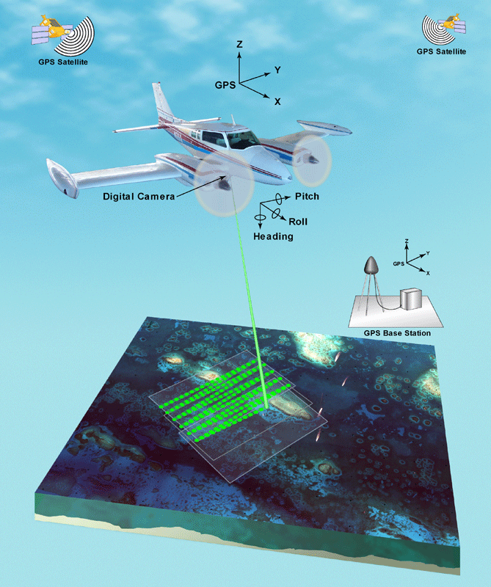

Lidar
  - Tf02 lidar WITH ARDUINO
Vishal Shinde | Robu.in | 30 Oct 2018

Introduction
Lidar Sensor:
- "Light Detection and ranging sensor" This sensor is used for distance measurement and depth measurement.
- It is also used to measure the elevation of things like buildings, trees and nowadays, we can also see that this technology is being rapidly adopted by the automobile industry.
- Overall, we can see that this technology is taking place of the ultrasonic sensors.
How Lidar sensor works?
- The functionality of the Lidar sensor is similar to Radar and Sonar, but here LIDAR uses a light source for its measurements. It uses green or near infrared light because this light source reflects strongly off of vegetation.
- It continuously emits light energy, when any object cut that light, it reflects back to sensor's receiver then control unit will calculates the time taken by light to reflect back.
Distance=Travel time*speed of light / 2

By doing this calculation we can calculate the distance between ground and LIDAR.
- The measured results will be OK if Lidar is mounted on ground level (in stable condition) but if it is mounted on moving object like drones then we can't say that it's giving accurate readings.
- So for accurate results, we will need the GPS module and Gyrosensor/altitude sensor along with LIDAR
- Gps = for proper positioning.
- Gyrosensor = because of turbulent flow of air the drone can rock and shakes so we can use gyrosensor and altitude sensors reading to minimize errors caused by tilt and jerks.
Now we can calculate accurate distance using the following calculation

Distance - Altitude= Accurate Distance.
In this way we will get accurate results.

Interfacing arduino with Lidar
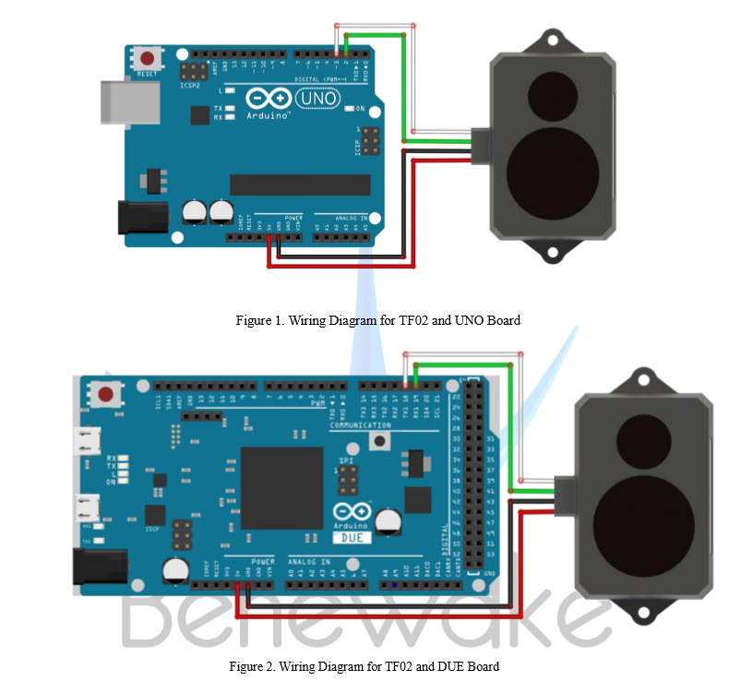
This module is compatible with Arduino, we can interface this module with Arduino using Arduinos GPIO pins.
Pinouts of TF02 Lidar=
Red= 5V
Black=Gnd
Green=Rx
White=Tx

If You are using Arduino Uno, connect Tx pin of TF02 to Arduino's pin no 2 and Rx to pin no 3 and if you are using Arduino mega connect Tx pin of Lidar to Rx pin of Arduino mega and Rx to Arduino's Tx.
In this, we will need two serial ports one is for sending data on the serial monitor and another for LIDAR. And in Arduino UNO there is only one serial port is available that's why we are using software serial port for Arduino Uno.
This link will help you to understand about ports of Arduino.

Software Part:-
Please refer the following code for LIDAR, this code is for Arduino Uno you can do some small changes to this and use this code for Arduino mega. Hope this information will be helpful for your project.
Vishino.ino

