2-channel PWM pulse frequency duty cycle adjustable module, square wave rectangular wave signal generator, stepper motor drive
Module Highlights:
1. Two independent PWM outputs, frequency and duty cycle can be set separately;
2. Wide frequency range and high precision;
3. Serial port communication
Dimensions: 41*28mm Thickness: 1.6mm
1. Module description
Two independent PWM outputs, which can be set to frequency and duty cycle respectively;
Frequencies are divided into three ranges:
1. XXX (no decimal point): The minimum unit is 1Hz, and the value range is 1Hz~999Hz;
2. XX.X (decimal point in 10 places): the smallest unit is 0.1Khz, and the value range is 0.1KHz~99.9KHz
3. X.X.X. (three digits have decimal points): the smallest unit is 1Khz, and the value range is 1KHz~150KHz
e.g. Frequency display: 100 indicates PWM output pulse of 100Hz;
54.1 indicates PWM output pulse of 54.1KHz;
1.2.4. Indicates PWM output pulse of 124KHz
占空比取值范围：0~100；
The three frequency ranges share a duty cycle, and all set parameters are saved when the power is down.
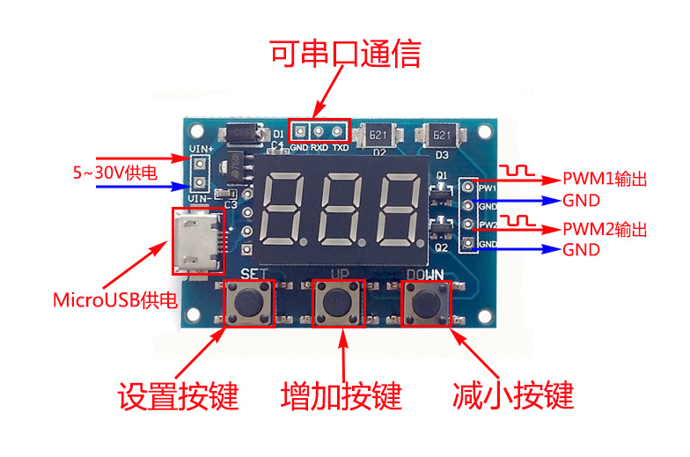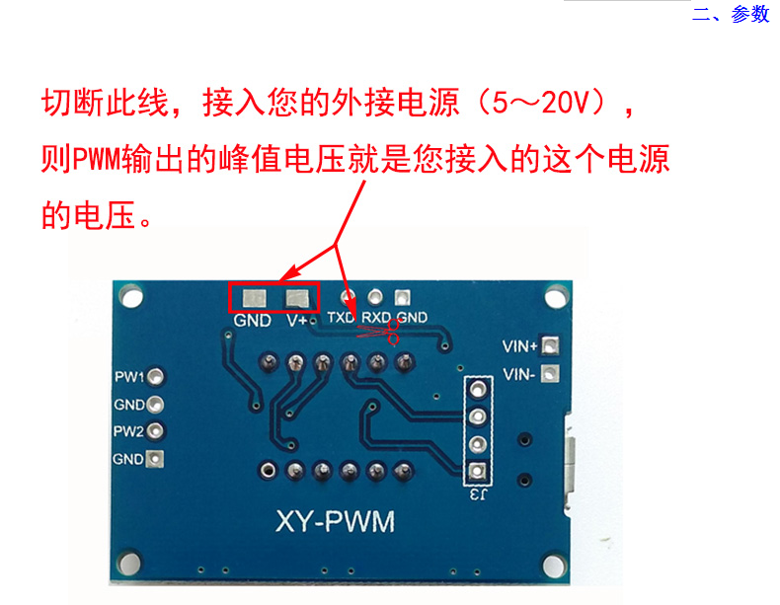
2. Parameter setting
The module has 3 buttons: Set, Up, Down;
1. By pressing the [Set] button, you can switch the display of four parameter values (FR1: PWM1 frequency; dU1: PWM1 duty cycle; FR2: PWM2 frequency; dU2: PWM2 duty cycle), and the corresponding parameter name will flash before switching.
2. Press the [Up] and [Down] keys directly to modify the current parameter value (long press to quickly add or decrease).
3. There are 3 frequency values for each of the two PWMs, and the duty cycle of the 3 frequencies is the same by pressing and holding the [SET] button in the frequency display interface. (XXX: Range: 1Hz~999Hz; XX.X: range 0.1Khz~99.9Khz;X.X.X.: range 1Khz~150Khz,).
3. Module parameters:
1. Working voltage: 5--30V, support micro USB 5.0V power supply;
2. Frequency range: 1Hz~150KHz;
3. Frequency accuracy: the accuracy in each range is about 2%;
4. Signal load capacity: the output current can be about 8--30mA;
5. Output amplitude: default 5V V-pp (can be changed by external power supply);
6. Ambient temperature: -30~+70°C.
4. Scope of application:
1. Used as a square wave signal generator to generate square wave signals for experimental development;
2. It is used to generate a square wave signal to drive the stepper motor driver;
3. Generate adjustable pulses for MCU use;
4. Generate adjustable pulses and control related circuits (PWM dimming speed regulation and other applications).
5. Serial port control
Communication standard: 9600 bpsData
bits: 8 stop bits
: 1 check bit
: noneFlow control
: none
1. Set the frequency of PWM
"S1FXXXT": Set the frequency of PWM1 to XXX HZ (001~999).
"S1FXX.XT": sets the frequency of PWM1 to XX.X KHZ (00.1~99.9).
"S1F:X.X.X.T": SET THE FREQUENCY OF PWM1 TO XXX KHZ (0.0.1.~1.5.0.).
‘S1’: PWM1
‘S2’： PWM2
'F': Frequency
‘D’:占空比
'T' is the end flag bit
2. Set the duty cycle of PWM
"S1DXXXT": set the duty cycle of PWM1 to XXX;(001~100).
"S2DXXXT": set the duty cycle of PWM2 to XXX;(001~100).
If the setting is successful, it will return: DOWN;
If the setting fails, it will return: FALL.

