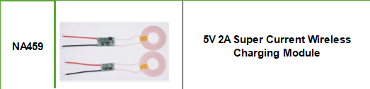

Module main parameters:
Input voltage：9~12V
Max load current：1.3A
Receiving output voltage current：5V/2A,12V/700mA
Launch coil size: outside diameter 43mm, thickness 2.3mm
Launch module size: 18mm*8.5mm*15mm
Receiving module size: 10mm*25mm*3mm
Receiving coil size: outside diameter 43mm, thickness 1.2mm
Receiving the best distance: 3~6mm

