SOIC/SSOP TO DIP 20 PIN Adapter-2pcs
SKU: 107400
====================================================================

Double Sided PCB
Side#1: Pitch 0.65mm, suitable for common SSOP20, TSSOP20.
Side#2: Pitch 1.27mm, suitable for common SO20, SOP20, SOIC20.
PCB Dimensions
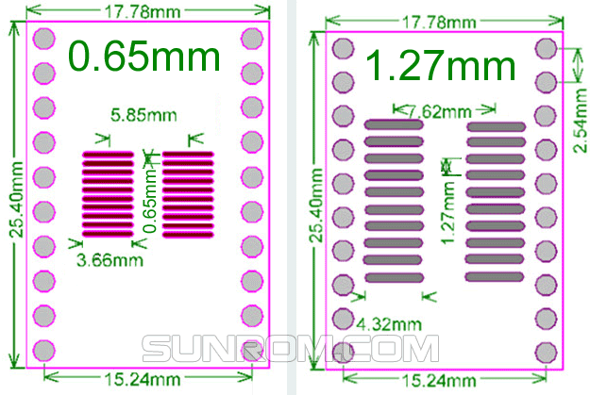

Suitable for below dimensions of ICs.
