Serial-port Uart-WIFI Module, SCM WIFI and HLK-RM04 Simple Testing Board
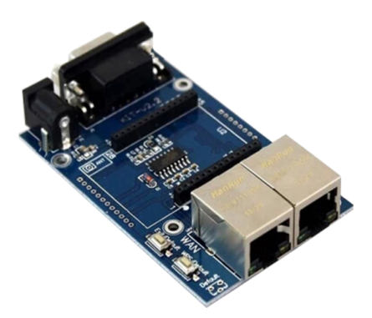
Specification
Weight: about 36.5g
Size: 80mm*50mm

Description of interfaces and keys
