Bluetooth MP3 Decoding Board Module w/ SD Card Slot / USB / FM / Remote Decoding Board Module
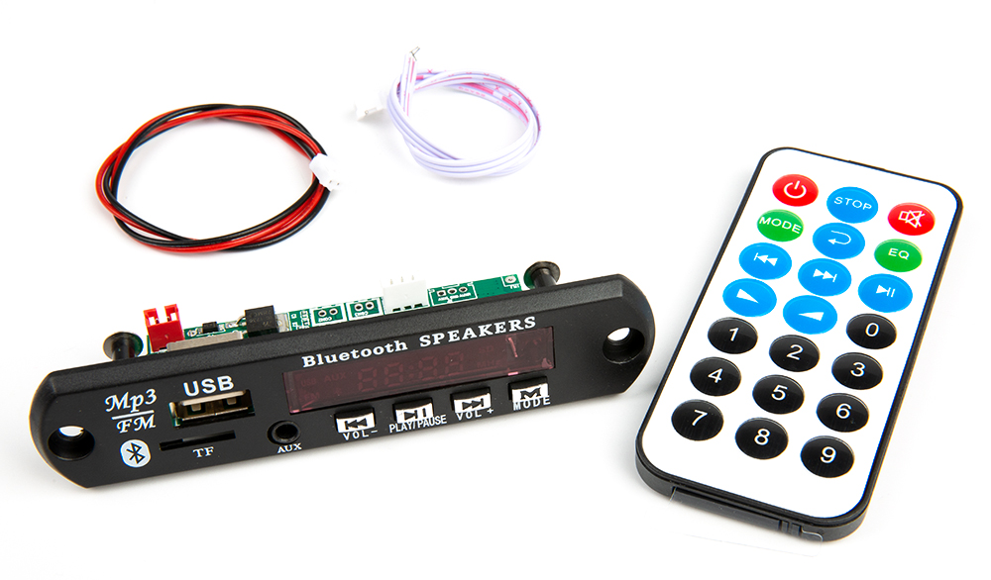
Module features
Support direct switching of external signals.
Support Bluetooth3.0EDR.
Support USB/SD/Bluetooth/FM/LINE automatic switching.
The module contains MP3/WMA song decoding chip.
Support USB, SD, MMC card for playback.
Support USB/SD card switching, previous song, next song, fast forward, fast backward, volume adjustment, EQ, play/pause, stop, single repeat, mute, shutdown, direct song selection.
Support Bluetoot Previous Song, Next Song, Volume Adjustment, EQ, Play/Pause, Mute, Shutdown.
Support FAT16, FAT32 file system.
Support MP1 Layer3, MP2 Layer3, MP3 Layer3 version of songs.
Support 32-320kbps MP3 songs.
Support power-off memory function: memorize the songs and volume played before power-off.

Panel key description
1、"PREV/VOL-":Set long press volume down; short press for the previous track in USB/SD/Bluetooth status; short press for the previous station in FM status.
2、"PLAY/PAUSE":in USB/SD/Bluetooth state short press play/pause; in FM state long press all channels to search and save stations.
3、"NEXT/VOL+":Set long press volume up; short press previous track in USB/SD/Bluetooth status; short press next station in FM status.
4、"MODE":When there are SD card and U disk: the switching order is USB→SD→Bluetooth→FM→AUX; only U disk: the switching order is USB→Bluetooth→FM→AUX; only SD card: the switching order is SD→Bluetooth→FM→AUX; there is no USB and Bluetooth: the switching order is USB→Bluetooth→FM→AUX; there is no USB and U disk: the switching order is USB→Bluetooth→FM→AUX. →AUX; when there is no USB and SD card: FM→AUX→Bluetooth.

Remote control key description
1、POWER:Standby:This key cannot be switched.
2、MODE:When there are SD card and U disk: the switching order is USB→SD→Bluetooth→FM→AUX; when there is only U disk: the switching order is USB→Bluetooth→FM→AUX; when there is only SD card: the switching order is SD→Bluetooth→FM→AUX; when there is no USB and SD card: FM→AUX→Bluetooth. When there is no USB and SD card: FM→AUX→Bluetooth.
3、PREV:In USB/SD/Bluetooth state short press for the last track; in USB/SD state long press for the song fast forward; in FM state short press for the last radio station, long press for scanning and searching the last station.
4、NEXT:Short press for next track in USB/SD/Bluetooth status; long press for song fast forward in USB/SD status; short press for next station in FM status, long press to scan and search next station.
5、VOL+:Short/long press for music plus.
6、VOL-:Short/long press for music minus.
7、REP: Toggle key between single song repeat and full loop during USB/SD playback, power on for full loop.
8、"STOP": In USB/SD state, short press to stop music playback.
9, MUTE: mute key, press the mute, and then press to lift (press VOL-/VOL+ can also lift).
10、EQ:Sound field mode. NORMAL→BAS→POP→ROC→JAZZ→CLA→CUT→NORMAL
11、PLAY/PAUSE:Play/Pause in USB/SD/Bluetooth state; Long press in FM state to search and store all channels.

Interface and Component Description Diagrams
