4A DC-DC Step-down Adjustable Constant Voltage Module

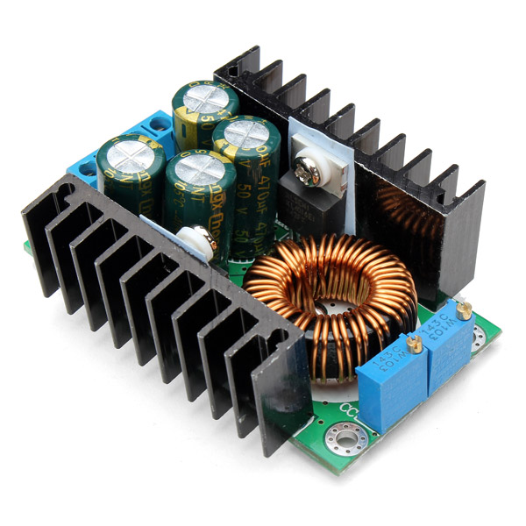

Features:
- Scope: High-power LED constant current driver, rechargeable lithium batteries 4V, 6V, 12V, 14V, 24V battery charging; nickel-cadmium nickel-metal hydride batteries (battery) charging, solar panels, wind generators.
- Output voltage: continuously adjustable (1.25-35V) (applied to the input voltage is higher than the output voltage applications can boost).
- Turn lights Current: current value * (0.1), turn the lamp current and constant value linkage, such as the constant value of 3A.
- Turn the lamp current is set to a constant current of 0.1 times (0.1 x 3A = 0.3A), when the constant 2A, when adjusted to the current value, then turn the lamp current constant current of 0.1 times (0.1 x 2A = 0.2A).
- This version is a fixed 0.1 times (actually turn the lamp current value is probably not very accurate) is full of instructions for charging.
- Minimum pressure: 1V.
- Output Ripple: about the ripple 50mV (without noise) 20M bandwidth (for reference) Input 24V Output 12V 5A measured.
- Operating temperature: -40 ℃ to + 85 ℃ (please note the actual use of the power tube temperature, the temperature is too high, please enhance heat dissipation).

How to do the Module adjustment:
- When the module output voltage cannot be adjusted (the output voltage is always equal to the input voltage) Please adjust the potentiometer counterclockwise 20 laps (20 turns) or more till it works.
- Turn trimmers CLOCKWISE to INCREASE, ANTICLOCKWISE to DECREASE.
- When adjusting the blue potentiometer, please use a multimeter to monitor the voltage
- The trimmer nearest the voltage output adjusts the output CURRENT (CC)
- The trimmer nearest the voltage input adjusts the output VOLTAGE (CV)

Charger application instructions:
- First, determine the float voltage and charging current required by the battery to be charged (the ‘target battery). The target battery disconnected from the module output, apply a voltage of 7V - 32V to the module input, being sure to observe correct polarity.
- Using the CV trimmer, adjust the output voltage to about 5V.
- Switch your multimeter into its 4A current scale and measure the modules short-circuit output current. Turn the CC trimmer to.
- adjust the current to the charging current required by the target battery.
- Using the CV trimmer, adjust the modules output voltage to the float voltage required by the target battery.
- Connect the target battery to the module output, observing correct polarity. Charging of the battery should commence.

Constant current LED Driver Application Instructions:
- First, determine the operating current and maximum operating voltage of the LED you need to drive.
With the CV trimmer, adjust the output voltage to about 5V.
- Adjust the current to the operating current of your LED.
- adjust the CV trimmer to make the output voltage reach the maximum LED operating voltage.
- Connect LED, test.

