USB Blaster (ALTERA CPLD / FPGA download cable)
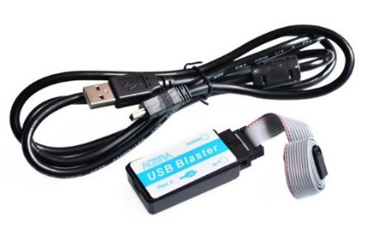
Basic Characteristics
1. Stable support for SignalTap II embedded logic analyzer function, capture data will not capture chaos! The data will not be messed up!
2. Support for ALTERA-IC company's full range of devices. Absolutely all series, do not worry about a device does not support!
CPLD: MAX3000, MAX7000, MAX9000 and MAXII and so on.
FPGA: Stratix, StratixII, StratxIII, Cyclone, CycloneII, CycloneIII, CycloneIV, ACEX1K, APEX20K and FLEX10K and so on.
Active serial configuration devices: EPCS1, EPCS4, EPCS16, EPCS64, etc.
Enhanced configuration devices: EPC1, EPC4, etc.
3. Support three download modes: AS, PS and JTAG;
4. Support communication and in-system debugging with Nios II embedded soft-core processor, the latest firmware version of Rev! C firmware!
5. Fast speed: 6 times faster than the commonly used parallel port download line ByteBlasterII;
6. Easy to use: MiniUSB interface, easy to connect, 2 status indicators to make debugging more handy.
7 must: the current laptop has almost eliminated the parallel port, so the commonly used ByteblasterMV and ByteblasterII download line can not be used in the laptop, so for laptop users, the choice of USB download line that is convenient, it is necessary.
- Fully compatible with ALTERA USB Blaster, the use of methods, functions and performance and ALTERA original download cable consistent.

Pin Definitions
The Altera-IC standard is used, and the definitions are as follows:
Standard JTAG interface:
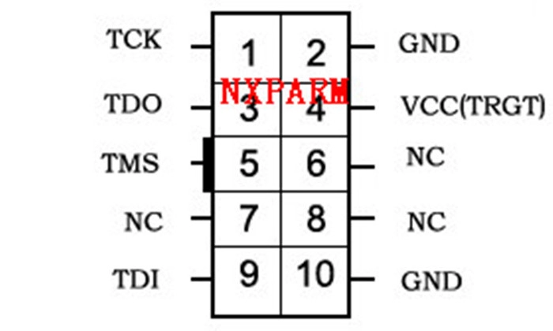
Standard AS interface:
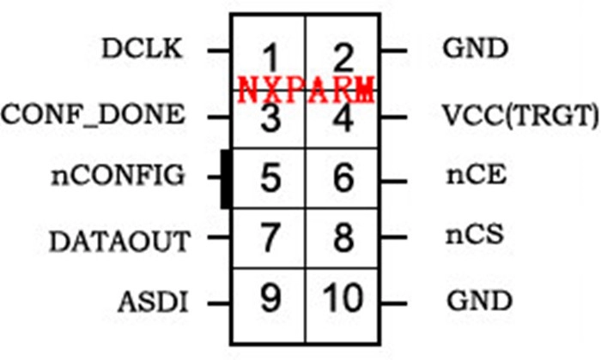
System Configuration
1, Support WindowsXP, Windows Vista, Windows7 (32bit/64bit) system, USB 2.0 interface;
2, Quartus II version 4.0, and above (the latest is Quartus II 18.0).

