钮子开关 MTS-203 DPDT 6脚3档

Mini MTS-203 6-Pin DPDT ON-OFF-ON 6A 125VAC Toggle Switches

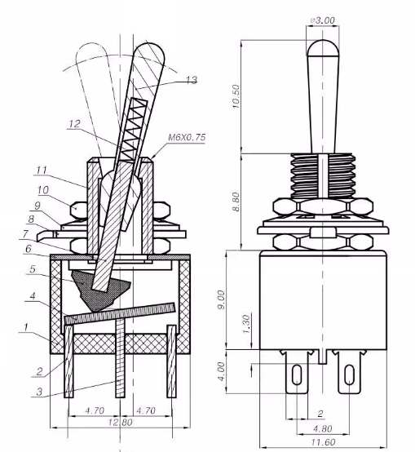
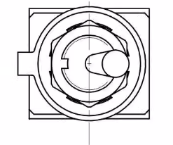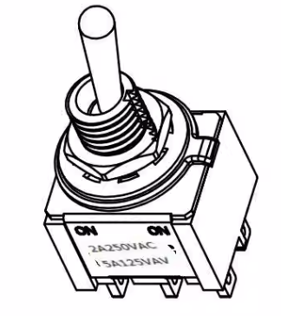
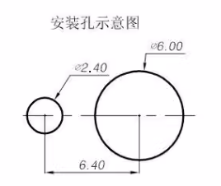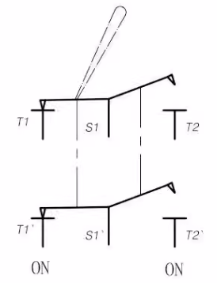
技术要求:
1.规格:2A 250VAC，5A 125VAC
2.操作温度:-25℃--+85℃
3.接触电阻:<0.02Q
4.绝缘电阻:>1000MQ
5.耐压:AC1500V/min
6.扭柄换向力:2--15N
7.寿命:10000次
Technical Requirements.
1.Specification:2A 250VAC, 5A 125VAC
2.Operating temperature:-25℃--+85℃
3.Contact resistance:<0.02Q
4. Insulation resistance:>1000MQ
5.Withstanding voltage:AC1500V/min
6. Torque handle reversing force: 2--15N
7. Life: 10000 times

