Stroke Length 200MM 7mm/S 1500N DC12V Electric Putter Electric Linear Actuator Putter for Doors /Windows

Product Features
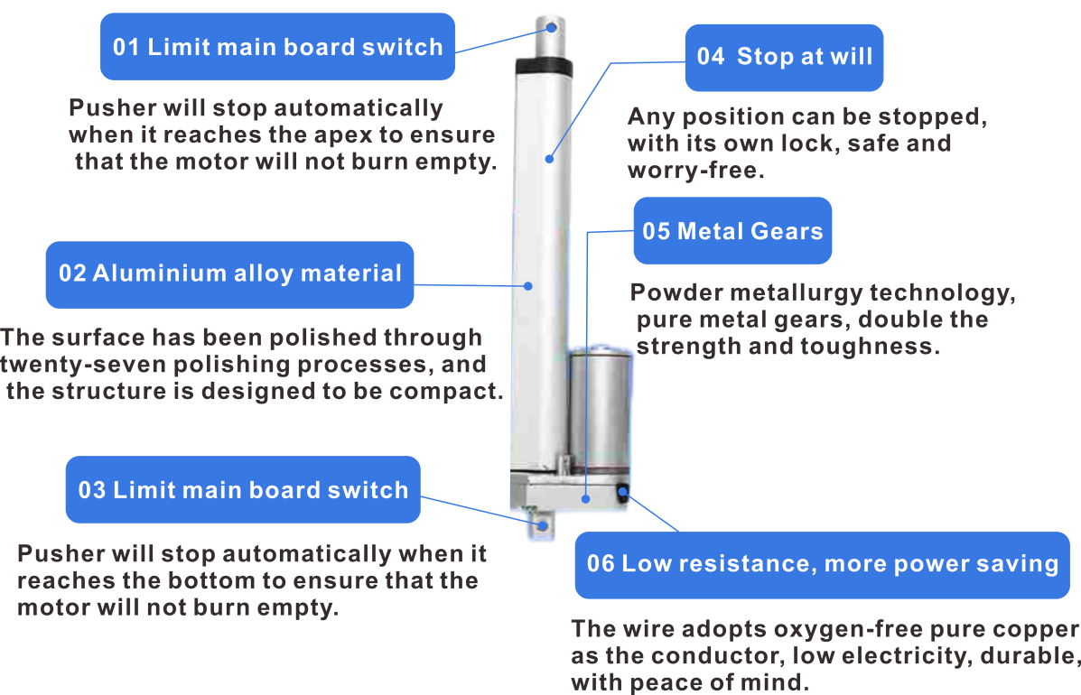

Specification parameters
(Installation space confirmation) (The faster the speed, the less force)
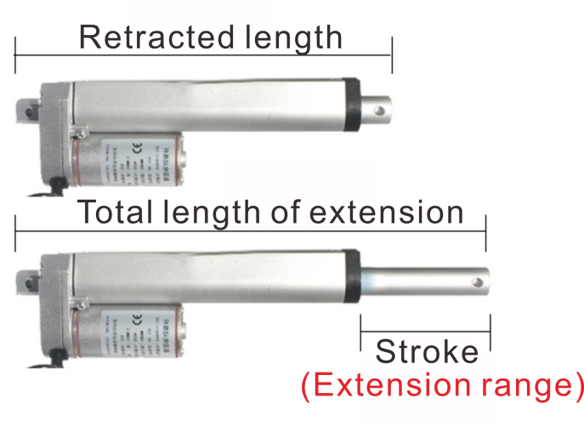
(Extension time=stroke/speed)
1：Check whether there is enough space for installation
2: Stroke (i.e., retractable range) needs to be how long
3: Select the appropriate speed according to the weight of the object to be pushed.

Working voltage: DC 12V
Stroke: 200
Retracted total length: 300mm
Extended total length: 500mm
speed | 5  mm/s | 10 mm/s | 15 mm/s | 20 mm/s | 30 mm/s | 45 mm/s | 60 mm/s | 90 mm/s
torsion | 1000N  About 100KG | 900N  About  90KG | 700N  About  70KG | 500N  About  50KG | 300N  About  30KG | 200N  About  20KG | 150N  About  15KG | 100N  About  10KG
horizontal thrust | 100KG | 90KG | 80KG | 50KG | 30KG | 20KG | 15KG | 10KG
vertical thrust | 50KG | 45KG | 40KG | 25KG | 15KG | 10KG | 7.5KG | 5KG
push to place time (sec) | 40 seconds | 20  seconds | 13.3  seconds | 10  seconds | 6.7  seconds | 4.4  seconds | 3.3  seconds | 2.2  seconds

Mounting Dimensions
(1): The centre distance between the front and rear mounting holes after the actuator is fully retracted, i.e. the fully retracted centre distance of the actuator (i.e. the actuator's own length).
Stroke below 300mm Mounting size L=105mm+S
Stroke over 300mm Mounting dimension L=155mm+S
(2): The centre distance between the two mounting holes before and after the actuator is fully extended.
Stroke less than 300mm = 105mm+S+S
Stroke over 300mm = 155mm+S+S
L=Centre distance after fully retracted
S=Stroke (retracted length)
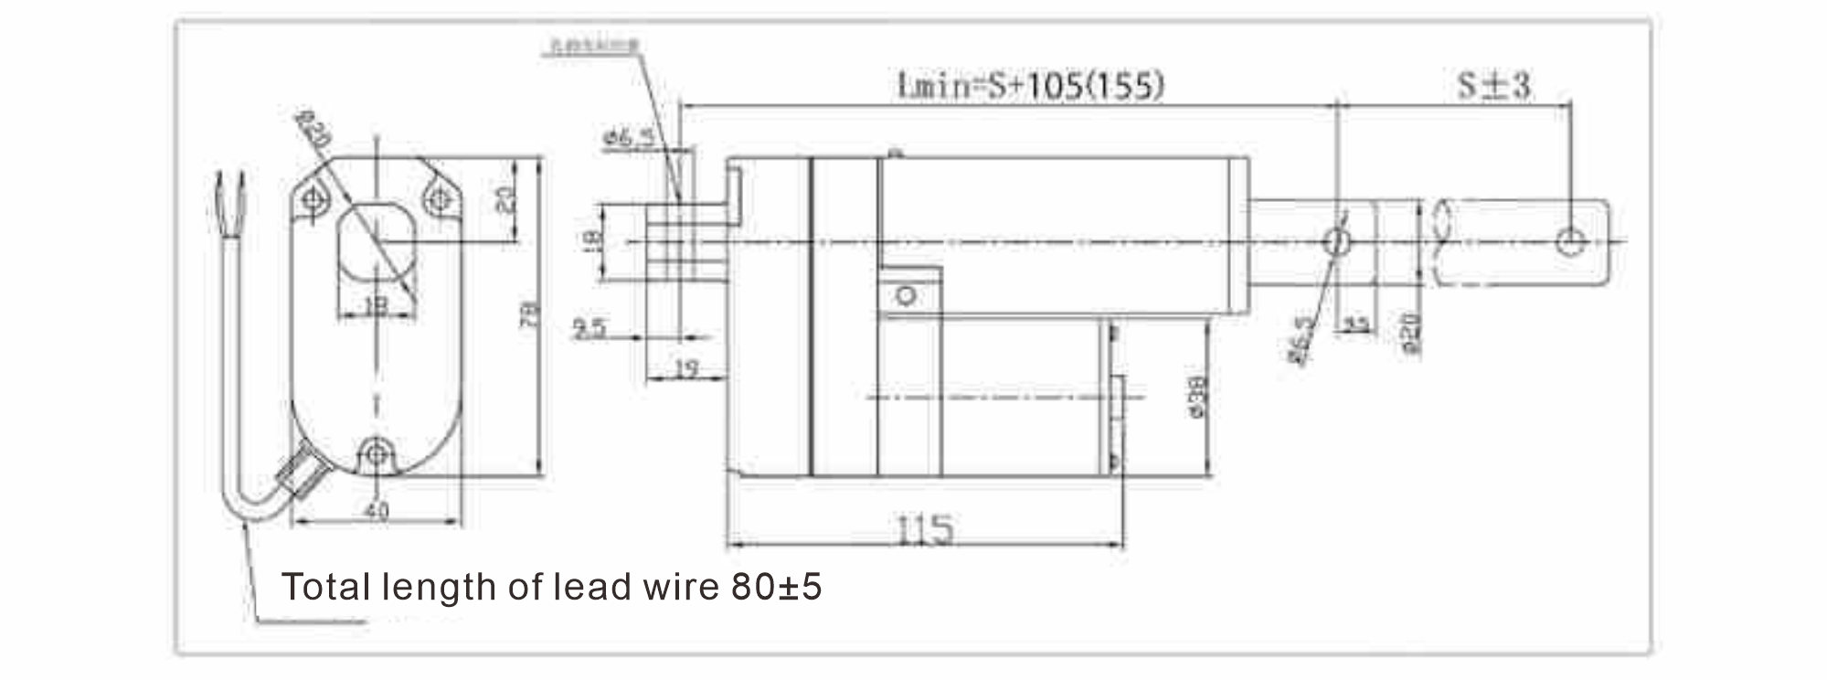
Example: Actuator with a stroke of 100mm
After fully retracted, the hole centre distance is 205mm (L=105mm+stroke 100mm)
When fully retracted, the hole centre distance is 305mm (L=105mm+stroke 100mm+stroke 100mm).

