Assembly as a diagram

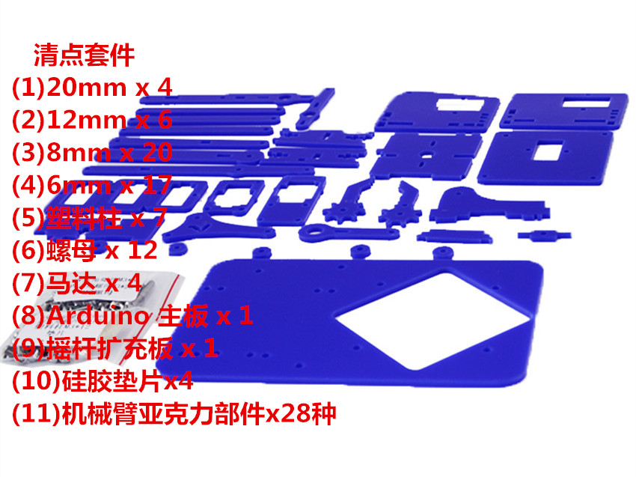

Clear Suites
(1) 20mm x 4
(2) 12mm x 6
(3) 8mm x 20
(4) 6mm x 17
(5) plastic column x 7
(6) nut x 12
(7) motor x 4
(8) Arduino main board x 1
(9) remote sensing expansion board x 1
(10) silica gel gasket x 1
(11) acrylic components of mechanical arm x 28

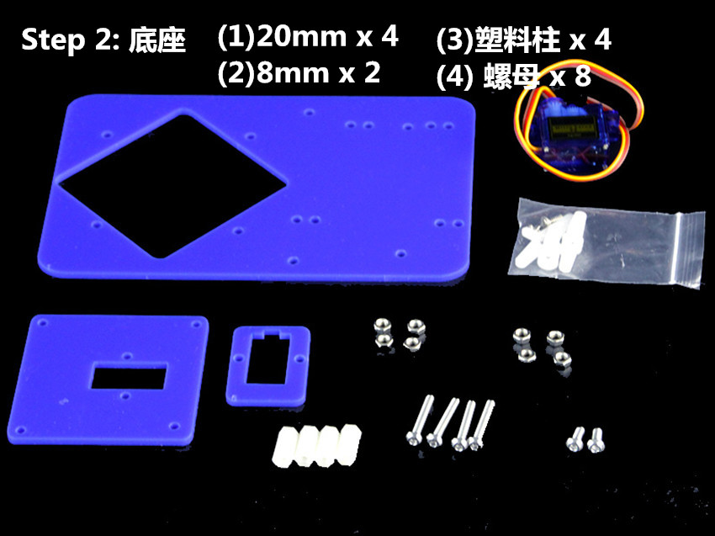

step 2 ：base
(1)20mm x 4
(2)9mm x 2
(3) plastic column x 4
(4) nut x 8

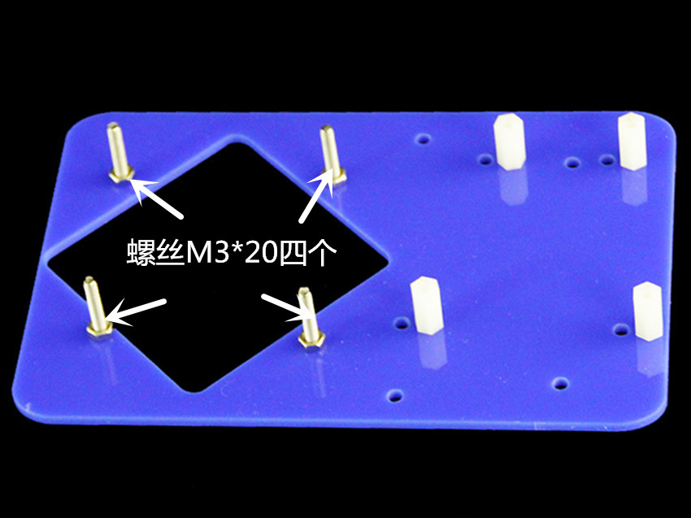

Screw M3*20 four

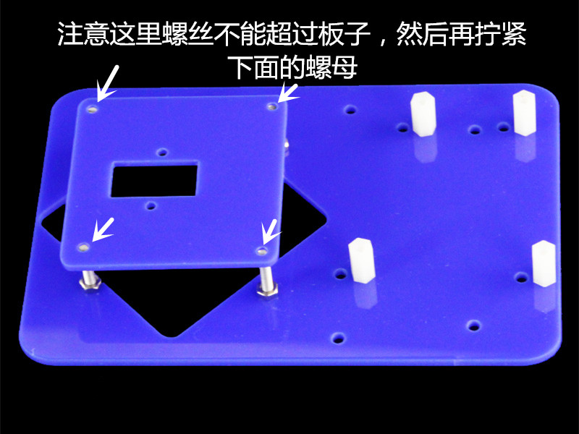

Be careful not to exceed the board, then tighten the nut below.

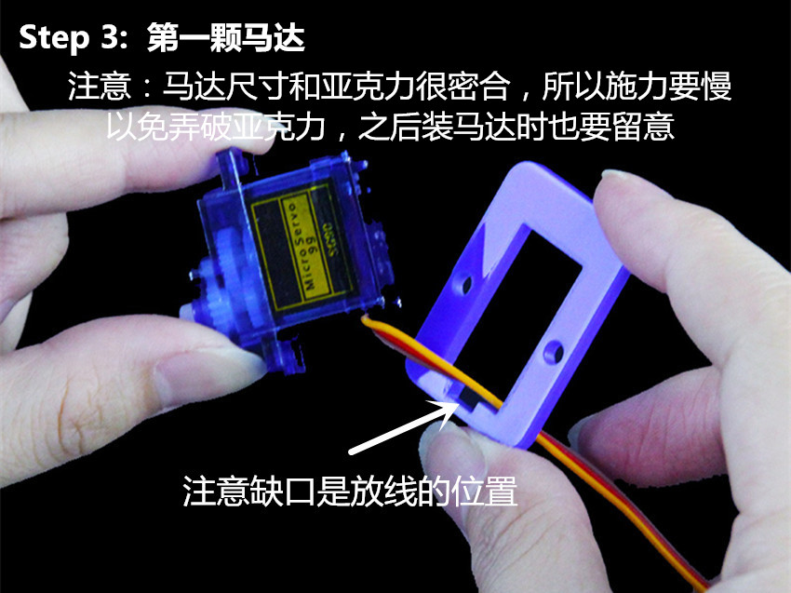

step 3：The first motor
NOTE：The size of the motor is very close to that of the acrylic, so the force must be slow, so as not to break the acrylic.
NOTE：The gap is the location of the line.

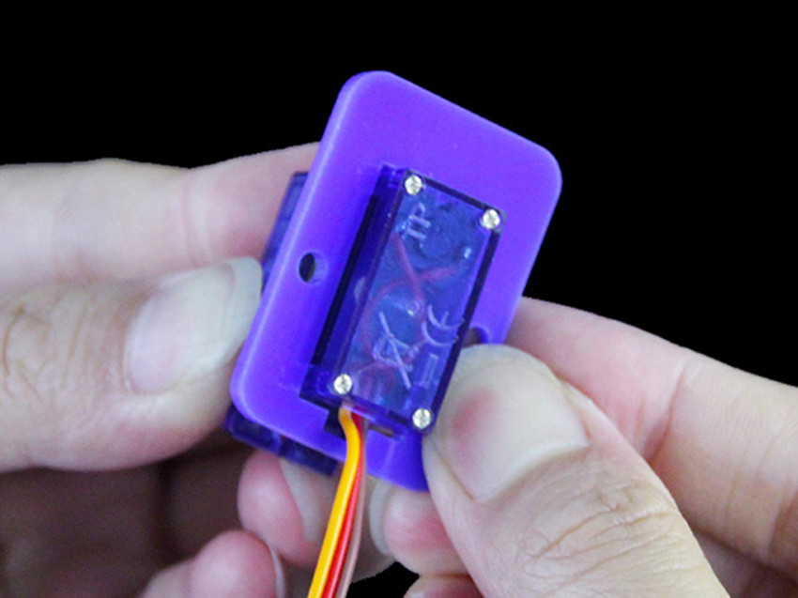

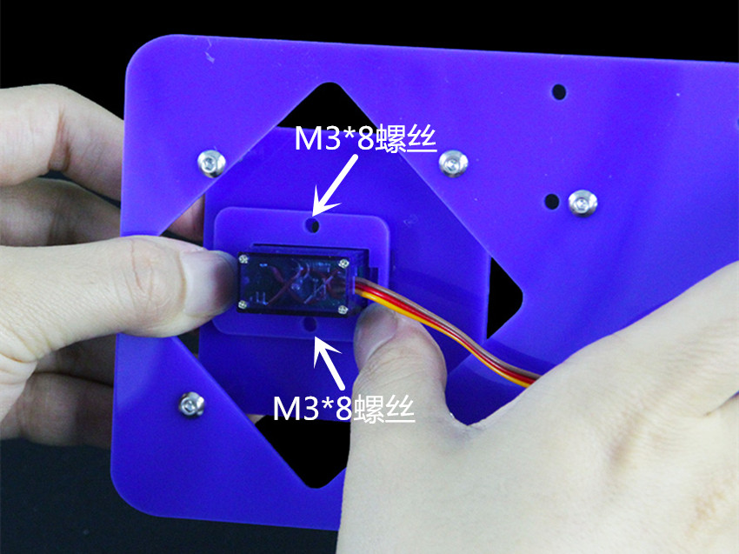

M3*8 screw（double）

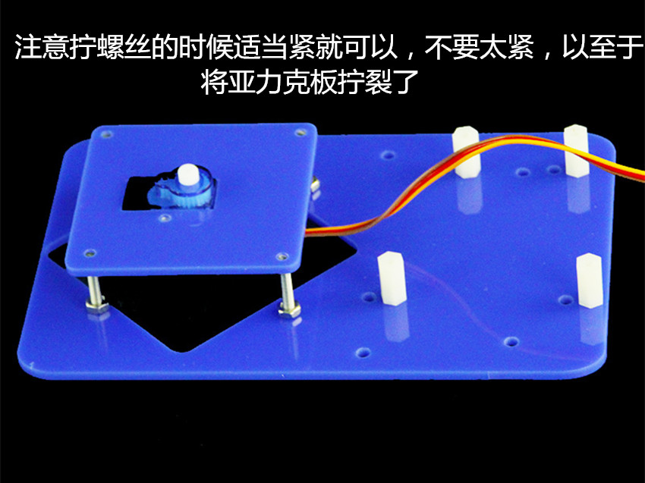

Be careful not to tighten the screws too tightly. It will crack the acrylic board too tightly.

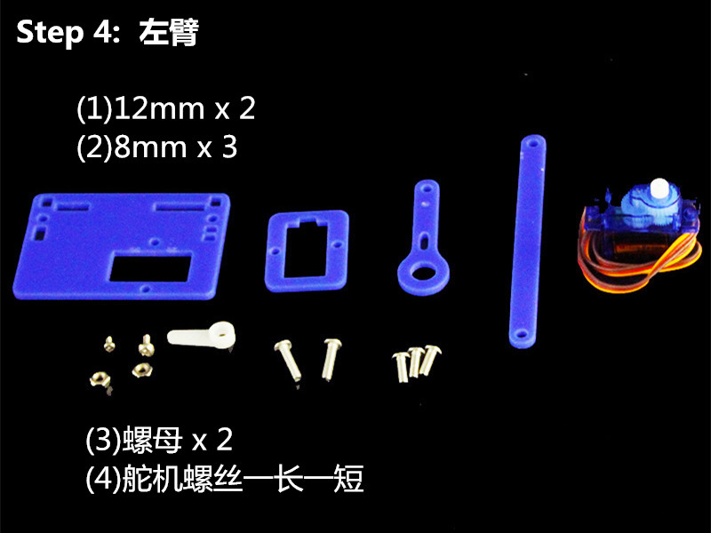

Step 4 ：Left arm
(1)12mm x 2
(2)8mm x 3
(3) nut x 2
(4) the screw of the steering gear is one length and one shor

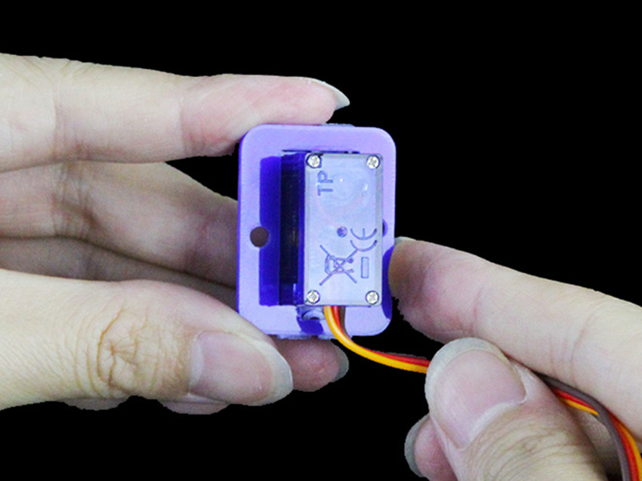

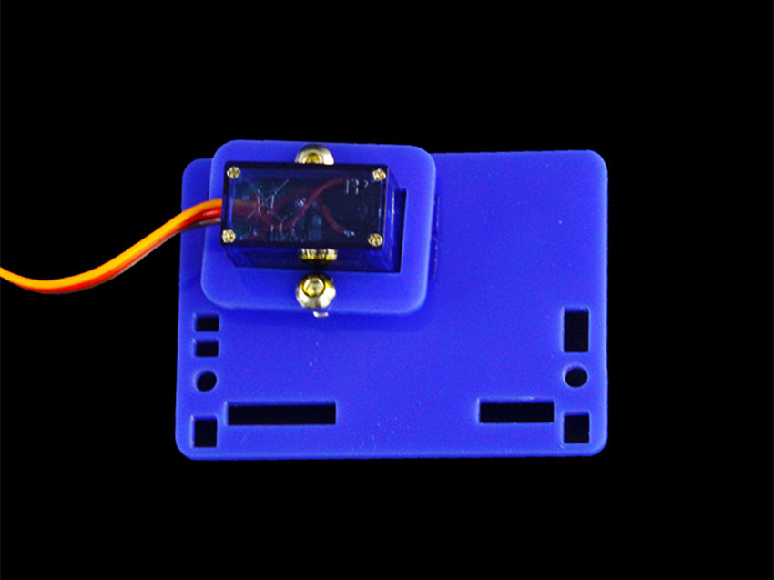

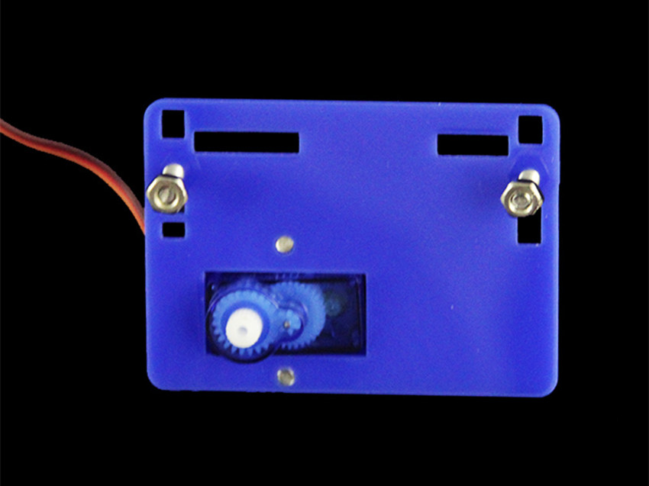

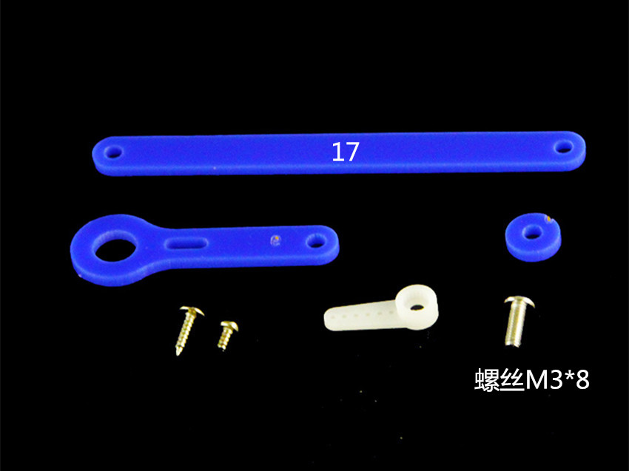

Screw M3*8

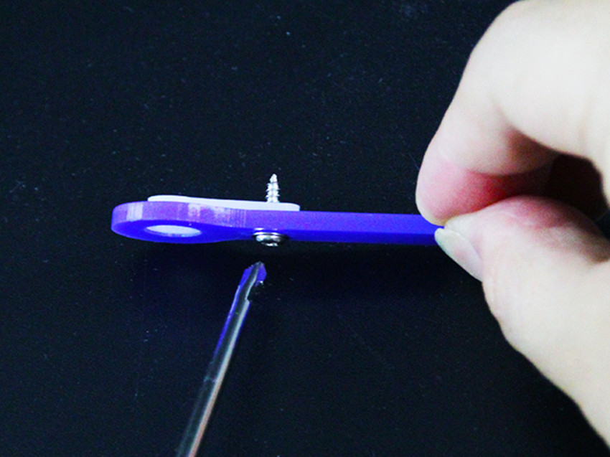

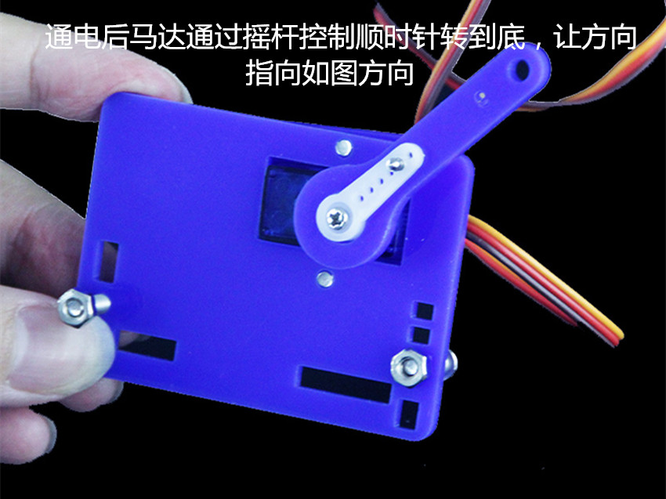

After power on, the motor is controlled by a rocker to turn clockwise to the end, so that the direction is consistent with the picture.
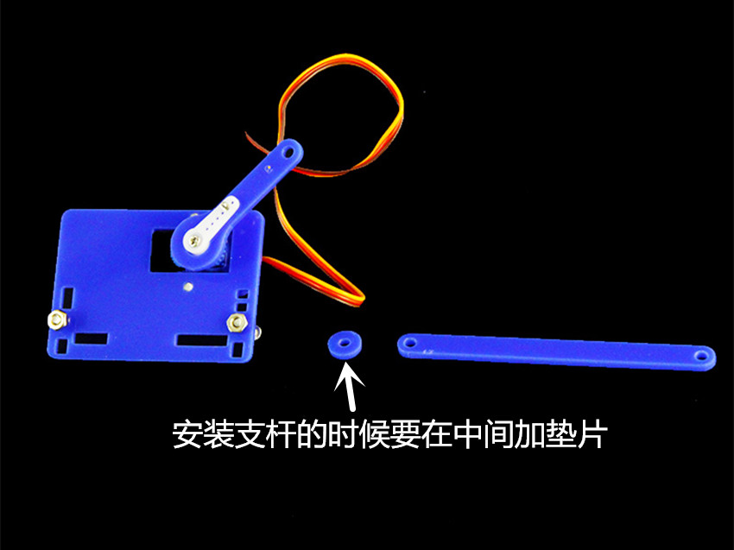

When installing a stick, add a gasket in the middle.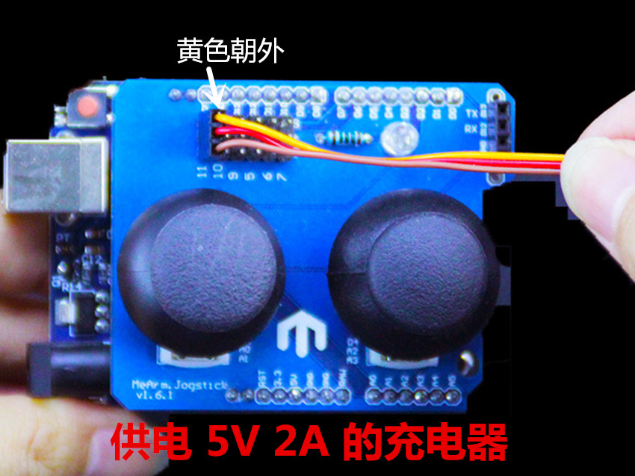

Yellow to the outside
Power supply 5V 2A charger

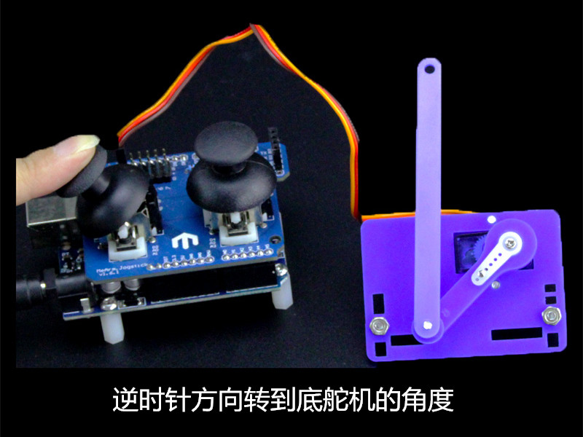

Turn to the rudder counter clockwise

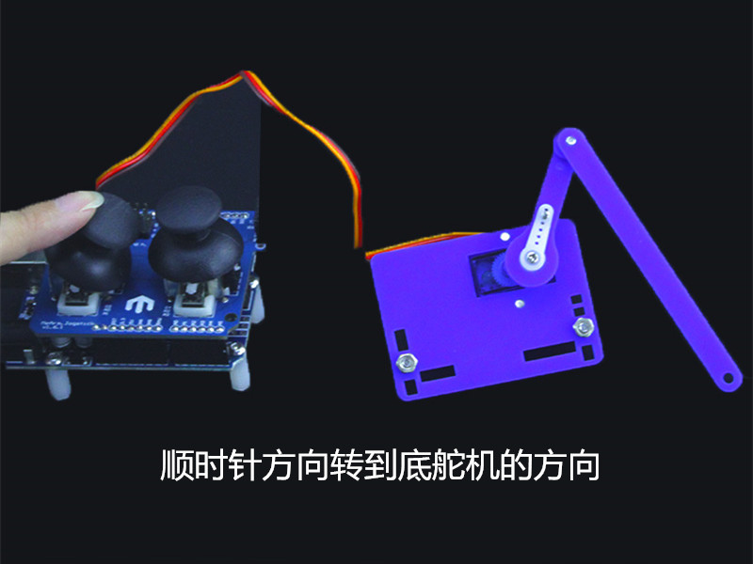

Clockwise steering wheel

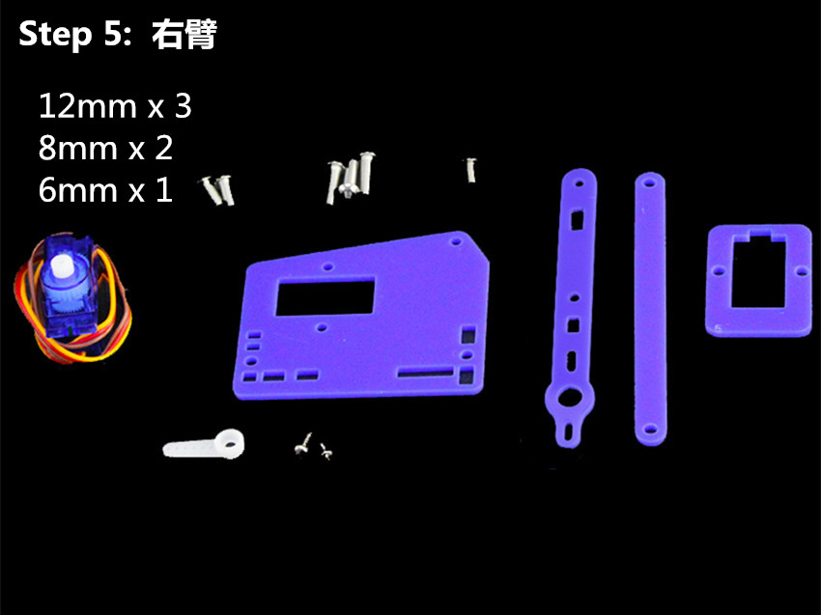

Step 5 ：Right arm
12mm X 3
8mm x 2
6mm x 1

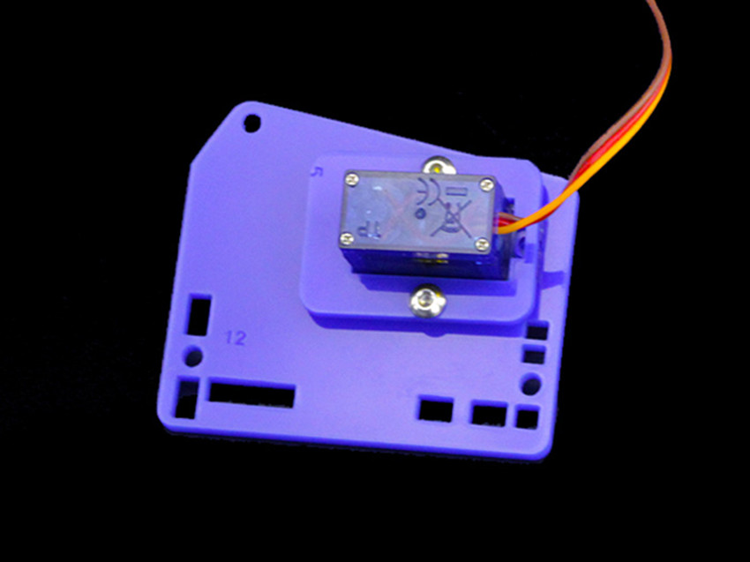

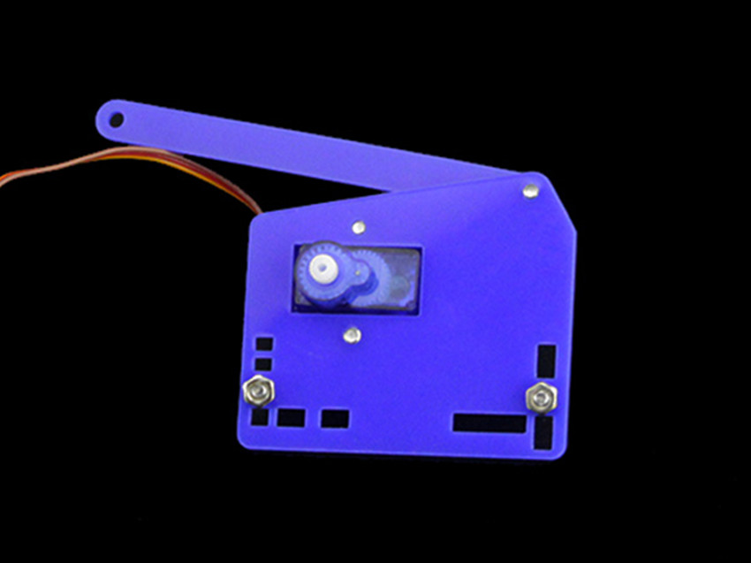

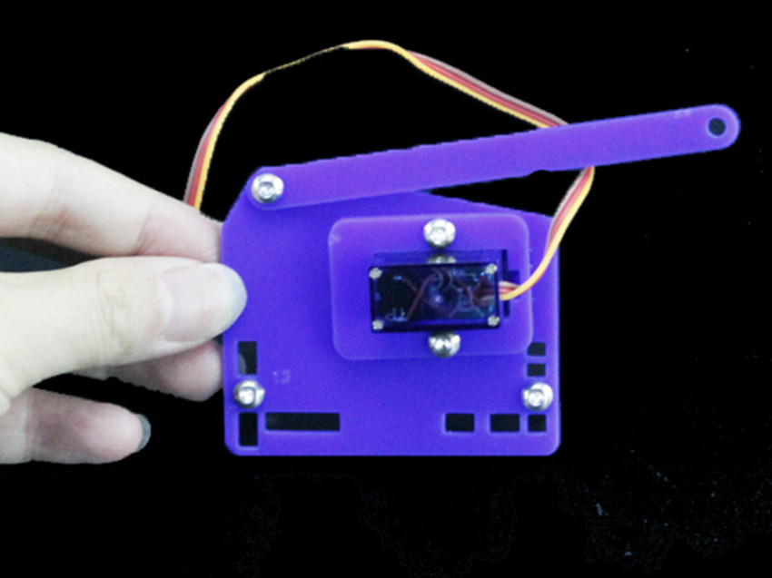

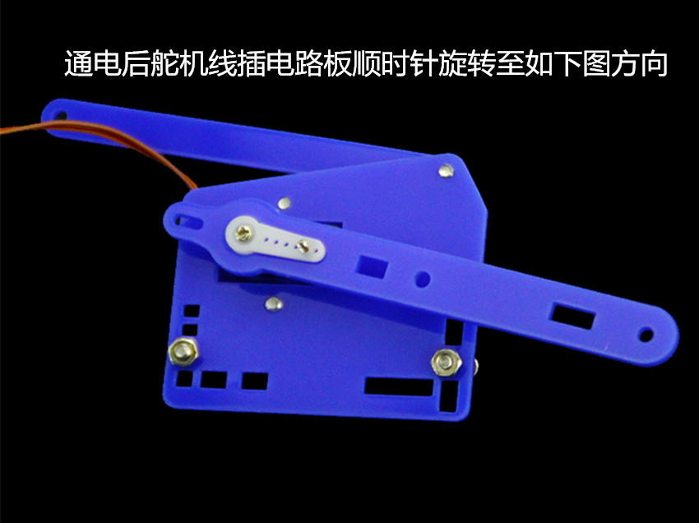

After power on, the steering wheel is inserted into the circuit board, turning clockwise to the same direction as the picture.

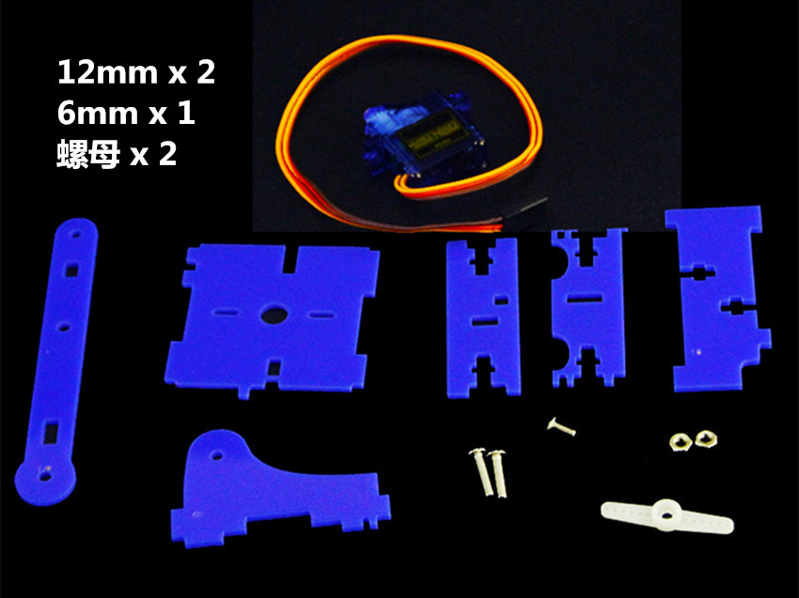

12mm x 2
6mm x 1
Nut x2

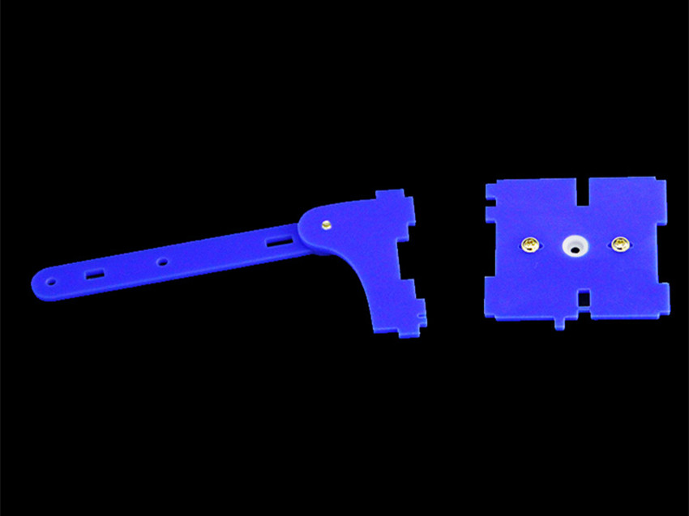

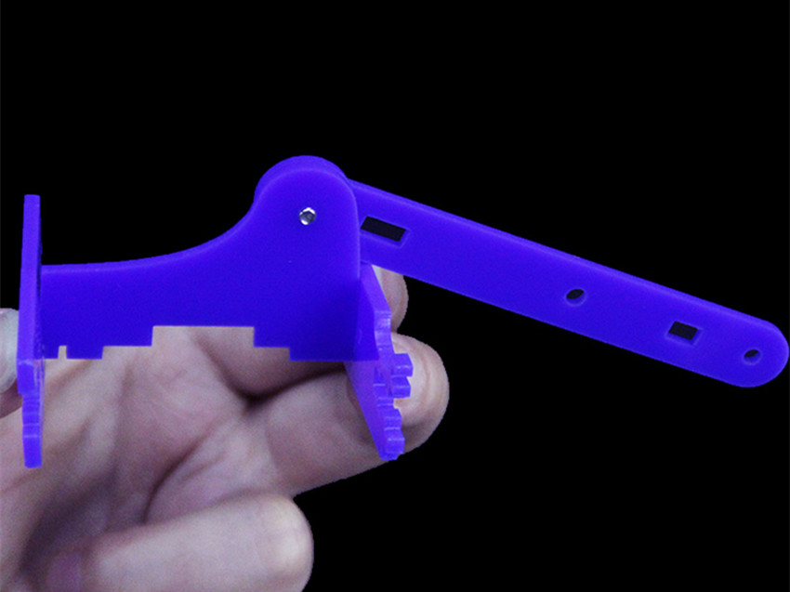

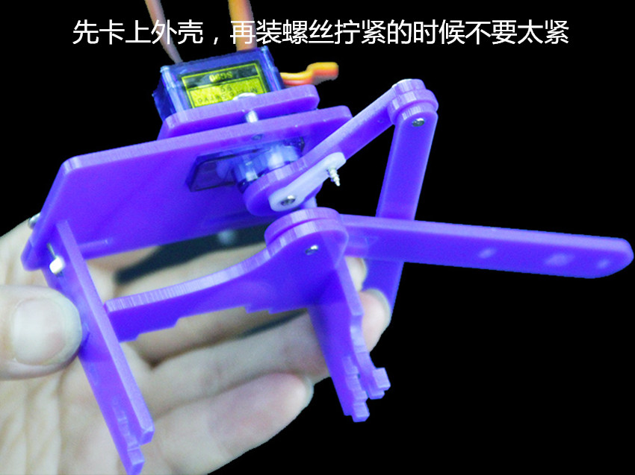

First put on the shell and then install the screws. When tightening, do not tighten too tightly.

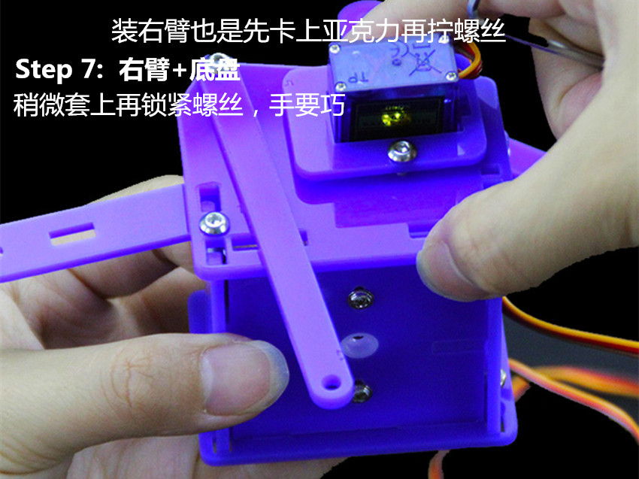

The right arm is put on the shell first and then tightened.
Step 7: right arm + chassis
Tighten the screw and tighten the screw

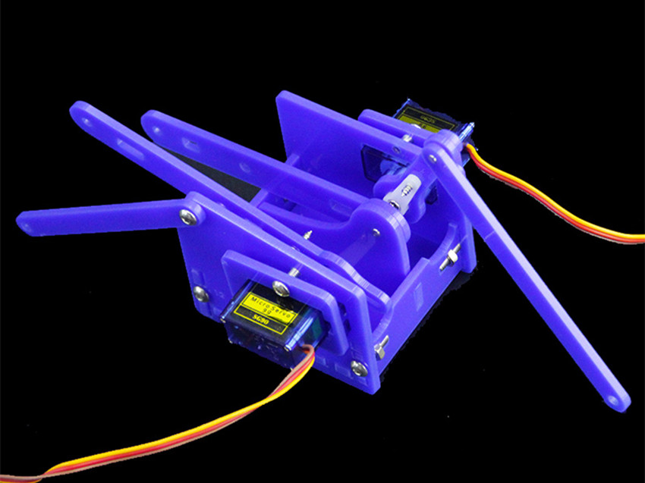

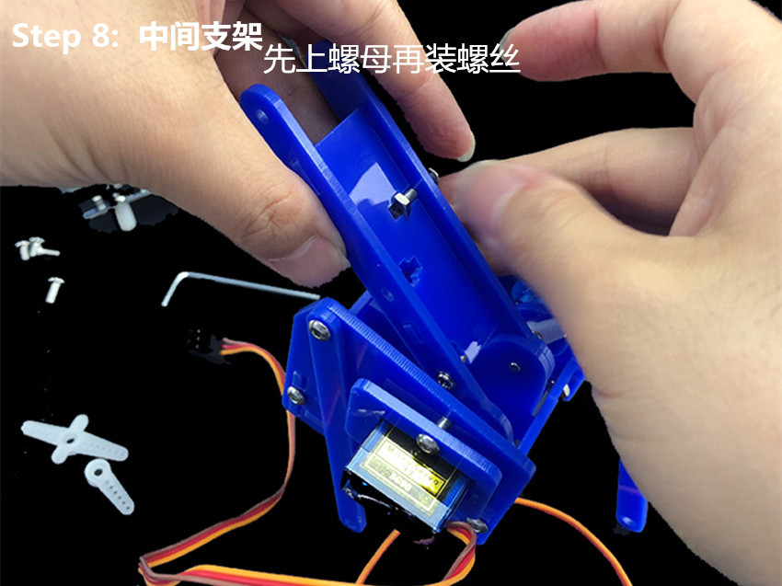

Step 8: intermediate bracket
Screw the nut first

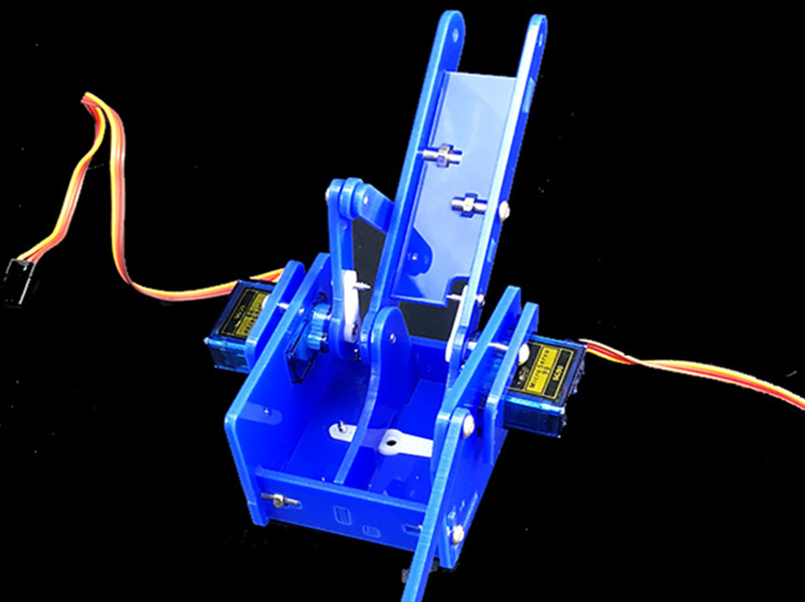

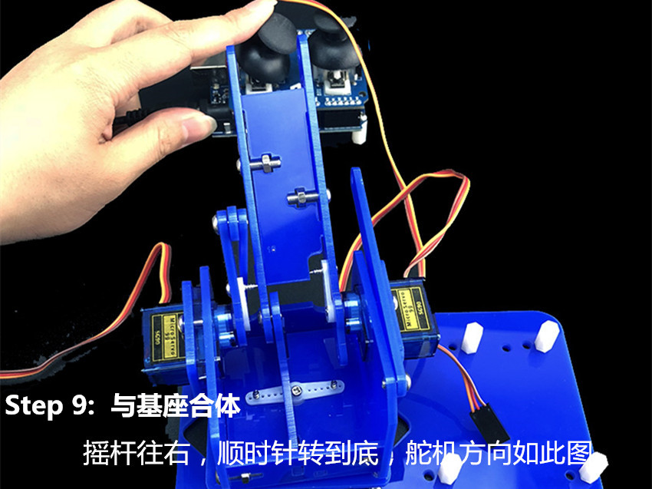

Step 9: complex with the base
The rocker moves to the right, clockwise to the end, and the steering gear is aligned with the picture

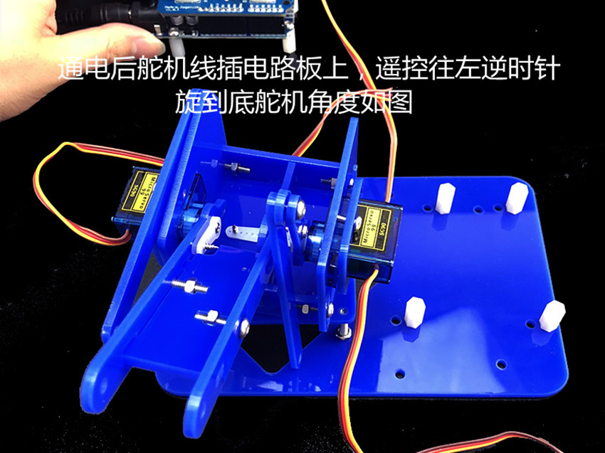

After power on, the rudder line is plugged into the circuit board, and the remote control counterclockwise turns to the end of the steering gear angle and the picture is consistent.

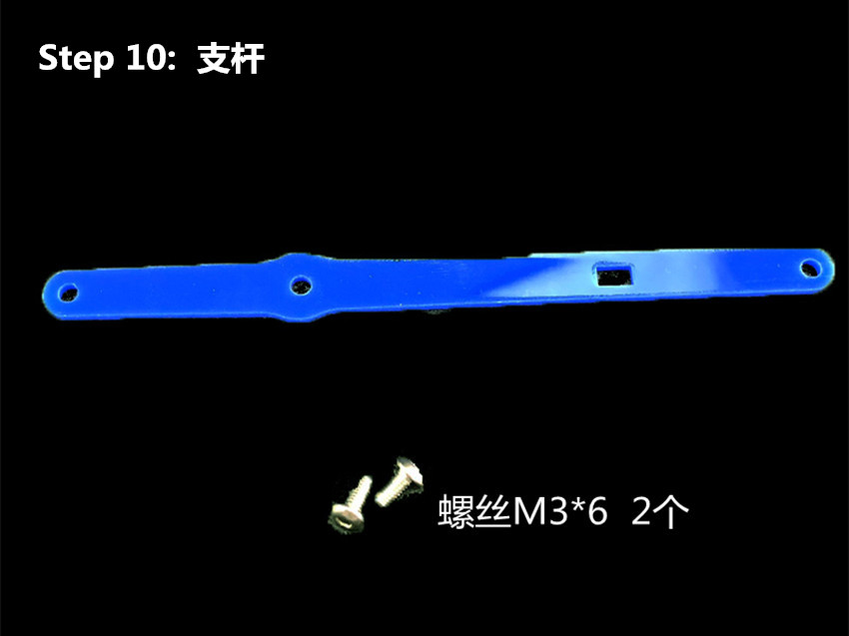

step 10 ：Branched rod
Two screw M3*6

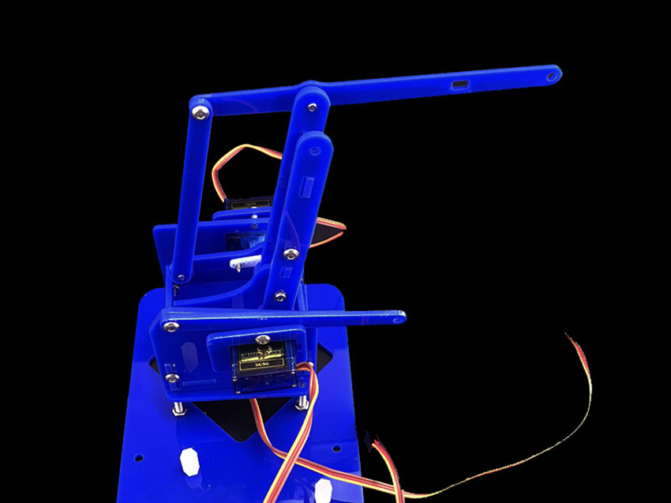

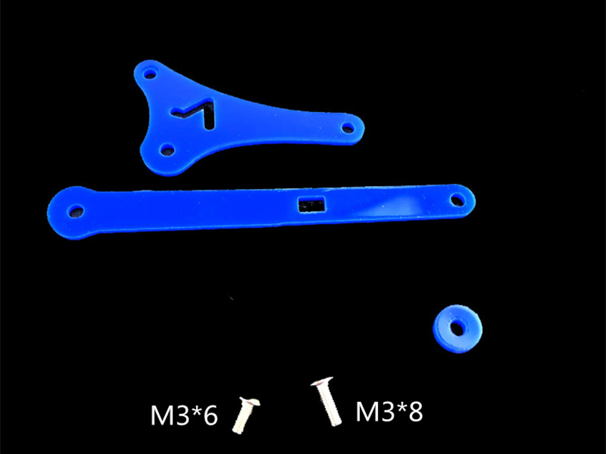

M3*6
M3*8

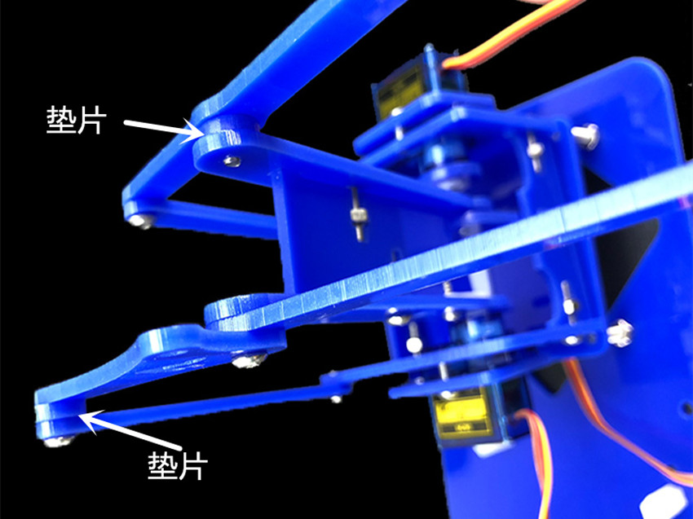

Shim(double)

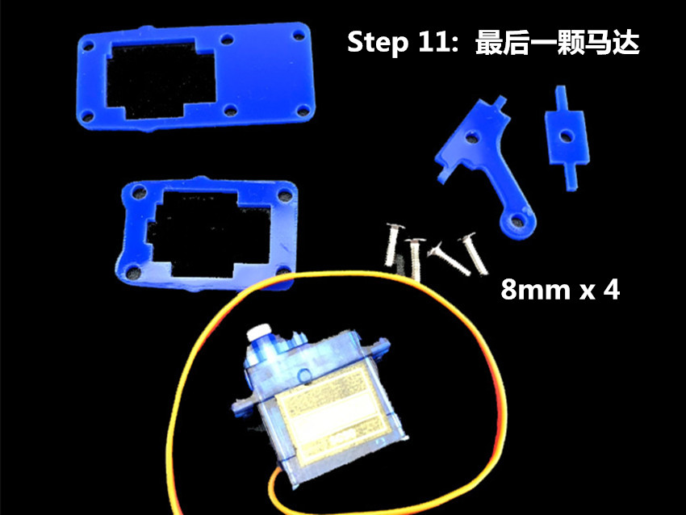

step 11 : The last motor
8mm x4

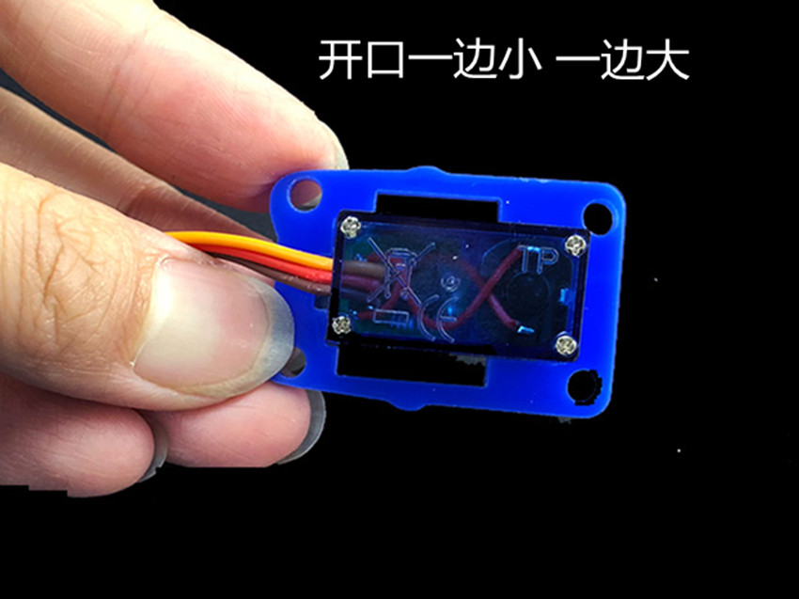

The side of the mouth is large and the side is small.

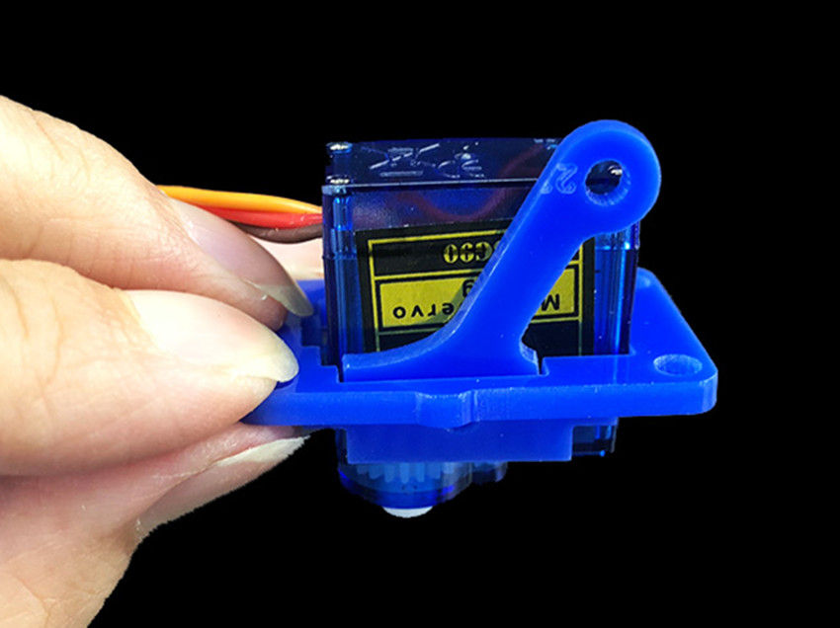

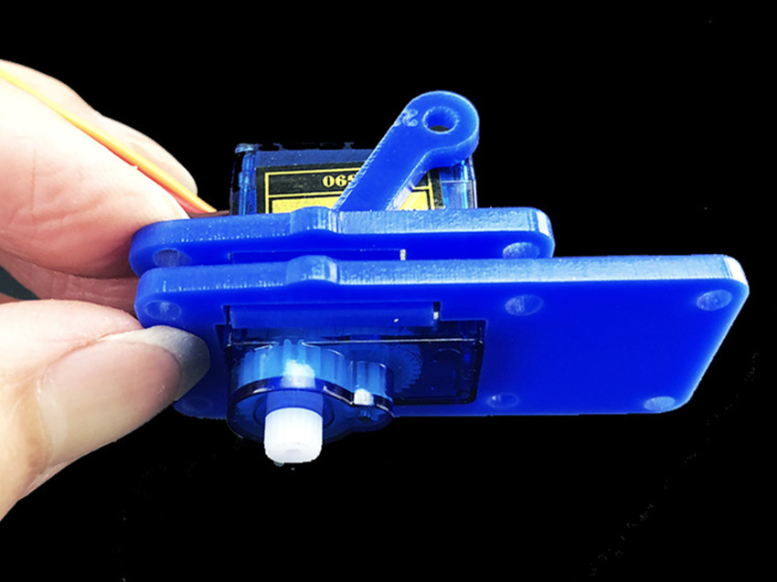

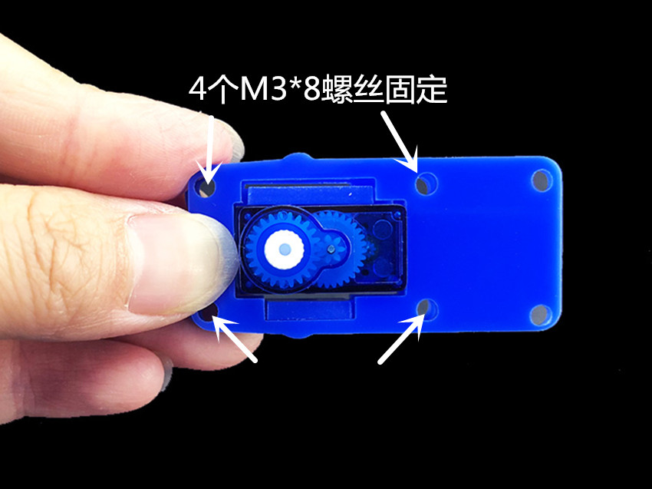
4 M3*8 screws fixed
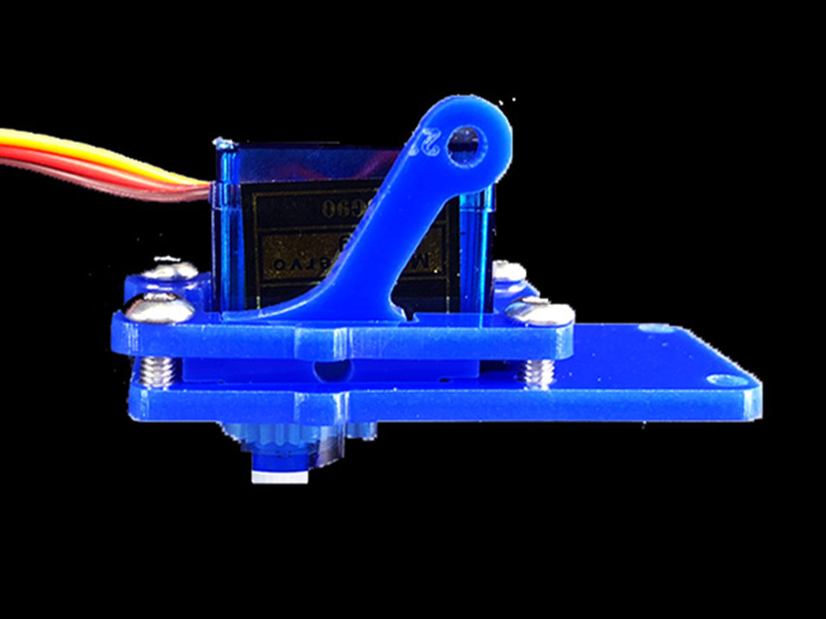

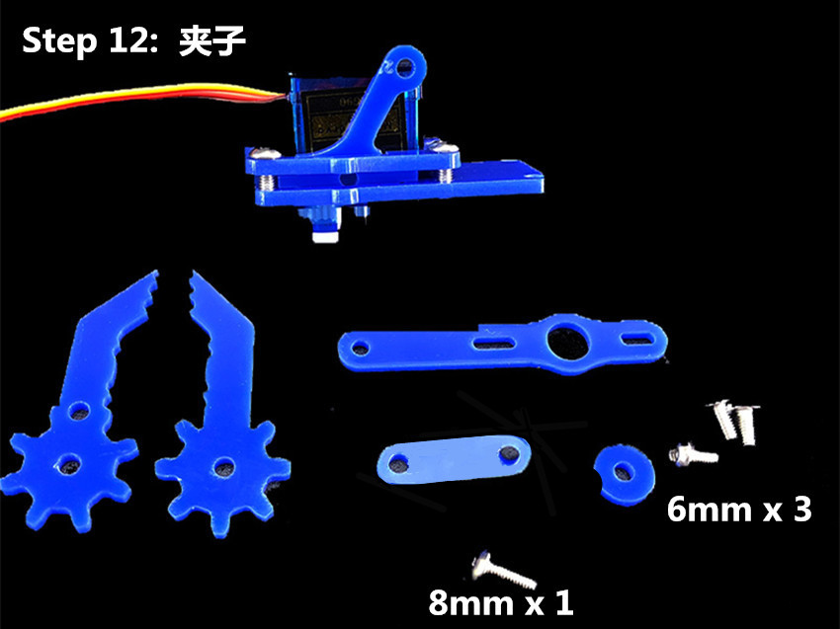
step 12 ： clip
6mm x 3
8mm x 1
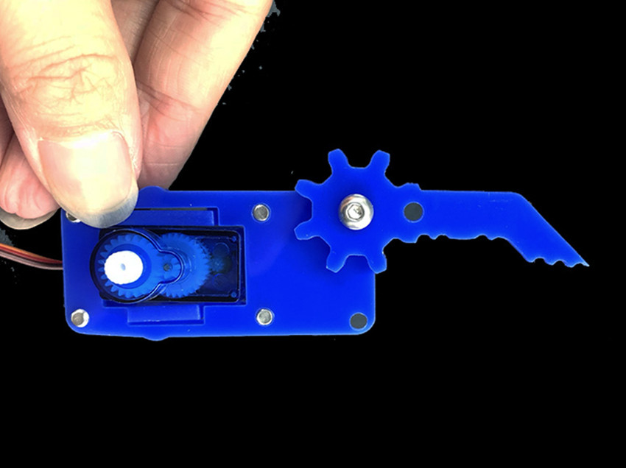

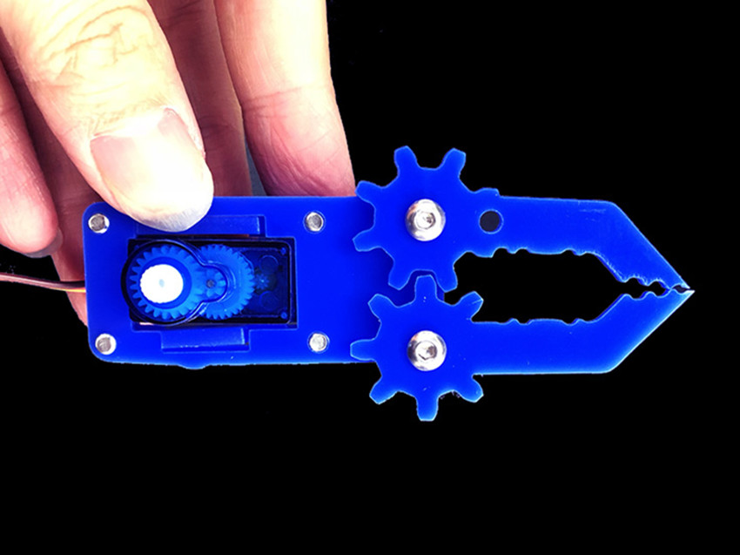

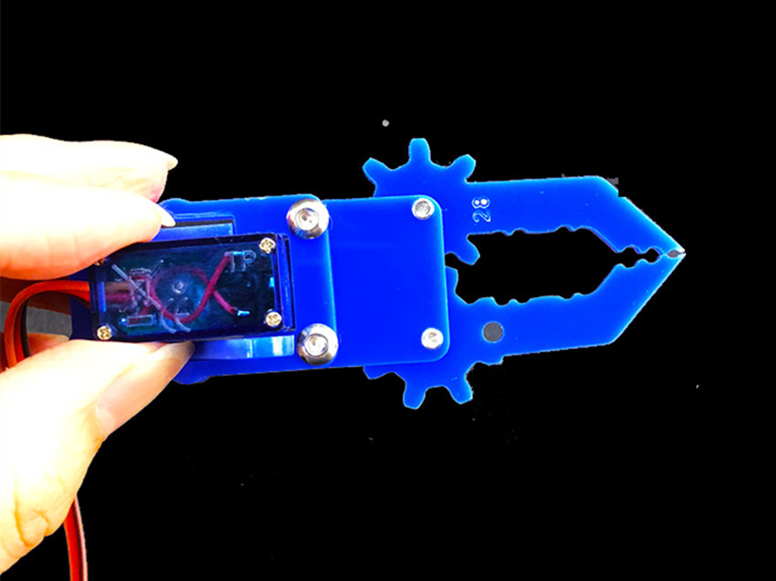

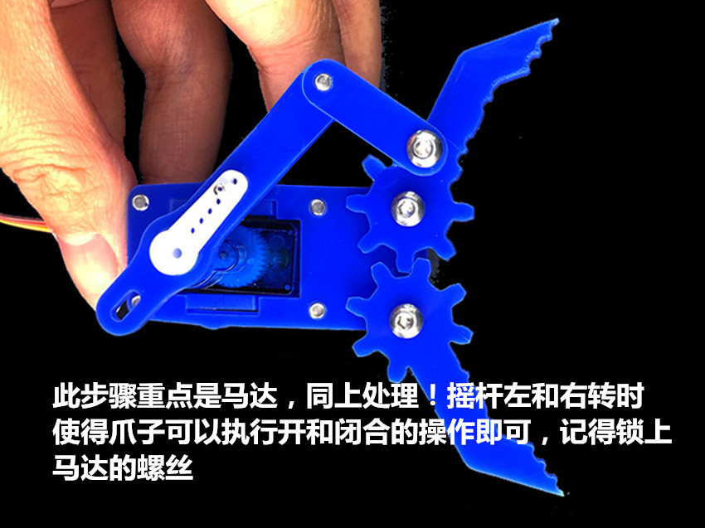
This step is focused on motors, the same way of operation as before. When the rocker turns left or right, the claw can be opened or closed. Finally, remember to lock the motor's screw.
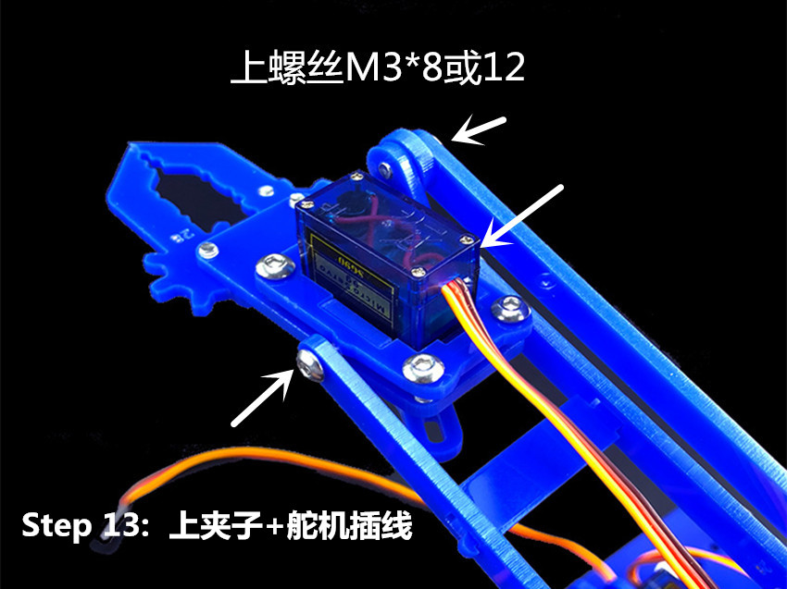

Install screw M8*8 or 12
Step 13: install the clamp, the rudder is connected to the line

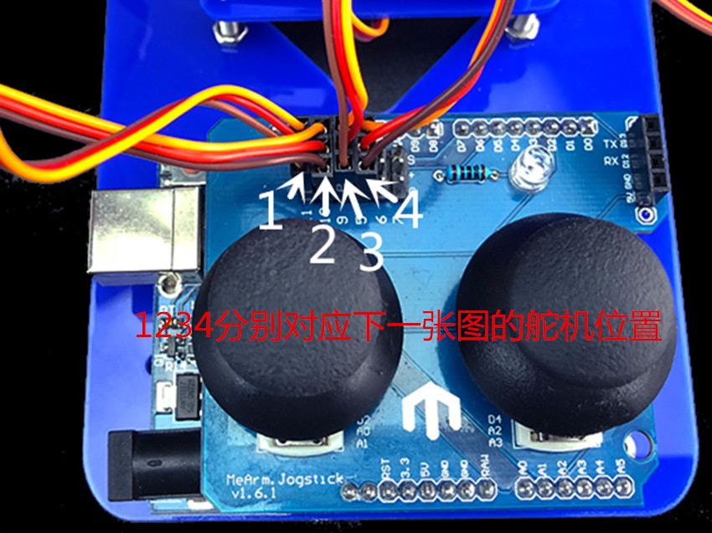

1234 corresponding to the position of the rudder in the next picture.

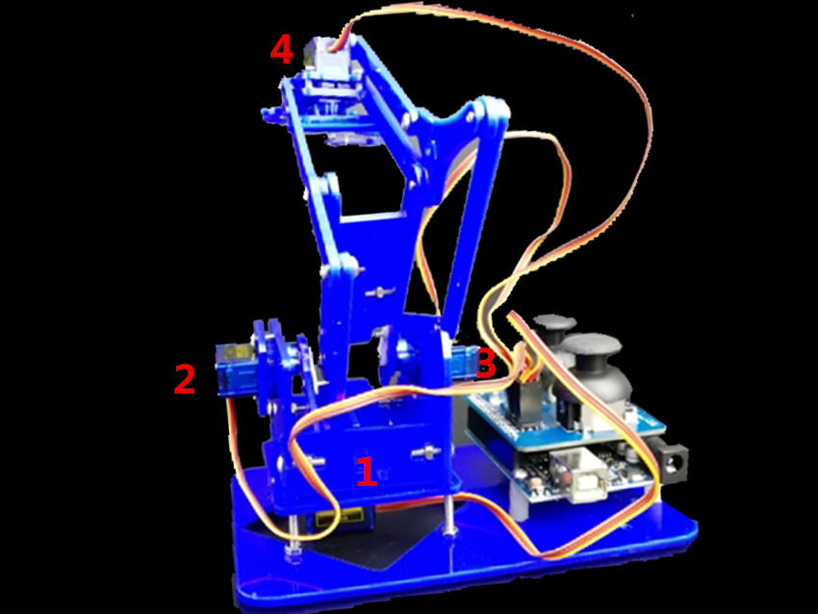

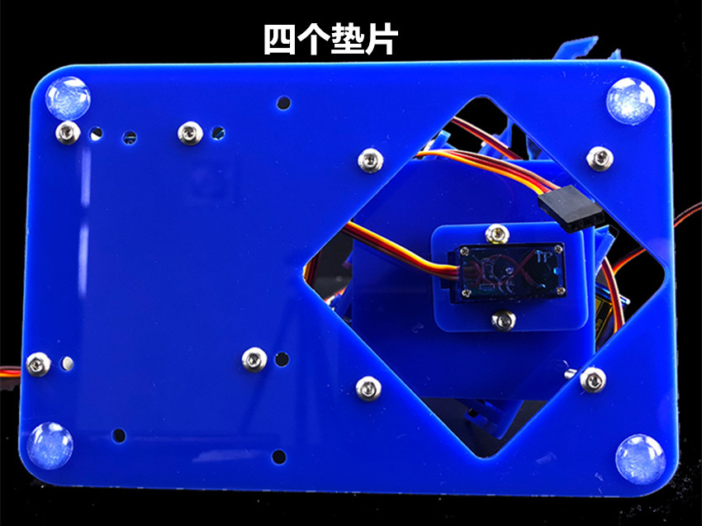

Four gaskets

