IRF540 Isolation Power Module Electronic Block 4 Channel MOSFET Switch
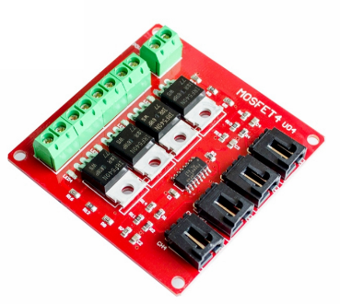
Product Description
IRF540 Isolated Power Module, can provide 4-channel switch to control different circuit modules, MOSFET is a kind of switching characteristics, applications: such as power switch, motor drive, lighting dimmer, etc., used to control the DC circuit below 100V/33A, it is recommended that the controlled DC voltage is greater than 9V, not suitable for AC circuit control.

Functional Diagram
Note:1. Need to be wired according to the diagram, do not connect the wrong. 2. The load power of the control output reaches more than 50W and needs to strengthen the heat dissipation.
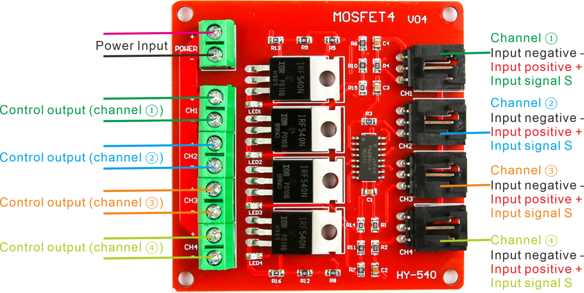
Simple example of use
12V power supply, 12V motor connected to channel ① control output or Connect the red wire to the positive terminal of the power supply, and connect the black wire of the motor to the negative terminal of one of the four output channels.
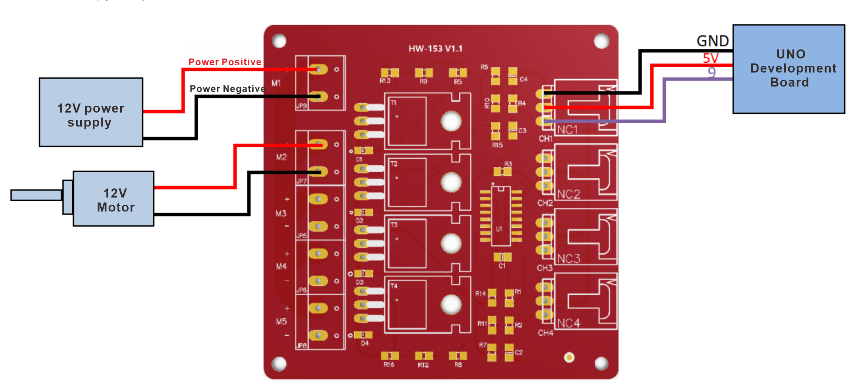
The four output channels correspond to the four signal pins, as shown in the following example.
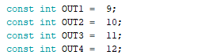
After burning the HW-153 routine into the development board, the LED light on pin 13 blinks synchronously with the corresponding channel indicator of the HW-153 module.
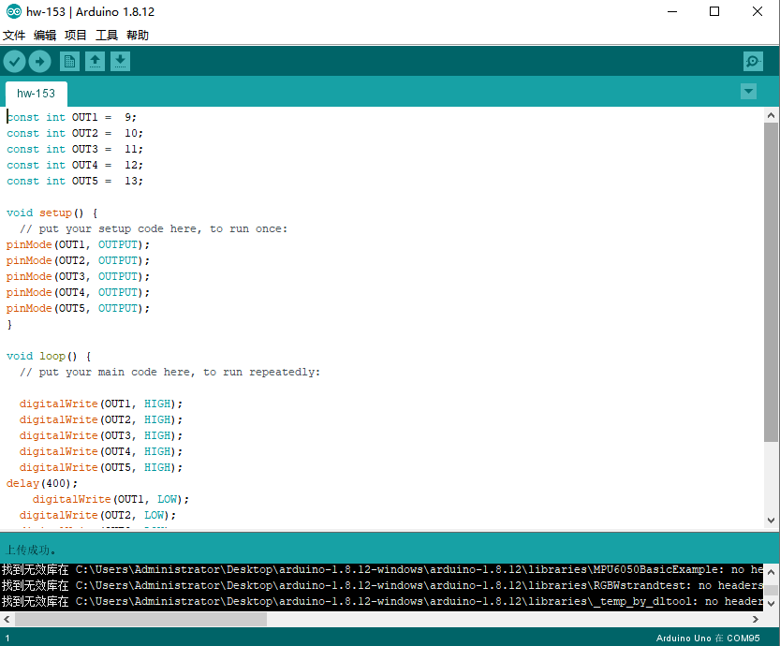
The test code is as follows:
const int OUT1 = 9;
const int OUT2 = 10;
const int OUT3 = 11;
const int OUT4 = 12;
const int OUT5 = 13;

void setup() {
// put your setup code here, to run once:
pinMode(OUT1, OUTPUT);
pinMode(OUT2, OUTPUT);
pinMode(OUT3, OUTPUT);
pinMode(OUT4, OUTPUT);
pinMode(OUT5, OUTPUT);
}

void loop() {
// put your main code here, to run repeatedly:

digitalWrite(OUT1, HIGH);
digitalWrite(OUT2, HIGH);
digitalWrite(OUT3, HIGH);
digitalWrite(OUT4, HIGH);
digitalWrite(OUT5, HIGH);
delay(400);
digitalWrite(OUT1, LOW);
digitalWrite(OUT2, LOW);
digitalWrite(OUT3, LOW);
digitalWrite(OUT4, LOW);
digitalWrite(OUT5, LOW);
delay(400);
}

Dimensional drawings
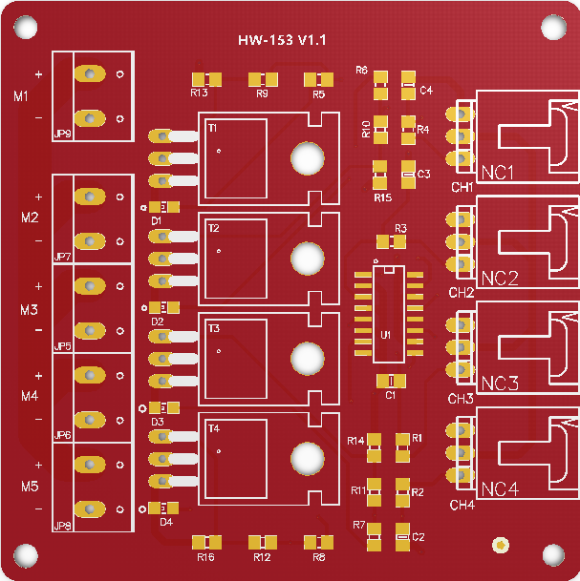
65.90mm
60mm
60mm
66mm

