1-8S Lipo Battery Voltage Tester
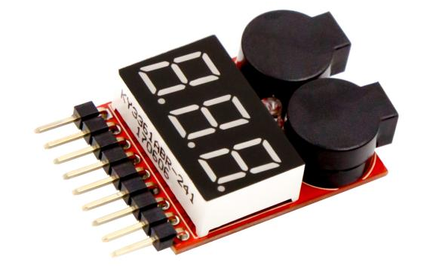
Product Description
The voltage display is used for 1S~8S lithium battery detection, automatically detect the voltage of each lithium battery cell and the total voltage. Support reverse connection protection.
It allows you to know the working status of your battery anytime and anywhere, so that the battery will not be harmed by over-discharge or over-charge.
Whether in flight or idle state, you can plug the electric display to the battery balance charging connector to understand the battery power status.
There is no multimeter is a must Oh!
When the voltage is lower than the set value, the buzzer will sound and the red LED light will flash; the set value is 3.3V, press the button to change the voltage set value, and automatically save the user's current set value.

Product parameters:
1.For 1S-8S lithium battery detection
2. Voltage detection accuracy: ± 0.01V.
3. Group voltage display range: 0.5V~4.5V.
4. Total voltage display range: 0.5V~36V
5.1S test mode voltage range: 3.7V~30V
6. Low voltage buzzer alarm mode 2S-8S
7. Alarm voltage setting range: OFF~2.7~3.8V
8. Size: 40mm x 25mm x 11mm Weight: 9g

Usage
The electric display front side up (digital display side), inserted against themselves, the white balance of the battery charging plug along the electric display of the leftmost pin into the electric display, the electric display will be immediately BB ringing two sound, the screen shows jumping numbers, if there is no response, will be balanced charging plug reversed on the plug can be. There is a small button on the other end of the display to set the alarm voltage of the display.

