TPA3116D2 Bluetooth digital amplifier board dual-channel audio amplifier board 120W * 2 high power
Product Features
- Uses digital amplifier TPA3116D2 high efficiency Class D operation.
- Integrated CSRB635 4.0 board Bluetooth module.
- Greater than 90% power efficiency and low idle loss .
- Reduces PSU requirements by utilizing a feedback power stage architecture with high PSRR.
- Preamplifier System - The "King of Op Amps", the NE5532, is a high performance, low noise dual operational amplifier.
- Excellent output drive capability and fairly high small-signal bandwidth, wide supply voltage range and other characteristics.
- High-efficiency coated matrix heatsink.

Product Parameters
- Amplifier chip model: TPA3116D2
- Bluetooth module: BTM835/CSR8635 (version 4.0)
- Transmission distance: Maximum 10 meters (no interference blocking)
- Supply voltage: DC12~24V
- Supply current:>3A
- Output power:120W*2
- Efficacy Ratio:>90%
- Number of channels: dual-channel (high and low sound adjustment)
- Weight: 78.9g

Interface Description
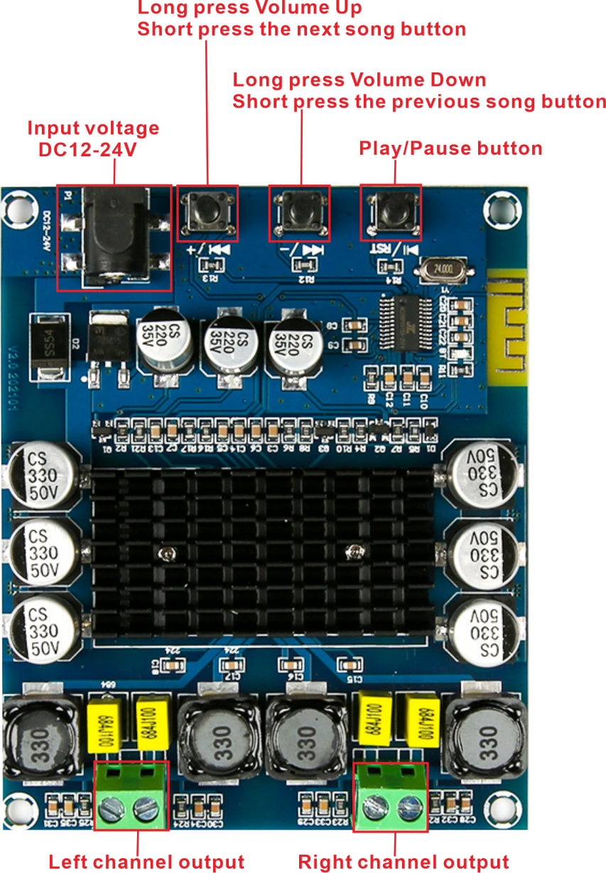
Dimensional drawings
