9-50V 2000W 40A DC Electronic Speeder PWM Motor Speed Controller 12/24/36/50V 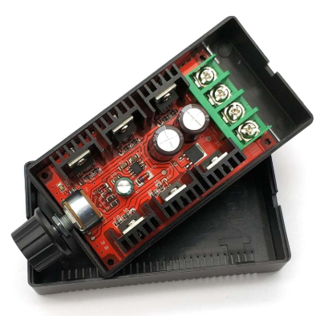
Product Characteristics
Working voltage: DC10V-DC 50V
Control power: 0.01-2000W (Maximum rated current 40A) Different working voltage corresponds to different control power as follows;
12V*40A =480W at 12V operating voltage
24V*40A =960W at 24V operating voltage
36V*40A =1440W at 36V operating voltage
40V*40A =1600W at 40V operating voltage
50V*40A =2000W at 50V operating voltage
Static current: 0.025A (working voltage in DC10V to DC50V static current will not exceed 25ma)
PWM Duty Cycle: 5%-100%.
PWM frequency: 12khz
Operating temperature: -20℃~+40℃ (ambient temperature minus 20 degrees to minus 40 degrees)
This governor is industrial grade quality, can work stably in the environment below zero degrees, general commercial grade quality governor is not able to work stably below zero degrees.
Circuit board dimensions: length 90 mm, width 51 mm, height of about 30 mm (excluding the potentiometer adjustment part)

External Dimensions

Main applications
1, All kinds of general-purpose DC brush motor speed control.
2, All kinds of automobile motor speed control (automobile cooling fan speed control, automobile fan speed control, automobile wiper motor speed control, automobile air conditioning fan speed control).
3, Production line conveyor belt speed control, pipeline exhaust fan speed control, treadmill speed control, multiple computer fan speed control in parallel, electronic fan speed control.
4, All kinds of DC bulb dimming, all kinds of DC heater temperature regulation.

Wiring Diagram

