Unsoldered GY-51 LSM303DLH module 3-axis magnetic field acceleration
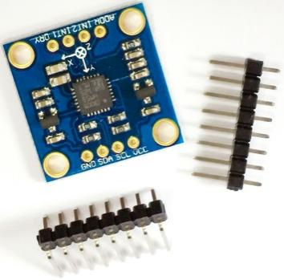
Product Description
The accelerometer, magnetometer, A/D converter and signal striping circuits of the LSM303DLH chip are integrated together and still communicate with the processor through the I2C bus. This realizes 6-axis data detection and output with only one chip, which reduces the customer's design difficulty, reduces the occupied area of the PCB board, and lowers the device cost.

Specification
Chip used: LSM303DLH
Power supply: 3-5v (internal low dropout voltage stabilization)
Communication mode: Standard IIC communication protocol
Magnetic field range:±1.3 / ±1.9 / ±2.5 /± 4.0 / ±4.7 / ±5.6 / ±8.1 gauss
Acceleration range: ±2 g / ±4 g / ±8 g

Pin and Component Descriptions
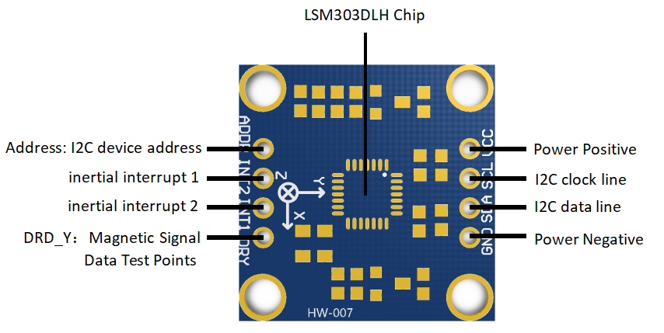

Usage
1. Take STM32 development board+serial data output as an example.
Hardware preparation: HW-007 module + STM32 development board + CH340 serial module + a number of DuPont cable
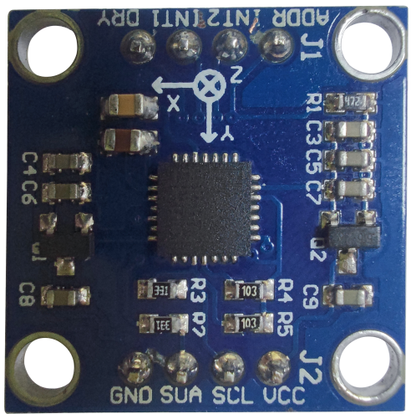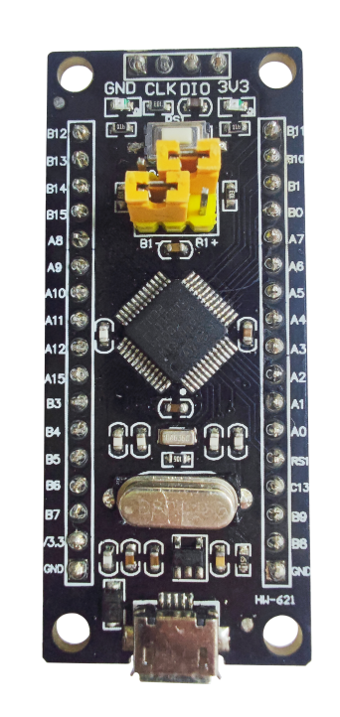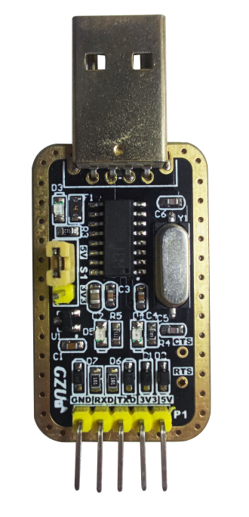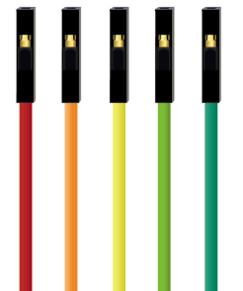
Software preparation: Demonstrator GUI + serial port assistant
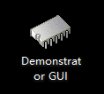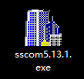
- Wire the STM32 development board to the NB050 product according to the following figure.
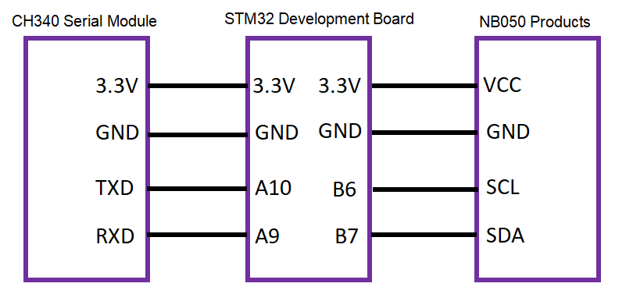

3.Program Burning
Serial module and STM32 development board wired according to the above figure, and connect the serial module to the computer. Port is normal, the next step, open the Demonstrator GUI burning tool, the interface is as follows.
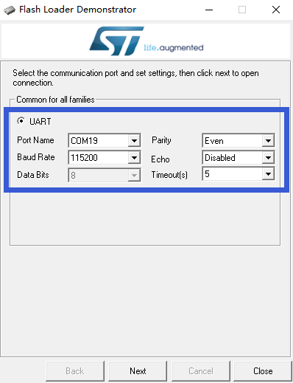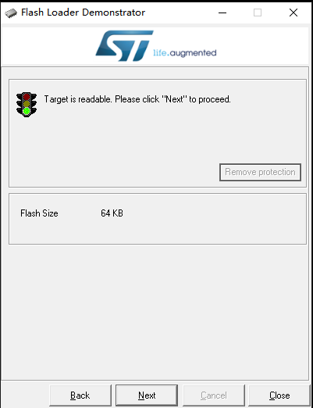
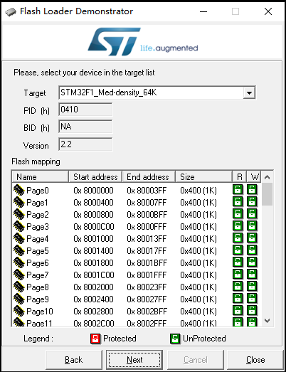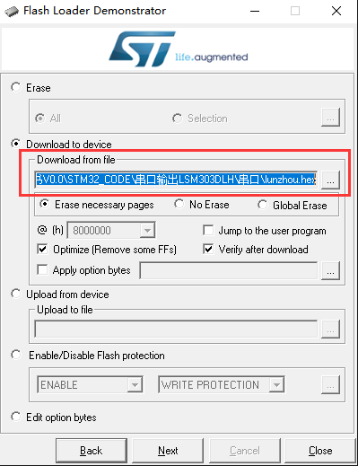

Select the burn file at the box - ".hex".
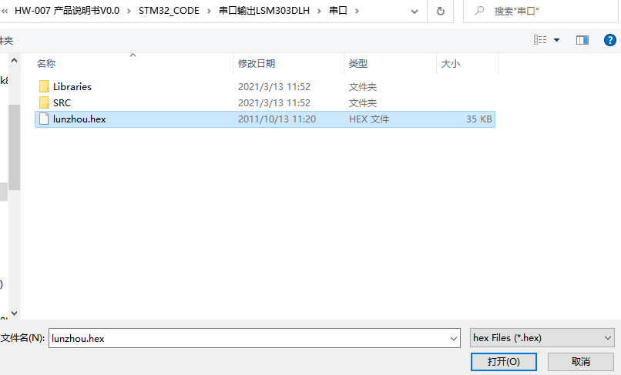
The program was burned successfully as shown below.
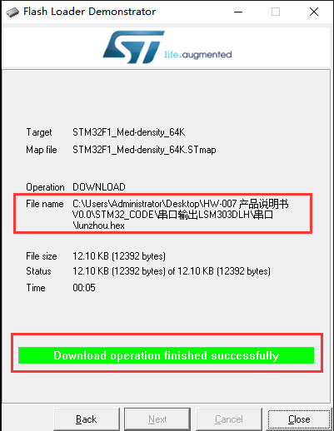
Special Note: If you need to use with arduino microcontroller, please refer to the following link.
Arduino | LSM303 Accelerometer + Compass Breakout | Adafruit Learning System

