Solar/Wind energy Charging CC/CV Power Supply Module
SKU: 766377
==========================================================
User Manual

As it seems, the module is a DC step up (boost) and step down (buck) converter module. The module uses an LM2577S for stepping the voltage up and an LM2596S for stepping the voltage down. It has an input range of 4 to 35V and an output range of 1.25 to 25V. Both the input and output are rated at 1A nominal and 3A maximum.
Here are its key specifications (borrowed from the seller’s page):
- Input voltage: 4-35V DC
- Output Voltage: 1.25-25V DC
- Output Current: 3A (max)
- Constant Current Output: 0-3A (Adjustable)
- Output Power: 15W (For more than 15W, it should be equipped with a heatsink)
This module is designed primarily for lithium-ion battery charging and high-power LED driving applications as it can maintain a steady output even with a fairly fluctuating input. As you can see, the module holds two independent series-wired voltage converters (LM2577S and LM2596S). The idea is simple to implement, but due to double conversion, the module will have a deliberately low efficiency. The module also has a linear fixed voltage regulator chip (78L05) onboard, and a dual op-amp (LM358).
Below is an annotated picture of the module. 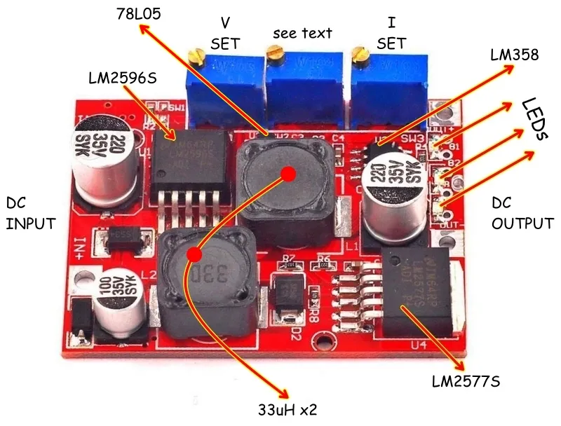
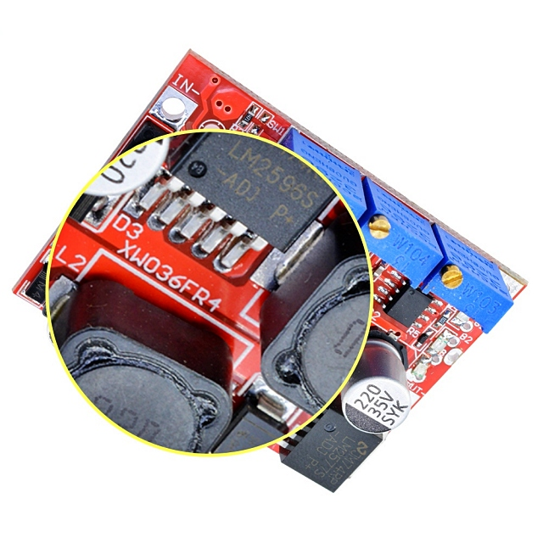

By default, the module output is set to 1A@4.2V, for charging lithium-ion type batteries. Trimpot SW1 sets the output voltage, SW2 sets the indicator threshold for battery charging process, and SW3 sets the output current limits.
Moreover, there are three LED indicators – constant current indicator and charging indicator LEDs are red (B1-B2), and the charged indicator is blue (B). It’s however noticed that a green LED is used in some modules for charged (end of charge) indication, and it doesn’t work correctly. This is due to the relatively low forward voltage (V_{F}) of the green LED, I think!
=====================================================================

Module parameters

Input voltage: 4-35V

Output voltage

( 1) Continuously adjustable (1.25-25V continuously adjustable )

( 2) Need fixed output (, please tell the shopkeeper when buying.

(3) Size: length 50*width 37*height 13 (MM)

Wiring

Input: IN+ input positive level, IN- input negative
output: OUT+ output positive level, OUT- output negative

Module nature: non-isolated buck constant current, constant voltage module (CC CV) charging module
=====================================================================
Scope of application:

1) High-power LED constant current drive.

2) Lithium battery charging (including ferroelectric), 4V, 6V, 12V, 14V, 24V battery charging, nickel-cadmium nickel-hydrogen battery (battery pack) charging.

3) Solar panel, wind generator voltage regulator circuit, vehicle stabilized power supply, and other automatic voltage regulator circuit.
=====================================================================

Adjustment method

First connect the input power correctly ( between 4-35V ), then use a multimeter to monitor the output voltage and adjust the potentiometer (generally turn the boost clockwise, and turn the voltage counterclockwise)

Output voltage: Continuously adjustable (1.25-30V no-load adjustment) Our default delivery voltage is 4.2V. If you need other voltage, you can adjust it yourself (or tell the shopkeeper.)

Output current: maximum 3A, (more than 15W, please install a Heat Sink constant current range :0-2A (adjustable) default adjustment 1A

Rotating lamp current : constant current value* (100-100), the rotating lamp current is linked with the constant current value , for example, the constant current value is 3A , and the rotating lamp current is set to 0.1 times the constant current (0.1*3A=0.3A) , when the time constant is adjusted to 2A, this time constant of the turn lamp current 0.1 times (0.1 * 2A = 0.2A).

The default Module has been adjusted to 0.1 times.

Output power : natural cooling 15W ,

Conversion efficiency : 80 hundred (the higher the output voltage, the higher the efficiency)

Operating temperature : industrial grade (-40°C to +85°C) (ambient temperature exceeds 40°C, please reduce the power usage, or enhance heat dissipation)

Full load temperature rise : 45℃

Indicator : constant current indicator red , charging indicator red , charging complete indicator blue

Output short circuit protection : yes, constant current (currently set constant current value)

Wiring method : direct lead welding on PCB
=====================================================================

How to charge the battery:

1. Determine the float voltage and current of the rechargeable battery you need to recharge, the input voltage of the module;

2. Adjust the constant voltage potentiometer to adjust the output voltage to about 3V.

3. Use a multimeter 10A current block to measure the output short-circuit current, and adjust the constant current potentiometer to make the output current reach the predetermined charging current value

4. The default charging lamp current is 0.1 times the charging current (constant current value), if you need to adjust, please adjust the lamp current potentiometer; (generally no adjustment)

5. Adjust the constant voltage potentiometer to make the output voltage reach the float charge voltage;

6. Connect the battery and try charging.

(Steps 1, 2, 3, 4, and 5 are that the module input is connected to the power supply, and the output is no-load and not connected to the battery.)

LED constant current drive use method:

1. Determine the operating current and maximum operating voltage of the LED you need to drive;

2. Adjust the constant voltage potentiometer to adjust the output voltage to about 3V.

3. Use a multimeter 10A current block to measure the output short-circuit current, and adjust the constant current potentiometer to make the output current reach the predetermined LED working current;

4. Adjust the constant voltage potentiometer to make the output voltage reach the highest working voltage of LED;

5. Connect the LED and test the machine.

(Steps 1, 2, 3, and 4 are that the module input is connected to the power supply, and the output is no-load without LED lights.
=====================================================================

