CN3791 Solar Charging Panel Input Voltage 12V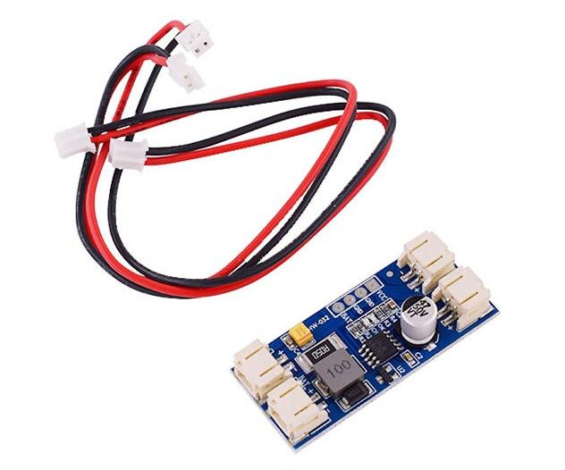
Product Description
This MPPT solar charger allows you to get as much power as possible from solar panels or other photovoltaic devices and put it into a rechargeable lithium battery. It has an input voltage of 12V, which means that it corresponds to the solar panel working voltage of 12V.

Product Characteristics
Input voltage: 12V
Output Voltage: Nominal 3.7V full junction voltage 4.2V lithium battery
Operating ambient temperature: -40℃ to +85
When the current output capacity of the input power supply decreases, the internal circuitry of CN3791 can automatically track the high power limit point of the solar panel.
Charging current up to 2A
PWM switching frequency: 300KHz
Constant-voltage charging voltage: 4.2V±1
Constant current charging current is set by an external resistor to trickle charge deeply discharged batteries.
The product is equipped with automatic re-charging function and soft-start function.
When charging, CH light (red light) will be always on, OK light off (blue light); when full CH light will flash, OK light always on.

Functional Diagram 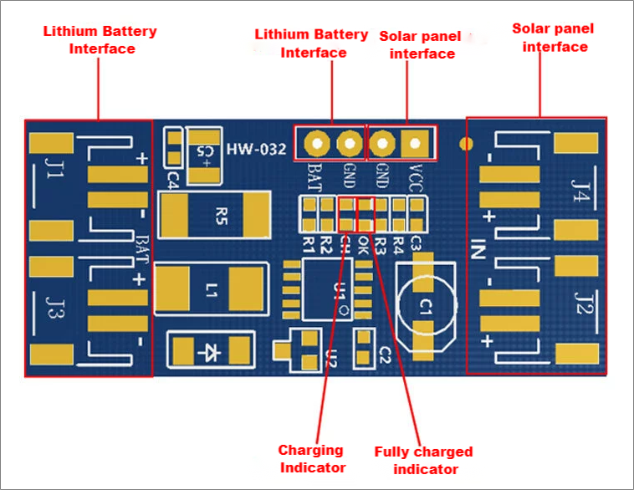

Dimension Drawing