Pressure Sensor

NB157

typical application:
Clean, non-corrosive gas and liquid pressure measurement

Technical Parameters:
Operating Voltage: | 5±0.5 | VDC | range of working temperature: | -20~120 | ℃
The output voltage: | 0.5~4.5 | VDC@5V | Storage temperature range: | -20~120 | ℃
Working current: | ≤ 10 | mA | Measurement error: | ±3.0 | %FS
Working pressure range: | 0 ~1.6 | MPa | IP65 | IP65
Maximum applied pressure: | 3.0 | MPa | Response time: | ≤ 2.0 | ms
Destroying pressure: | 4.0 | MPa | Cycle life: | 1,000,000 | pcs

Output curve:
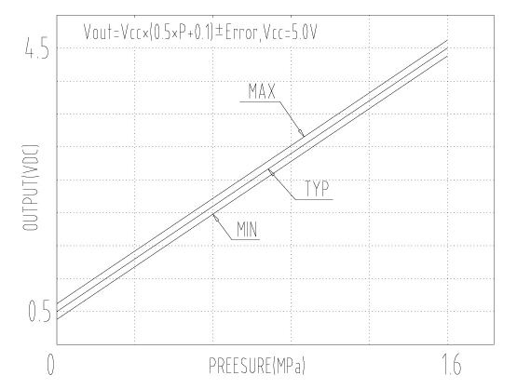

Product pictures and dimensions :
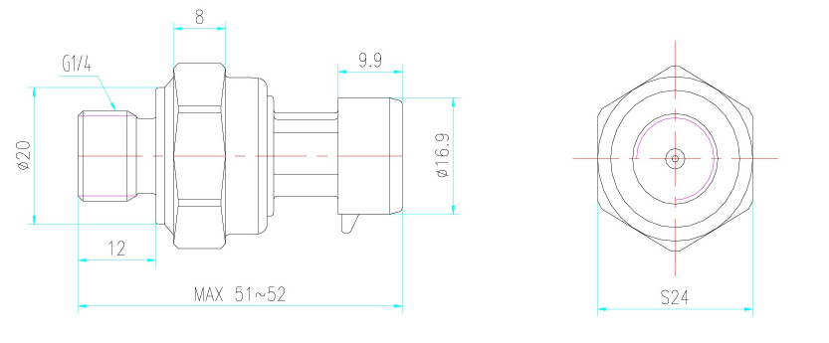
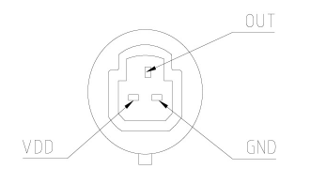

Pin definition:
VCC: red wire (power +)
OUT: yellow line (signal output)
GND: black wire (power-)

