Pressure gauge manual
temperature display
Use time display
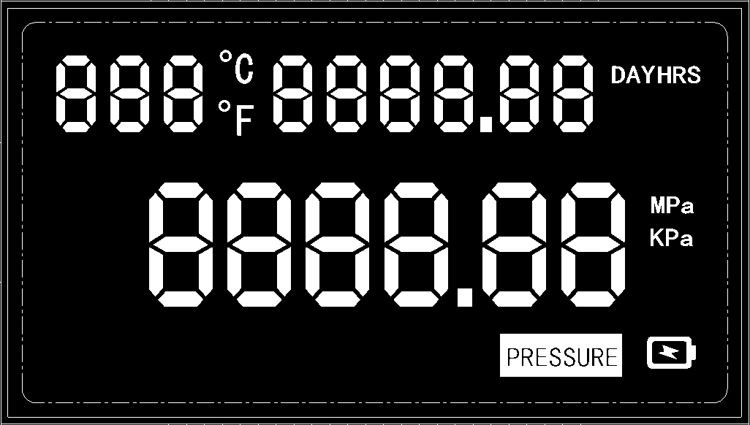
water pressure display

Water pressure interface characters PRESSURE

图1水压计功能框图

- key definition
The keys from left to right are the setting key "SET", the plus key "+", and the minus key "-".

- show description
- temperature
The temperature display range is -99°-999°, and the unit is C for Celsius and F for Fahrenheit. The temperature unit can be switched by short pressing the "+" key.
(Only time is displayed in water pressure mode). The total time unit DAY indicates days, HRS indicates hours, and the time unit indicates the amount of electricity.
A battery indicator icon will appear and flash when the battery is low, prompting the user to replace the battery. It will not display when the battery is fully charged。

- K value setting character (K ​​SETTING)
The K value setting character will be displayed when entering the K value setting interface.
Water Pressure Interface Characters (PRESSURE)
When the system works in the water pressure gauge mode, the water pressure interface characters will be displayed under the main interface

- water pressure display
When the system works in the water pressure gauge mode, the water pressure is displayed in units of Kpa ​​and Mpa. The default display is Mpa, which can be switched by short pressing the "-" key.

- Settings and interface description
Water pressure measurement interface
In the water pressure gauge mode, the characters PRESSUER, current water pressure value, total usage time, etc. will be displayed.
- Water pressure sensor parameter setting interface
When the system works in the water pressure gauge mode, short press the "SET" key once in the main interface to jump to the water pressure sensor parameter setting interface.
Under the water pressure sensor parameter setting interface, the interface number 00 and the current maximum range of the water pressure sensor (unit MPa) will be displayed.
In the water pressure sensor parameter setting interface, long press the "SET" button to set the water pressure sensor parameters. After long pressing the "SET" button, the first digit of the water pressure sensor parameter will flash; short pressing the "+" flashing digit will increase by 1; short pressing the "-" flashing digit will decrease 1; short pressing the "SET" button will switch to next digit. After setting, long press the "SET" button to save the settings.

