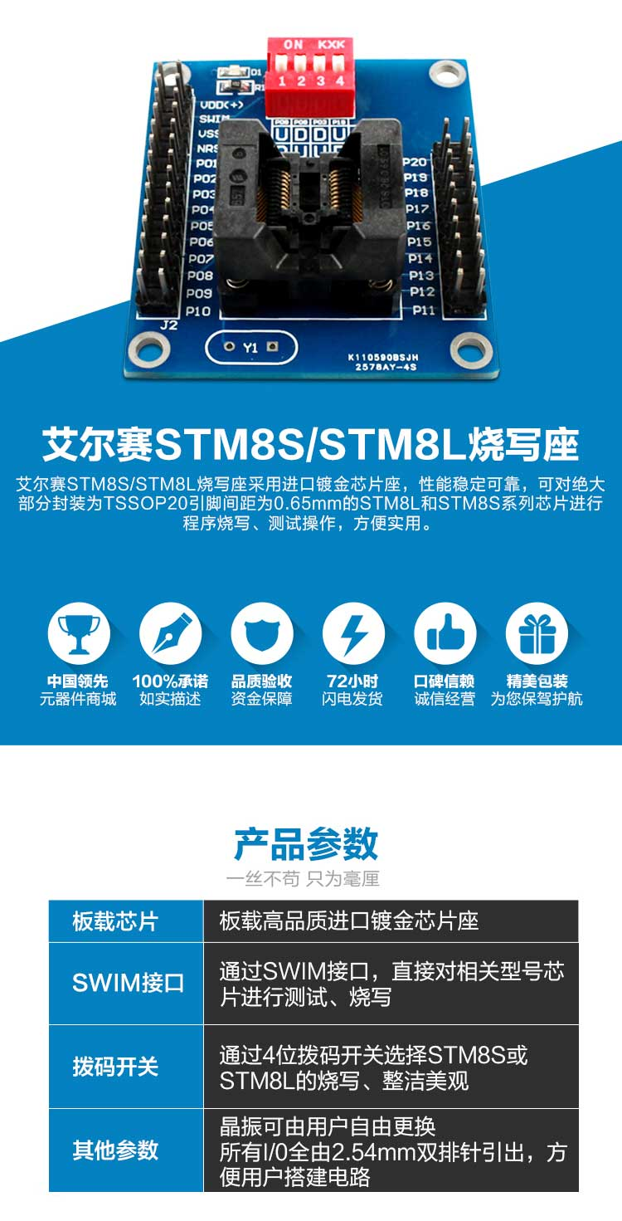

Product Parameters：
On-board chip: On-board high-quality imported gold-plated chip holder
SWIM interface: through the SWIM interface, directly on the relevant type of chip for testing, burning write
DIP switch: Select STM8S or STM8L by 4-digit dip switch, neat and beautiful.
Other parameters: the crystal can be freely replaced by the user all 1 / 0 by 2.54mm double row of pins lead out, convenient for users to build the circuit

Interface Profile:

Product Images:
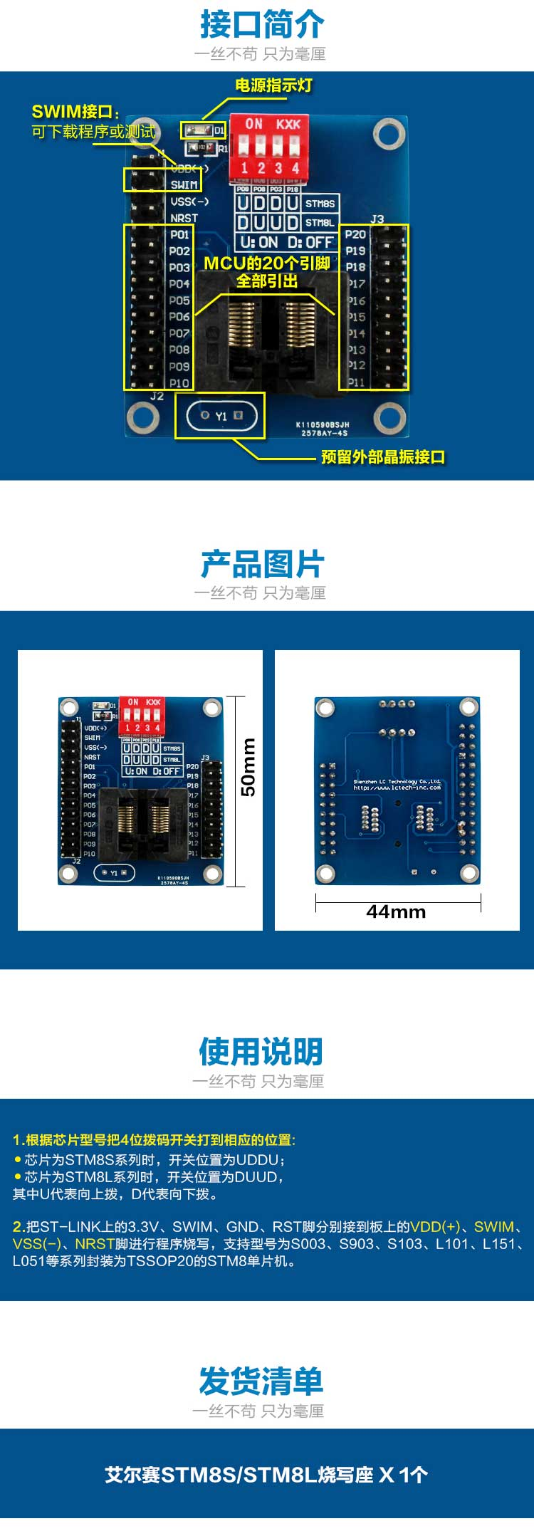
Instructions for use:
1. According to the chip model, the 4-digit dip switches should be set to the corresponding positions: - UDDU when the chip is STM8S series; - DUUD when the chip is STMBL series.
-When the chip is STM8S series, the switch position is UDDU; -When the chip is STMBL series, the switch position is DUUD.
When the chip is STM8S series, the switch position is UDDU; - When the chip is STMBL series, the switch position is DUUD.
Where U stands for upward dialing and D stands for downward dialing.
2. Connect the 3.3V, SWIM, GND and RST pins on ST-LINK to the VDD (+), SWIM.VSS (-) and NRST pins on the board respectively to burn the program and support the STM8 microcontrollers with the model number of S003, S903, S103, L101, L151, L051, etc. in the package of TSSOP20.

