Nova PM sensor SDS011 High Precision Laser pm2.5 Air Quality Detection Sensor

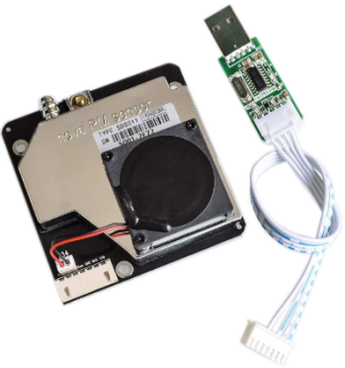
Product Description
This product uses the laser scattering principle to obtain the concentration of suspended particles in the air from 0.3 to 10 microns.
Note: This product supports 5V power supply voltage, output signal TTL The output signal TTL is 5V, higher than this voltage, the product will burn out. Please keep in mind!

Pin Definition Parameters
CTL: control pin, spare
1um: >0.3 micron particle concentration, PWM output
5V: 5V power input
25um: >2.5µm-particle concentration, PWM output
GND: Ground
R: Serial port receive RX
T: Serial port transmit TX
Note: The interface pitch is 2.54 pitch, and the 90-degree pin connector is used without special
instructions.

Specification Parameters
Measurement output: PM2.5, PM10
Range: 0.0-999.9 ug/m3
Supply voltage: DC 5V
Large working current:100mA
Sleeping current:2mA
Operating temperature range:-20~50°C
Response time:1sec
Serial data output frequency:1 time/sec
Particle diameter resolution:0.3 micron
Relative error:10%
Product Size:71x70x23mm

Communication Protocol
Serial communication protocol: 96008N1 (rate 9600, data bit 8, parity bit none, stop bit 1)
Serial communication cycle: 1+0.5 sec.
Data frame (10 bytes): header + command number + data (6 bytes) + checksum + end of message
Byte number | Name | Remarks
0 | Header | AA
1 | Command number | C0
2 | Data 1 | PM2.5 low byte
3 | Data 2 | PM2.5 high byte
4 | Data 3 | PM10 low byte
5 | Data 4 | PM10 high byte
6 | Data 5 | 0 (Reserved)
7 | Data 6 | 0 (Reserved)
8 | Checksum | Checksum
9 | End of message | AB
Checksum: Sum of bytes from data 1 to data 6.
PM2.5 data content: PM2.5(ug/m3) = ((PM2.5 high byte * 256) + PM2.5 low byte) / 10 byte)/10
PM10 data content: PM10(ug/m3) = ((PM10 high byte * 256) + PM10 low byte)/10

Usage
1. Install the USB to TTL driver software first.
2. Connect the USB to TTL serial cable to the PM2.5 sensor and plug it into the computer.
3. After power on, open the serial port debugging assistant software, select the serial port used by the USB to TTL serial line, and use 9600 baud rate. (Download the serial port debugging assistant from http://www.gu-wen.com/Product/260.html )
4. Receive the data as follows
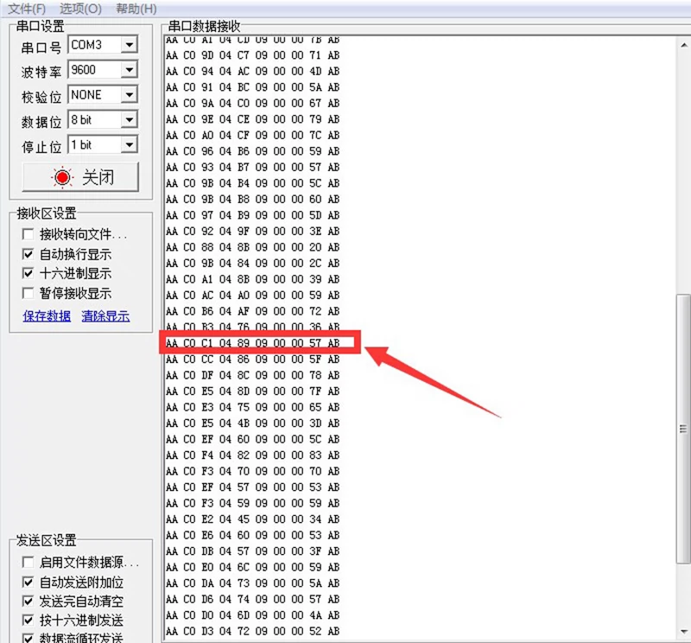
5. Here is a randomly selected set of data for calculation, such as the red box in the above figure: AA C0 C1 04 89 09 00 00 57 AB
Specific meaning:
AA---- message header
C0---- command number, the customer develops the product, see the reception of a CO, that is
Indicates that it is a signal output by the PM2.5 sensor
C1----PM2.5 low byte
04----PM2.5 high byte
89----PM10 low byte
09----PM10 high byte
00---- reserved bit, not used for the moment, can be used as the ID of the sensor (when multiple sensors are used at the same time, in order to facilitate the use of the sensor).
can be used as sensor ID (when multiple sensors are used at the same time, so as to facilitate the distinction)
00---- reserved bit, not yet used, can be used as the ID of the sensor (when multiple sensors are used at the same time, in order to distinguish).

The 00 reserved bit, not yet used, can be used as the ID of the sensor (when multiple sensors are used at the same time, in order to distinguish)
57---- checksum, i.e. C1+04+89+09+00+00=157 (i.e. 0X0157)
Omit the high byte, keep the low byte.
AB---- end of message
Because the output is hexadecimal data, please convert it to a decimal number for
Please convert it to decimal number for calculation.
Calculation of PM2.5 value:C1 04
Low byte C1: 12*16+1=193
High byte 04: 0*16+4=4
((PM2.5 high byte*256) + PM2.5 low byte)/10
(4*256+193)/10=121.7ug/m3
Calculation of PM10 value:89 09
Low byte 89: 8*16+9=137
High Byte 09: 0*16+9=9
((PM10 high byte*256) + PM10 low byte)/10
(9*256+137)/10=244.1ug/m3
Checksum: 57 C1+04+89+09+00+00

