Product name: Light control switch
Wire length: about 14cm(black, white, red line)
Power: 220V incandescent lamp; 1000 energy-saving lamps. Fluorescent lamp exhaust fan S400W; LED lamp ≤600W
Voltage: AC110-250V, AC/DC12V,24V,36V,48V,60V voltage are produced
Purpose: Control; It closes automatically during the day and opens automatically at night
Working current: 10A, 15A optional
Application: Widely used in street lights, highways, gardens, etc
Warning: Do not install under the light. Install on the sunny side, above the light
Net weight: about 48g

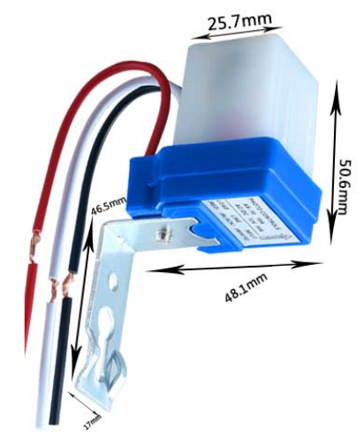

alternating current：
The white and black wires are connected to a 220V power supply
The white and red lines are connected to the load
direct current：
The black line inputs the positive red line and outputs the positive white line common negative

