technology technique refer to mark
serial number  NO | project  ITEM | Specification  SPECIFICATION | Test Conditions  TESTING CONDITION
1 | caliber  NOMINAL SIZE | 36MM
2 | Nominal impedance  VOICE COIL IMP | 8 OHM ±15% | AT 1800Hz
3 | Resonance frequency  RESONT FREQ | 610 Hz ±20%
4 | output sound pressure  OURPUT SPL | AT 1 KHz: 98.3±2db  Average sensitivity: 92.9±2db | AT 1m1w MEASURMENT
5 | Frequency response  FREQ RESPONSE | Fo~7KHZ output sound pressure -10db | High limit frequency ±20%  reduce 10db
6 | Approved power  RATED POWER | 0.5w
7 | maximum output power  MAX POWER | 0.75w
8 | distortion  DISTORATION | 5%MAX（1000HZ 0.75W）
9 | action  OPERATION | must be normal  MUST BE NORMAL | PROGRAM SOURCE 0.5W
10 | Different sound  NOISE | must be normal  MUST BE NORMAL8.9 | SINE WAVE 2.0 V
11 | Heat resistance test  HEAT TEST | AFTER TEST MEET ITEM8.9 | 55±2°C 16HOURS
12 | Moisture resistance test | AFTER TEST MEET ITEM8.9 | 40±2°C  90-95%RH 48 HOURS
13 | line load  LOAD TEST | AFTER TEST MEETITEM | 0.25W 100 HOURS
14 | magnet  MAGNET | Φ12.5X1.3 N35  MATERIAL WEIGHT OZ
15 | total magnetic flux  TOTAL FLUX | MAXWELL
16 | Magnetic flux density  FLUX DENSITY | GAUSS
17 | Polarity marking  POLARIZATION | - When the terminal is down ( ) side ( ) pole  - The terminal is positive with (+) or red dot
18 | net weight  NET WEIGHT | 8.3G+-0.2

2.Frequency response/Frequency Response
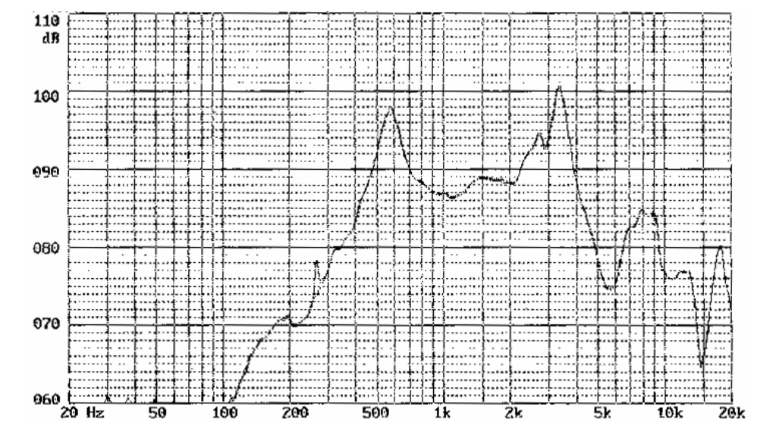

3.Dimensions

