Waveshare 5.5inch 1080×1920 HDMI AMOLED Capacitive Touch Screen with Case
SKU: 1051929
====================================================================
Issues:
1. The GUI is in vertical orientation.
2. Touchscreen doesn’t work properly. ====================================================================
Solution to Issue 1:
Follow the steps given below in Images to rotate image by 90 degrees.
Step1:
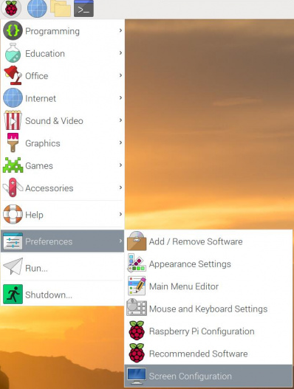

Step2:
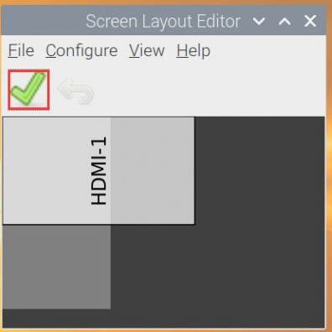

Step3:

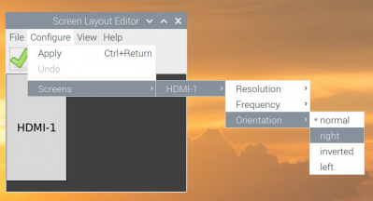

Step4:

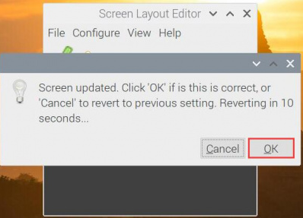
After reboot, your GUI will be turned by 90 degrees and it will be in Horizontal position.
=====================================================================
Solution to Issue 2:
Touchscreen doesn’t work properly.

Touch Rotation
With the operation above. The screen could rotate in the display. However, the touch works improperly. To rotate the touch as display, you could do as below:

- Hardware Rotate Touch: Press and hold the Touch Rotate button on the bottom panel, and each long press will rotate the touch direction by 90 degrees.

- 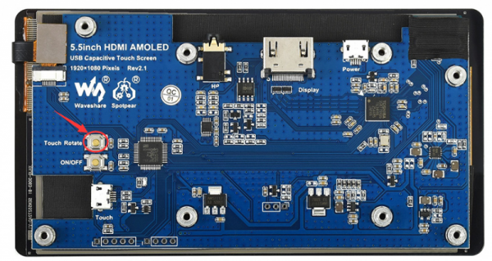
- If there are special circumstances that cannot be rotated by hardware, please refer to the following steps to rotate the touch:
1. Install libinput
sudo apt-get install xserver-xorg-input-libinput
If the system you installed is Ubuntu or Jetson Nano. The installation code is:
sudo apt install xserver-xorg-input-synaptics
2. Create the xorg.conf.d directory under /etc/X11/ (if the directory already exists, proceed directly to step 3).
sudo mkdir /etc/X11/xorg.conf.d
3. Copy the 40-libinput-conf file to the directory you created just now.
sudo cp /usr/share/X11/xorg.conf.d/40-libinput.conf /etc/X11/xorg.conf.d/
4. Edit this file.
sudo nano /etc/X11/xorg.conf.d/40-libinput.conf

Find the part of the touchscreen, add the following statement inside, and then save the file.
Option "CalibrationMatrix" "0 1 0 -1 0 1 0 0 1"
Similar to the picture below:
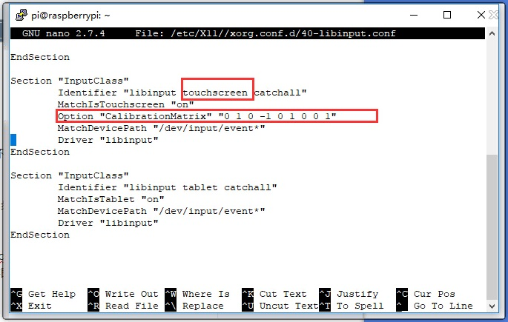
5. save and reboot your Pi
sudo reboot
After completing these steps. The LCD could rotate 90 degrees both display and touch.
Note:
90 degree: Option "CalibrationMatrix" "0 1 0 -1 0 1 0 0 1"
180 degree: Option "CalibrationMatrix" "-1 0 1 0 -1 1 0 0 1"
270 degree: Option "CalibrationMatrix" "0 -1 1 1 0 0 0 0 1"
==========================================================================================================================================

