Translated from Chinese (Simplified) to English - www.onlinedoctranslator.com

485 Relay Product Description

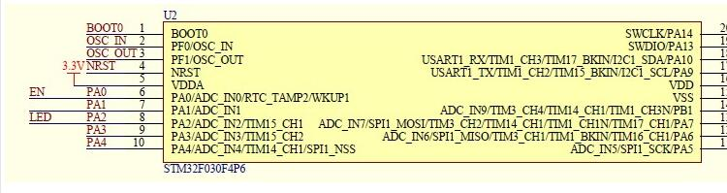

Hardware resources:
1. RS485 communication interface
2. TTL communication interface
3. 1 input
4. 1 output
5. One user LED indicator
6. A STM32F030F4 microcontroller
7 1 relay status indication LED lights
10. Power terminal interface (12V power supply)

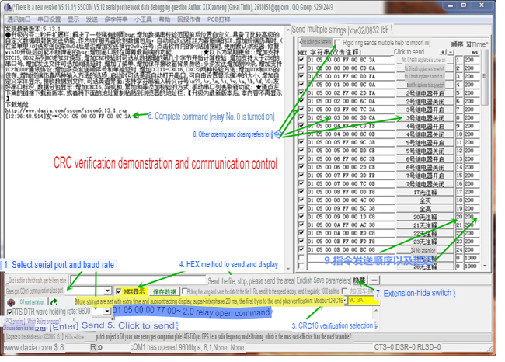

Modbus RTU command
Baud rate: 9600 8 NONE 1
hexadecimal send hexadecimal receive
Operation steps: 1. The software sets the communication baud rate 2. Sets the address (the device address used for communication, the default address is 01) /********************** ************************************************/
Note: Only connect one device, otherwise the address will be set.
Set the address as: 0100 10 00 00 00 01 02 00 01 6A 00// Modify to 01
Set the address to: 0200 10 00 00 00 01 02 00 02 2A 01// Modify to 02
Set the address as: 0300 10 00 00 00 01 02 00 03 EB C1// Modify to 03
read address 00 03 00 00 00 01 85 db
Return: 00 03 02 00 01 44 44 //01 is the address
/**************************************************** ********************//******************************** ************************************/
The meaning of each byte: [Address No. 1]//------------------------------------------------ --------No.1 relay is on: 01 05 00 01 01 00 9d 9a
Byte 1: Address
byte 2: function
Byte 3 4: Register address
Byte 5 6: Register data
Byte 7 8: CRC check
//==================================================== =============[Address No.1]//---------------------------- --------------- No. 0 relay on: 01 05 00 00 FF 00 8C 3A No. 0 relay off: 01 05 00 00 00 00 CD CA//--------- ------------------------------------ Relay 1 is ON: 01 05 00 01 FF 00 DD FA 1 No. relay off: 01 05 00 01 00 00 9C 0A //------------------------------------------------ -------No.2 relay on: 01 05 00 02 FF 00 2D FA No.2 relay off: 01 05 00 02 00 00 6C 0A //---------------- --------------------------- No. 3 relay on: 01 05 00 03 FF 00 7C 3A No. 3 relay off: 01 05 00 03 00 00 3D CA//-------------------------------------------- Relay No. 4 On: 01 05 00 04 FF 00 CD Relay FB4 is off: 01 05 00 04 00 00 8C 0B //------------------------------------ ------------------Relay 5 is on: 01 05 00 05 FF 00 9C Relay 3B is off: 01 05 00 05 00 00 DD CB //----- -------------------------------------- Relay 6 is ON: 01 05 00 06 FF 00 6C Relay 3B6 is closed:01 05 00 06 00 00 2D CB //--------------------------------------- ---Relay No. 7 is open: 01 05 00 07 FF 00 3D FB No. 7 relay is closed: 01 05 00 07 00 00 7C 0B
//--------------------------------------------
/**************************************************** ************************/
Read all relay status: 01 01 00 00 00 01 FD CA
/**************************************************** *********************/
Dodge command:
Description: Turn off immediately after opening, 100MS is a unit [1 represents 100MS]
Address No. 1: Relay No. 0 is open: 01 05 02 00 07 00 CE 42 //700MS = 7*100MS = 700MS Relay No. 1 is open: 01 05 02 01 08 00 9A 72 //800MS
Return: same as sending command No. 2 Address: No. 0 relay out of the way: 02 05 02 00 05 00 CF 11 //500MS No. 1 relay out of the way: 02 05 02 01 06 00 9E 21 //600MS
//==================================================== =======================
All off: 01 0F 00 00 00 08 01 00 FE 95
All bright: 01 0F 00 00 00 08 01 FF BE D5
/**************************************************** ********************/
Single flip command: No. 0 relay flip: 01 05 00 00 55 00 F2 No. 9A1 relay flip: 01 05 00 01 55 00 A3 No. 5A2 relay flip: 01 05 00 02 55 00 53 No. 5A3 relay flip: 01 05 00 03 55 00 02 No. 9A4 relay flip: 01 05 00 04 55 00 B3 No. 5B5 relay flip: 01 05 00 05 55 00 E2 No. 9B6 relay flip: 01 05 00 06 55 00 12 No. 9B7 relay flip: 01 05 00 07 55 00 43 5B
All flip command: 01 05 00 00 5A 00 F7 6A
/**************************************************** ********************/
Read all interface input status
Send: 01 02 00 00 00 08 79 CC //Read 8 input states
Return: 01 02 01 00 A1 88

