485 relay product description

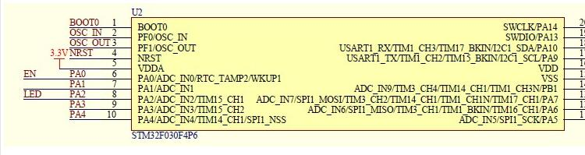

Hardware resources:
1. RS485 communication interface
2. TTL communication interface
3. 1 input
4. 1 output 5.
One user LED indicator
6. One STM32F030F4 microcontroller
7 1 relay status indicator LED
10. Power terminal interface (12V powered by)
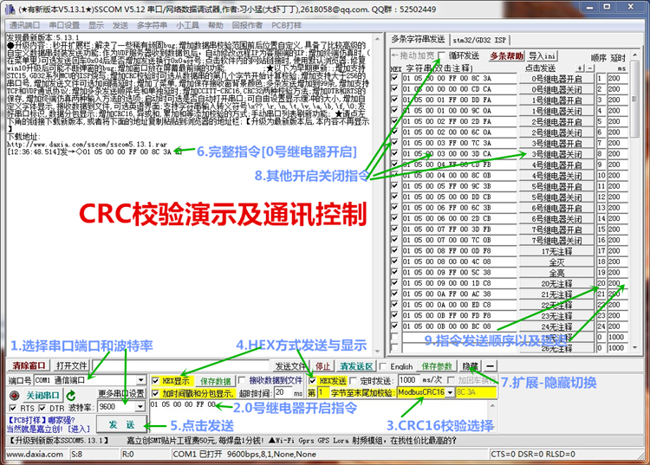
Modbus RTU command
baud rate: 9600 8 NONE 1
Hexadecimal sending
and hexadecimal receiving
operation steps:
1. Software sets the communication baud rate
2. Set the address (the device address used for communication, the default address is 01)
/*** *************************************************** ******************/
Note: Only connect one device, otherwise the address will be set.
Set the address to: 01
00 10 00 00 00 01 02 00 01 6A 00// Change to 01.
Set the address to: 02
00 10 00 00 00 01 02 00 02 2A 01// Change to 02.
Set the address to: 03
00 10 00 00 00 01 02 00 03 EB C1// Modify to 03
to read the address
00 03 00 00 00 01 85 db
returns:
00 03 02 00 01 44 44 //01 is the address
/*********** *************************************************** ******//****************************************** *************************/
The meaning of each byte:
[ Address No. 1]
//---------- ---------------------------------- Relay No. 1 is on: 01 05 00 01 01 00 9d 9a
byte 1 : Address
byte 2: Function
byte 3 4: Register address
byte 5 6: Register data
byte 7 8: CRC check
//================== ============================================[ Address No. 1]
/ /-------------------------------------------------- Relay No. 0 is on: 01 05 00 00 FF 00 8C 3A Relay No.
0 is closed: 01 05 00 00 00 00 CD CA
//--------------------------- ------------------ Relay No. 1 is on: 01 05 00 01 FF 00 DD FA Relay No.
1 is off: 01 05 00 01 00 00 9C 0A
//----- ----------------------------------------------- Relay No. 2 is on: 01 05 00 02 FF 00 2D FA relay No.
2 is closed: 01 05 00 02 00 00 6C 0A
//---------------------------------- ---------- Relay No. 3 is on: 01 05 00 03 FF 00 7C 3A Relay No.
3 is off: 01 05 00 03 00 00 3D CA
//------------- ---------------------------------- Relay No. 4 is on: 01 05 00 04 FF 00 CD FB Relay No.
4 is off: 01 05 00 04 00 00 8C 0B
//------------------------------------------------ --Relay No. 5 is on: 01 05 00 05 FF 00 9C 3B Relay No.
5 is off: 01 05 00 05 00 00 DD CB
//-------------------- ----------------------- Relay No. 6 is on: 01 05 00 06 FF 00 6C 3B Relay No.
6 is off: 01 05 00 06 00 00 2D CB
/ /--------------------------------------------- Relay No. 7 is on: 01 05 00 07 FF 00 3D FB Relay No.
7 is closed: 01 05 00 07 00 00 7C 0B
//------------------------------- ---------------
/************************************ ***************************************/
Read all relay status: 01 01 00 00 00 01 FD CA
/********************************************** *************************/
Get out of the way command:
Description: Close immediately after opening, 100MS is a unit [1 represents 100MS]
Address No.
1 : Relay No. 0 is open: 01 05 02 00 07 00 CE 42 //700MS = 7*100MS = 700MS Relay No.
1 is open: 01 05 02 01 08 00 9A 72 //800MS
returns: the same as sending the command . Address No.
2 : Relay No.
0 is open: 02 05 02 00 05 00 CF 11 //500MS Relay No.
1 is open: 02 05 02 01 06 00 9E 21 //600MS
//================================================ ======================
All out: 01 0F 00 00 00 08 01 00 FE 95
all on: 01 0F 00 00 00 08 01 FF BE D5
/* *************************************************** *******************/
Single flip command: Relay No.
0 flips: 01 05 00 00 55 00 F2 9A Relay No.
1 flips: 01 05 00 01 55 00 A3 5A Relay No.
2 flips: 01 05 00 02 55 00 53 5A Relay No.
3 flips: 01 05 00 03 55 00 02 9A Relay No.
4 flips: 01 05 00 04 55 00 B3 5B Relay No.
5 flips: 01 05 00 05 55 00 E2 9B No.
6 relay flip: 01 05 00 06 55 00 12 9B No.
7 relay flip: 01 05 00 07 55 00 43 5B
all flip command:
01 05 00 00 5A 00 F7 6A
/********* *************************************************** **********/
Read all interface input status
and send: 01 02 00 00 00 08 79 CC //Read 8 input status
and return: 01 02 01 00 A1 88

