MP1584EN DC-DC 3A 5V-12V 24V to 5V Step-down Power Supply Module
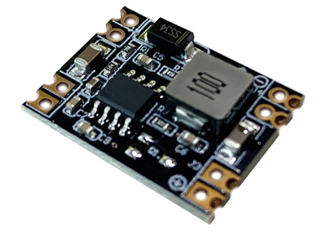
Specification
Input voltage: DC7V-26V
Output voltage: DC 5V
Output current: 3A (peak) within 1.6A for long-time operation
Conversion efficiency: 96% (peak) (Vin-V out ≥ 2V) the smaller, the higher the efficiency
Output ripple: <30mV
Operating temperature: -40 ℃ ~ +85 ° C
Module size: 22.3*17*4.2mm

