跑马灯4X4按键模块
LED Scroller 4x4 Matrix keyboard
NA456
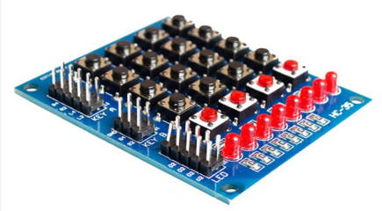

产品简介Product introduction：
本产品是一个4*4的矩阵键盘加4位独立按键，带8位跑马灯，适用于各种单片机外部扩展键盘和跑马灯。
This product is a 4*4 matrix keypad plus 4-bit independent keypad with 8-bit running light, suitable for a variety of microcontrollers external expansion of the keypad and running light.

产品详情Product Details：
产品尺寸:5cm*6cm
产品重量:24g
使用电压:3.3V/5V

Product size:5cm*6cm
Product weight:24g
Use voltage:3.3V/5V

Matrix Keyboard：
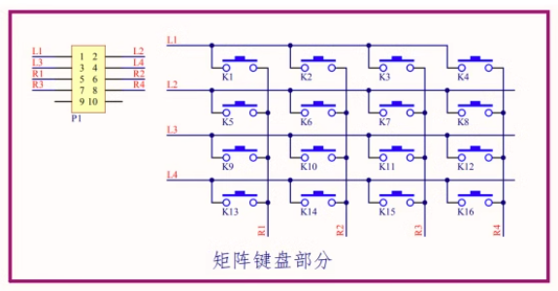

Separate keyboard：
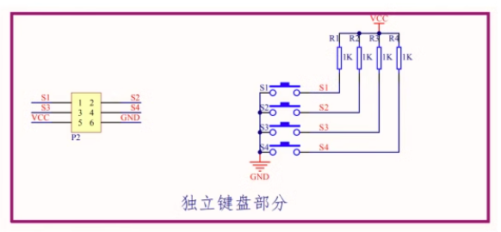
Running light：
