Channel 8 data Parameter description
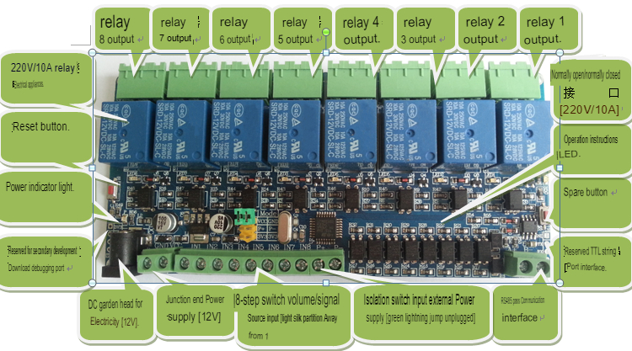
size：143mm *67mm
Hardware resources：
1. RS485 communication port

2. TTL communication interface

3.8 Optical coupler isolated inputs

4.8 Output isolation by the optical coupler

5. A reset button

6. A user button

7. A user LED indicator

8. A power indicator

9. A STM8S103K microcontroller (the new version is changed to STM8S030K, 103K is the microcontroller and 030K is the ARM)

10 8 relay status indicator LED light

11. DC power socket (12V power supply)

12. Power terminal interface (12V power supply)
