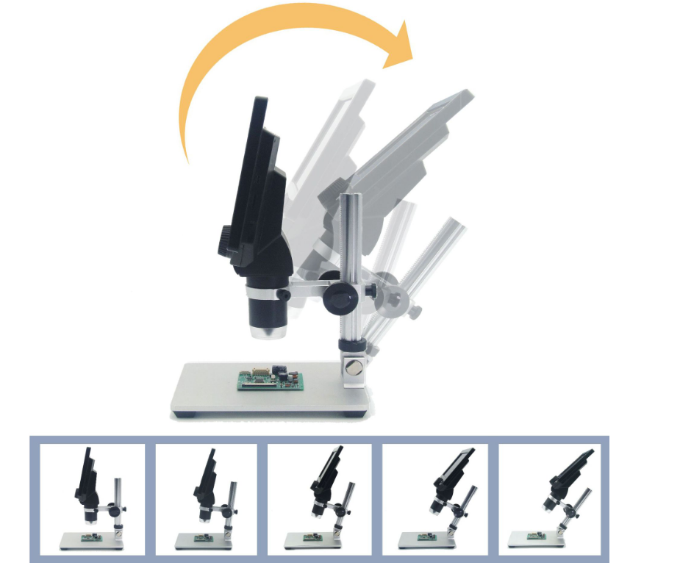 : Switch the machine on and off
Short press for two seconds to turn on and off
M key: Function key
Screen Saver: Off ·30 seconds ·1 minute ·2 minutes (optional)
Automatic shutdown: Off ·3 minutes ·5 minutes ·10 minutes
Hz Light source: 50Hz·60Hz
Language options :16 language options
When the adjustment date: year, month, day |, minutes, seconds
Format: YES/NO
Default setting: YES/NO
V. Version 1.0; Version: H69G - V1.0-20190824
In video mode:
Resolution: 1080FHD, 720P, VGA
Cyclic recording: Turn off /3 minutes /5 minutes /10 minutes. When the flash memory card is full, the first recording data will be deleted and then the recording will be saved.
High dynamic range of HDR: On/off (When on, the recording function will be automatically opened if something moves under the camera, without manual operation.)
Exposure compensation: 7 speed options
Date label: The screen can be selected to show/close - date time
In photo mode:
Photo delay: Single shot ·2 seconds ·5 seconds ·10 seconds
Photo pixel: 1.3M·2M·5M·8M·10M·12M
Consecutive beat: 3 consecutive beats
Photo quality: Quality, Standard and compression
Sharpness: Strong, standard, soft
Color: No · black and white · Nostalgia
ISO: Automatic ·100·200·400
Exposure Compensation: 7 stops to choose from
Photo aid: Anti hand shock open/close
Date label: On/off
Storage space:
Watch: Up · Down remove protection
D key: Mode key:
Switch: Camera mode · Photo Mode · Playback Mode:

Scroll up key, scroll down key, OK key (take photo/video, open key)

1: Power supply DC port (Micro USB).
2: Flash memory card socket (MicroSD), supporting 1-128GB. More than Class10 speed
3: light brightness regulator.
4: REST key, system restore button. (If the machine cannot be operated, please press the button in the hole with a needle-shaped sharp object to restart the machine)
5: Highlight 8 LED lights, continuous service life of up to 100,000 hours.
