Black 2.4 Inch 150W DC USB Electronic Load Battery Tester Discharge Charge Power Supply Meter
SKU: 1165419
Before operating the product, please read the useful info given below:
Electronic loads are instruments that you would use to provide a programmable load when testing voltage and current sources, including power supplies and batteries. Modern electronic loads are actually sophisticated electronic test instruments that can offer a number of different modes, including Constant Current (CC) mode, Constant Resistance (CR) mode, Constant Voltage (CV) mode, and Constant Power (CP) mode.

CC Mode
In Constant Current (CC) mode, the load will sink a current equal to the programmed current setting regardless of the input voltage, up to the maximum current rating of the load. You might use the constant current mode to ensure that your power supply can output the maximum specified current under all conditions.
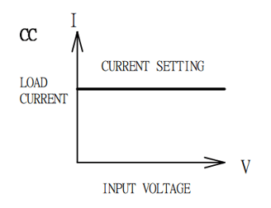

CR Mode
In Constant Resistance (CR) mode, the electronic load will act like a fixed resistor. It senses the voltage at its input and sinks a current linearly proportional to the input voltage. You might use the constant resistance mode to test the capacity of batteries. Constant resistance mode is also most often used to measure the start-up conditions of electronic devices.
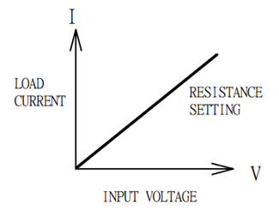

CV Mode
In Constant Voltage mode, the load will attempt to sink enough current to maintain the programmed voltage setting at its input terminals. Of course, if there are some limitations on how much current that the load is able to sink.
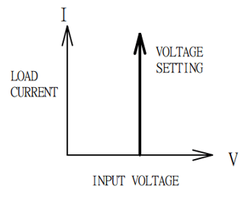

CP Mode
In Constant Power (CP) mode, the load will attempt to sink whatever load power is programmed. It senses the voltage at the input, calculates the appropriate current, and then attempts to sink that amount of current. You might use this feature to ensure that your power source is able to supply the specified output power over the entire output voltage range of the source.
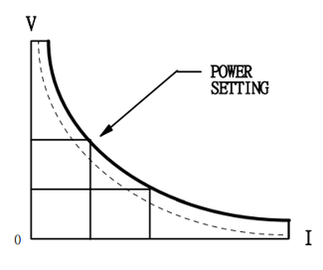

====================================================================

Images of Load Tester in different modes:
- CC Mode

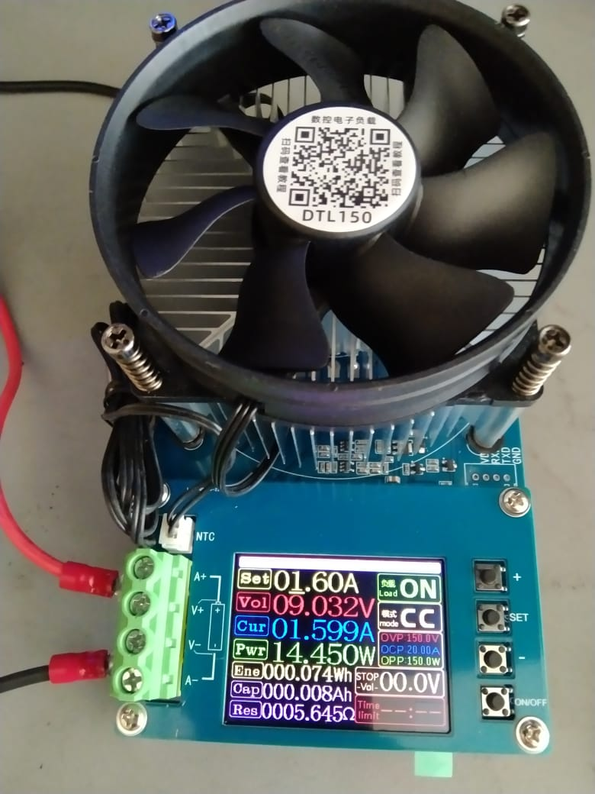

2.CV Mode
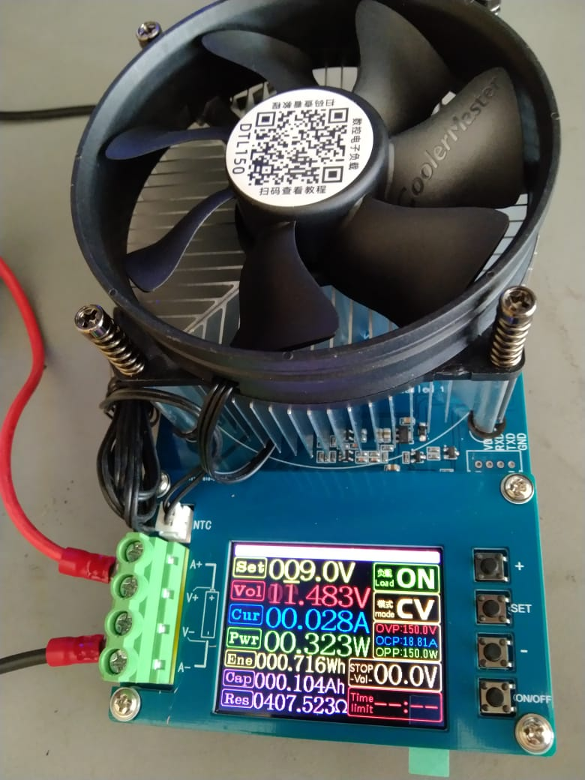

3. CR Mode
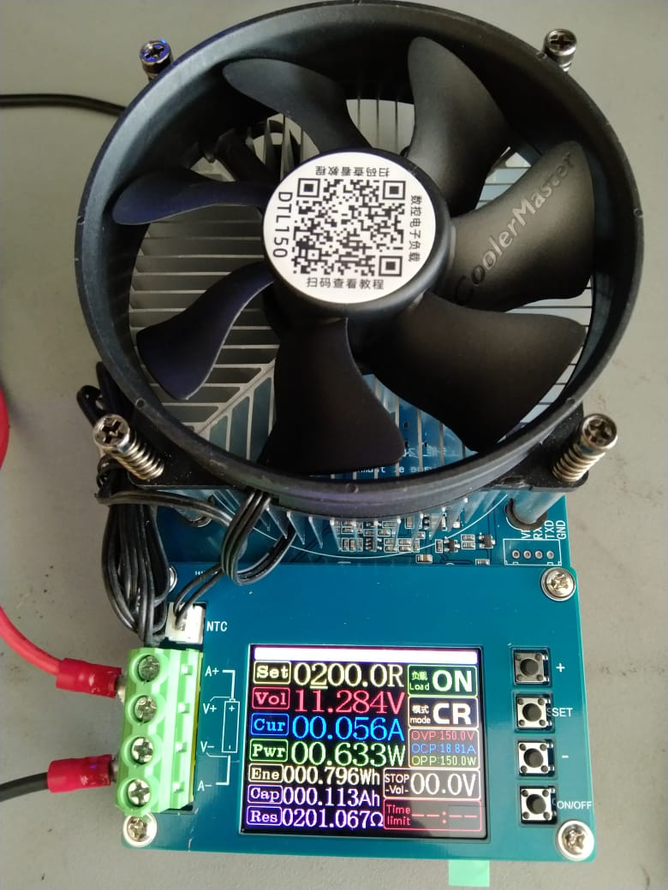

4.CP Mode
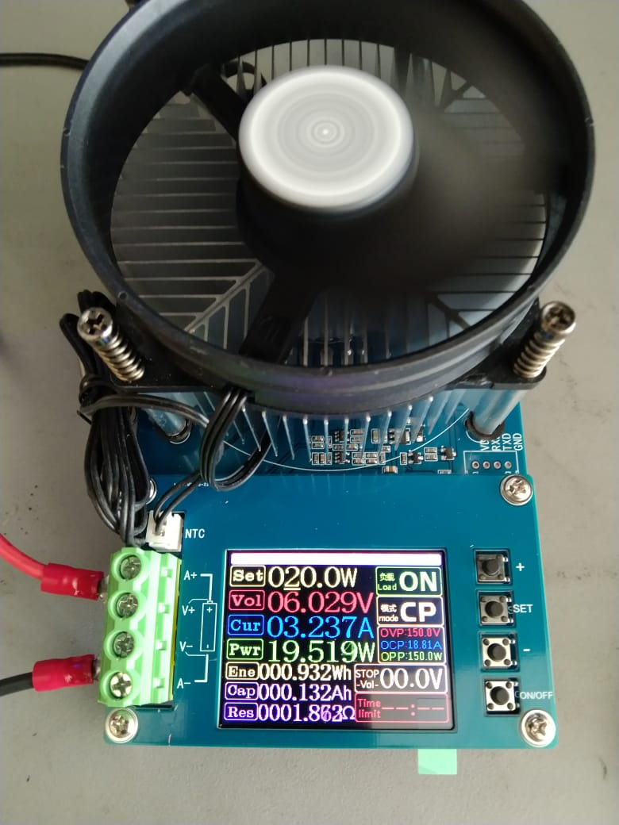

Visit website: https://www.banber.com/gather/62b17152189e2500088d27e2.html

