Fermion Multifunctional Environmental Sensor
SKU:SEN0500
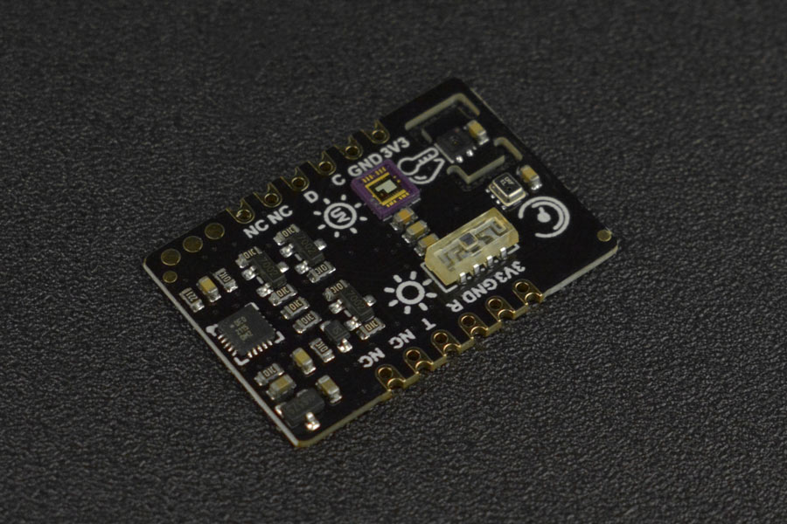

Introduction
This multifunctional environmental sensor comprises SHTC3 temperature & humidity sensor, BMP280 atmospheric pressure sensor, VEML7700 light sensor, and ML8511 ultraviolet sensor into one and offers 5 kinds of environmental parameters. Professional sensor chip is selected for each kind of parameter measurement. The reasonable layout and heat conduction of main chip are carefully considered in the circuit design, which effectively guarantees the accuracy of the data
The product has an MCU processing chip onboard that converts the raw data of sensor into values with standard unit so you can directly use them. For example, ℃ and °F for temperature, % for humidity, Kpa for atmospheric pressure, lx for light illuminance, and mw/m² for ultraviolet.
The environmental sensor supports two communication methods, UART and I2C. There are two versions: Gravity and breakout, also complete Arduino and Python libraries are provided.
Exquisite and small, you can use it to make a home indoor and outdoor environmental monitoring system, or for your environmental monitoring topics. This DFRobot environmental sensor can greatly simplify wirings and codes of your project.

Features
- Mini size, can be directly soldered onto your PCB
- Switchable I2C and UART two output modes
- Highly integrated module, can test a variety of data at the same time (temperature, humidity, atmospheric pressure, altitude, ultraviolet intensity, ambient light intensity)
- Reasonable layout and high precision.

Application
- Home indoor and outdoor environment detection system
- Environmental monitoring work

Specification
- Working Voltage: 3.3VDC
- Working Current: 35mA
- Output Signal: I2C, UART
- Working Temperature: -20~70℃
- Size: 30mm × 20.5mm/1.18 × 0.81"

Atmospheric pressure sensor
Atmospheric pressure unit relationship: 1000pa = 10hpa = 1kpa
- Sensor chip model: BMP280
- Atmospheric pressure measurement range: 3000~1100 hPa
- Relative accuracy of atmospheric pressure: ±0.12 hPa
- Absolute atmospheric pressure accuracy: ±1 hPa

Temperature & Humidity Sensor
- Sensor chip model: SHT-C3
- Relative humidity accuracy: ±2%RH
- Relative humidity resolution: 0.01%RH
- Relative humidity measurement range: 0~100
- Temperature accuracy: ±0.2℃
- Temperature resolution: 0.01℃
- Temperature measurement range: -40~125℃

Ultraviolet Sensor
- Sensor chip model: ML8511
- Ultraviolet sensitive wavelength UV-A (320-400nm), UV-B (280-320nm)
- Ultraviolet output unit: mW/㎡

Ambient light sensor
- Sensor chip model: VEML7700
- Ambient light accuracy: 0.0036 lx/ct
- Ambient light range: 0~120 klx

Function Overview

Dimension
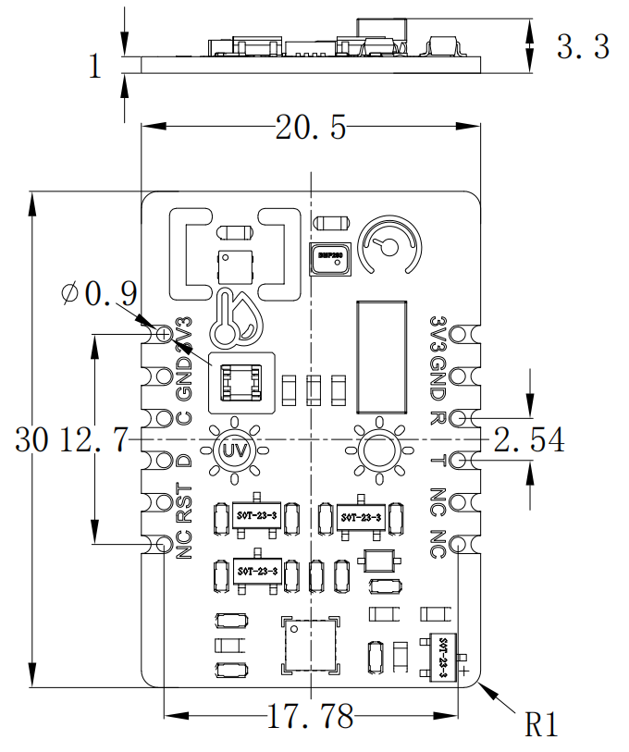

Board Overview
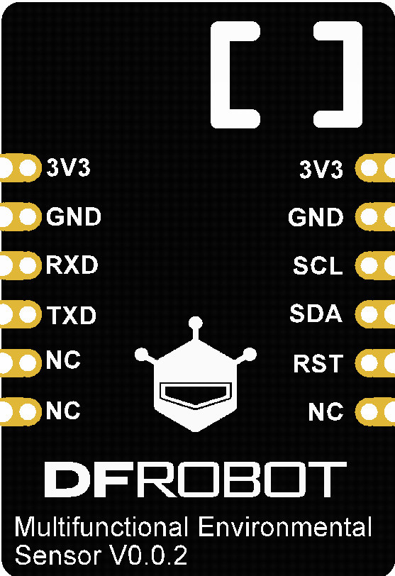
Num | Label | Description
1 | 3V3 | Power +
2 | GND | Power -
3 | RXD | UART receiving
4 | TXD | UART transmitting
3 | SCL | I2C Clock Line
4 | SDA | I2C Data Line
3 | RST | Reset Pin
4 | NC | Empty

Tutorial
Download the program to FireBeetle Board ESP32-E, open the serial monitor to check various environmental parameters.

Requirements
- Hardware
  - FireBeetle Board ESP32-E (or similar) x 1
  - SEN500 Multifunctional environmental sensor x1
  - Wires
- Software
  - Arduino IDE
  - Download and install the DFRobot_EnvironmentalSensor Library (About how to install the library?)

Read Sensor Data via I2C/UART

Connection for UART and I2C
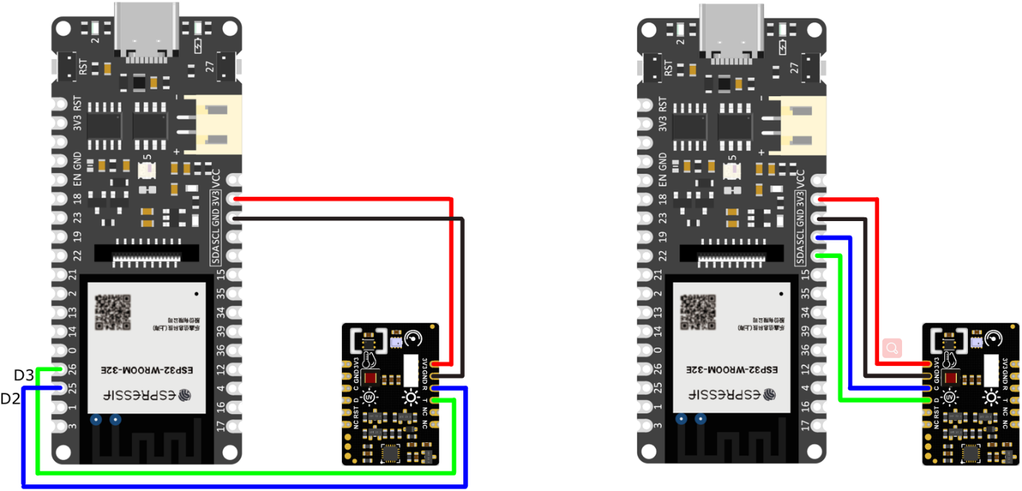
UART on the left, I2C on the right.
- Click to check more wiring diagrams

Switch Communication Mode
About UART/I2C mode switching:
- The default mode in the code is UART. Dial the switch to UART side to use it.
- For using I2C, dial the switch to I2C side and replace the 1 at the beginning of the code with 0, as shown below:
to
Steps:
Note: Please use 3.3V maincontroller with this product(Arduino UNO is not recommended). Different motherboards correspond to different wiring pins (refer to “more wiring diagrams” above). In the Arduino IDE, they also correspond to different motherboard options and different ports (COM). The other steps are the same as FireBeetle Board ESP32-E.
- Connect the module and FireBeetle Board ESP32-E according to the wiring method above.
- Open the Arduino IDE and upload the following code to FireBeetle Board ESP32-E.
- Open the serial port monitor of Arduino IDE, adjust the baud rate to 115200, and observe the serial port printing result.

Sample Code
Function: Print all data obtained by the module
Copy

Expected Results
The read data will be dipalyed on the serial monitor.
