DFRobot Gravity HCL Sensor (Calibrated) – I2C & UART

Introduction
This is a sensor that detects oxygen concentration and supports three output modes: analog, I2C, and UART. The probe has been calibrated at the factory, which can quickly and accurately measure the concentration of oxygen in the environment. Can be widely applied to fields like portable devices, air quality monitoring devices, industries, mines, warehouses, and other spaces where the air is not easy to circulate.
The probe adopts the electrochemical principle, has the characteristics of strong anti-interference ability, high stability, high sensitivity, etc., and the service life is as long as two years. The sensor has 32 modifiable I2C addresses, an integrated temperature compensation algorithm, and a threshold alarm function, It has good compatibility with mainstream main control devices such as Arduino, ESP32, and Raspberry Pi. The easy-to-use Gravity interface, coupled with our sample code, can quickly build an oxygen concentration detector.

Precautions for use
- The white waterproof and breathable membrane of the sensor on the module is strictly forbidden to open, otherwise it is regarded as artificial damage.
- It is forbidden to plug or unplug the probe with power on.
- It is forbidden to directly solder the pins of the module, but the sockets of the pins can be soldered.
- The module should avoid contact with organic solvents (including silica gel and other adhesives), paints, pharmaceuticals, oils and high-concentration gases.
- The module must not be subjected to excessive shock or vibration.
- The module needs to be warmed up for more than 5 minutes when powered on for the first time. It is recommended to warm up for more than 24 hours if it has not been used for a long time.
- Do not apply this module to systems involving personal safety.
- Do not install the module in environment with strong air convection.
- Do not leave the module in high-concentration organic gas for a long time.
- The data returned by the serial port of the module is the real-time concentration value in the current environment. If there is no standard gas, please do not try the calibration command. This command will clear the calibrated data, and the data returned by the serial port will be inaccurate.
- To judge whether the module communication is normal, it is recommended to use a USB to TTL tool (communication level 3V) to observe and judge according to the communication protocol through the serial debugging assistant software.

Features
- Factory calibrated, accurate measurement
- High sensitivity, low power consumption
- Excellent stability and anti-interference
- Three output modes: I2C, UART and analog
- Long service life(2 years)
- Compatible with 3.3~5.5V main controllers
- 32 modifiable I2C addresses
- Reverse connection protection
- Temperature compensation
- Threshold alarm

Specification
SKU | SEN0465 | SEN0466 | SEN0467 | SEN0468 | SEN0469 | SEN0470
Type | O2 | CO | H2S | Cl2 | NH3 | SO2
Detection Range | (0-25)%Vol | (0-1000)ppm | (0-100)ppm | (0-20)ppm | (0-100)ppm | (0-20)ppm
Resolution | 0.1%Vol | 1ppm | 1ppm | 0.1ppm | 1ppm | 0.1ppm
V0 Voltage output range | (1.5-0)V | (0.6-3)V | (0.6-3)V | (2-0)V | (0.6-3)V | (0.6-2.4)V
Vout1 | 1.0V@10%vol | 0.9V@200ppm | 1.5V@50ppm | 1.3V@10ppm | 1.4V@50ppm | 1.5V@10ppm
Response Time（T90) | ≤15S | ≤30S | ≤30S | ≤60S | ≤150S | ≤30S
SKU | SEN0471 | SEN0472 | SEN0473 | SEN0474 | SEN0475 | SEN0476
Type | NO2 | O3 | H2 | HCL | HF | PH3
Detection Range | (0-20)ppm | (0-10)ppm | (0-1000)ppm | (0-10)ppm | (0-10)ppm | (0-1000)ppm
Resolution | 0.1ppm | 0.1ppm | 1ppm | 0.1ppm | 0.1ppm | 0.1ppm
V0 Voltage output range | (2-0)V | (2-0.7)V | (0.6-3)V | (2-0.7)V | (2-0.5)V | (0.6-3)V
Vout1 | 1.2V@10ppm | 1.3V@5ppm | 1.3V@500ppm | 1.4V@5ppm | 1.3V@5ppm | 0.7V@50ppm
Response Time（T90) | ≤30S | ≤120S | ≤120S | ≤60S | ≤60S | ≤30S

- Detection Gas: CO, O2, NH3, H2S, NO2, HCL, H2, PH3, SO2, O3, CL2, HF(Need to change different probe)
- Working Voltage: 3.3～5.5V DC
- Working Current: <5mA
- Output Signal: I2C, UART output (0~3V), analog voltage (see the characteristic parameters of specific probe)
- Working Temperature: -20～50℃
- Working Humidity: 15～90%RH (non-condensing)
- Storage Temperature: -20～50℃
- Storage Humidity: 15～90%RH (non-condensing)
- Lifespan: >2 years (in the air)
- Adapter Plate Size: 37×32mm

Characteristic Parameters

Explanation of VO use:
VO: It means original voltage (linear) after amplifying circuit, rather than concentration value of current environment.
Calculation method: concentration in the current environment N= 200/(Vout1-Vout0)*(Voutx-Vout0)
Where Vout1 corresponds to Vout1 in the table and Vout0 corresponds to the voltage value of the gas at 0 ppm in the table. Take CO as an example: zero point voltage Vout0 = 0.6V, Vout1 = 0.9V, the current voltage of VO Voutx = 1.2V, then the current concentration in the environment N = 400ppm
Note: The analog output is the original uncalibrated voltage of the probe, the UART/I2C data is factory calibrated, if there is no special requirement, it is recommended to use the calibrated UART/I2C data.

Board Overview
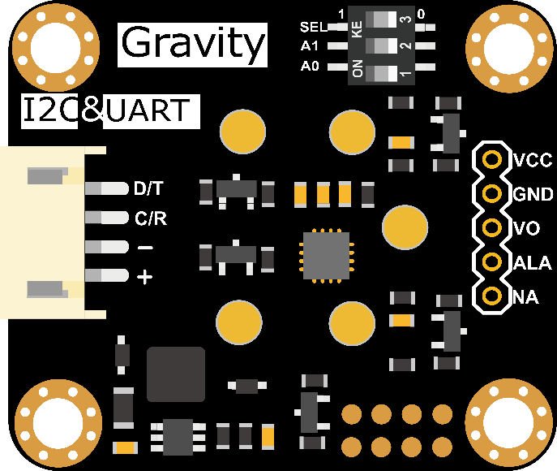
Smart Gas Sensor Terminal
Label | Name | Function description
1 | D/T | I2C data line SDA / UART data transmitting-TX
2 | C/R | I2C clock line SCL / UART data receiving-RX
3 | - | GND -
4 | + | Power supply + (3.3-5V compatible)

Label | Name | Function description
1 | VCC | Positive power supply (3.3-5V compatible)
2 | GND | GND negative power supply
3 | V0 | The raw voltage output of the gas probe. You can develop your own conversion algorithm based on the original output.
4 | ALA | Threshold alarm function, the threshold can be set through API, when exceeding this value, the pin will output high level.
5 | NA | Reserve custom pins, you can contact us for custom functions.

Tutorial for Arduino
Download the program to UNO and open the serial monitor to check the gas concentration.
Note:
- The initial power-on requires more than 5 minutes of preheating. It is recommended to preheat more than 24 hours if it has not been used for a long time.
- After switching the communication mode or changing the I2C address, the system needs to be powered off and on again.

Requirements
- Hardware
  - DFRuino UNO R3 x1
  - DFR0784 Smart Gas Sensor Terminal x1
  - Gas probe x1
  - Jumper wires
- Software
  - Arduino IDE
  - Download and install the DFRobot_GasSensor Library (About how to install the library?)

Acquire data in passive mode

Connection
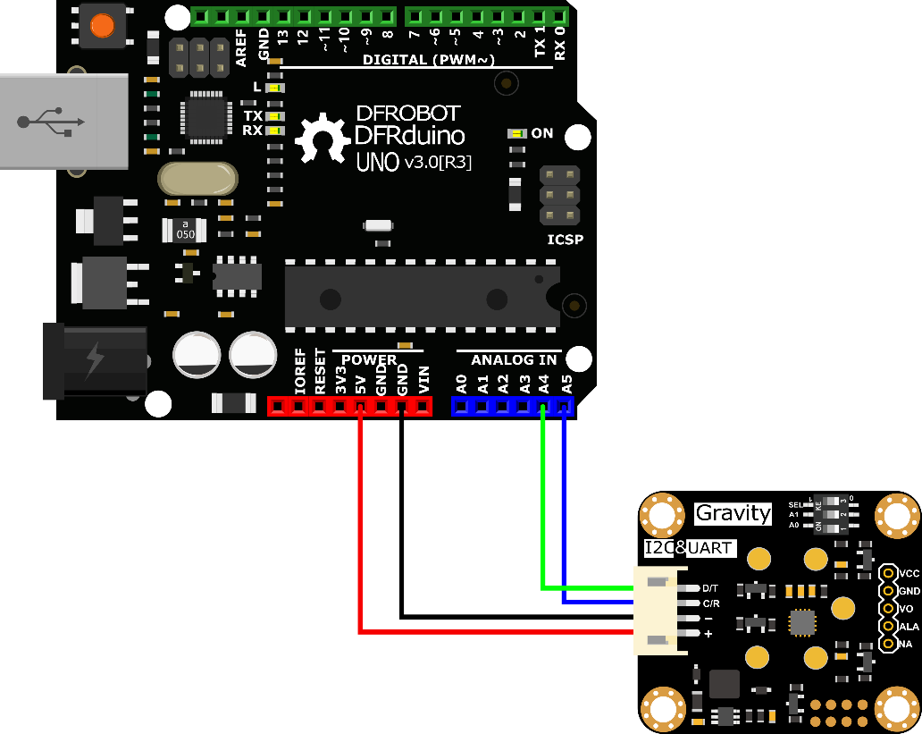

Sample code
- Connect the module to the Arduino according to the connection diagram above. Of course, you can also use it with Gravity I/O Expansion Board to build the project prototype more conveniently and quickly.
- Set the DIP switch SEL on the sensor to 0, and use I2C communication by default.
- The default I2C address is 0x74. If you need to modify the I2C address,You can configure the hardware I2C address through the DIP switch on the module, or run the code to modify the address group to modify the address. The corresponding relationship between the DIP switch and the I2C address parameter is as follows:
  - ADDRESS_0: 0x74, A0=0, A1=0
  - ADDRESS_1: 0x75, A0=1, A1=0
  - ADDRESS_2: 0x76, A0=0, A1=1
  - ADDRESS_3: 0x77, A0=1, A1=1
- Download and install the DFRobot_GasSensor Library (About how to install the library?)
- Open Arduino IDE and upload the following code to Arduino UNO.
- Open the serial port monitor of Arduino IDE, adjust the baud rate to 115200, and observe the serial port print result.

Statement
- In this routine, the controller needs to request data from the sensor every time, and then the sensor returns the data.
- Default use I2C communication, mask #define I2C_COMMUNICATION in the code, and set the dip switch SEL to 1, the sensor is connected to the corresponding port defined by the controller, if use UNO, the blue line is connected to D3 and the green line is connected to D2, if use ESP32, the blue line is connected to IO17 and the green line is connected to IO16. After re-uploading the code, the whole system will be re-powered and will switch to UART communication.
- Turn off temperature compensation by default, modify the code gas.setTempCompensation(gas.ON);, turn on temperature compensation after re-uploading the code
/*!
* @file initiativereport.ino
* @brief The sensor actively reports all data
* @n Experimental method: Connect the sensor communication pin to the main control, then burn codes into it.
* @n Communication mode selection, dial switch SEL:0: IIC, 1: UART
@n I2C address selection, the default I2C address is 0x74, A1 and A0 are combined into 4 types of IIC addresses
| A1 | A0 |
| 0 | 0 | 0x74
| 0 | 1 | 0x75
| 1 | 0 | 0x76
| 1 | 1 | 0x77 default i2c address
* @n Experimental phenomenon: Print all data via serial port
*/
#include "DFRobot_MultiGasSensor.h"

//Enabled by default, use IIC communication at this time. Use UART communication when disabled
#define I2C_COMMUNICATION

#ifdef I2C_COMMUNICATION
#define I2C_ADDRESS 0x74
DFRobot_GAS_I2C gas(&Wire ,I2C_ADDRESS);
#else
#if (!defined ARDUINO_ESP32_DEV) && (!defined __SAMD21G18A__)
/**
UNO:pin_2-----RX
pin_3-----TX
*/
SoftwareSerial mySerial(2,3);
DFRobot_GAS_SoftWareUart gas(&mySerial);
#else
/**
ESP32:IO16-----RX
IO17-----TX
*/
DFRobot_GAS_HardWareUart gas(&Serial2); //ESP32HardwareSerial
#endif
#endif

void setup() {

Serial.begin(115200);

while(!gas.begin())
{
Serial.println("NO Deivces !");
delay(1000);
}
Serial.println("The device is connected successfully!");

gas.changeAcquireMode(gas.PASSIVITY);
delay(1000);

gas.setTempCompensation(gas.OFF);
}

void loop() {

Serial.print("Ambient ");
Serial.print(gas.queryGasType());
Serial.print(" concentration is: ");
Serial.print(gas.readGasConcentrationPPM());
Serial.println(" %vol");
Serial.print("The board temperature is: ");
Serial.print(gas.readTempC());
Serial.println(" ℃");
Serial.println();
delay(1000);
}
Copy

Result
Open the serial monitor to get the gas type, concentration and temperature.
- The initial power-on requires more than 5 minutes of preheating. It is recommended to preheat more than 24 hours if it has not been used for a long time.
- After switching the communication mode and changing the I2C address, the system needs to be powered off and on again.
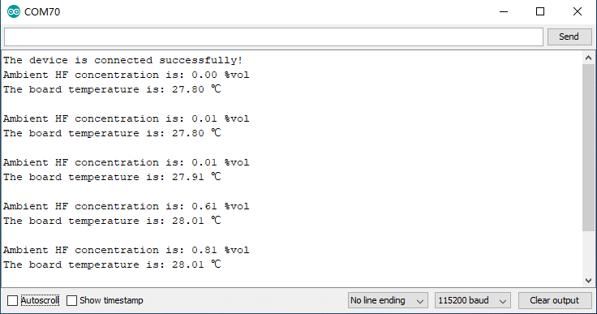

Acquire data in initiative mode

Connection
- Sample code
- Connect the module to the Arduino according to the connection diagram above. Of course, you can also use it with Gravity I/O Expansion Board to build the project prototype more conveniently and quickly.
- Set the DIP switch SEL on the sensor to 0, and use I2C communication by default.
- The default I2C address is 0x74. If you need to modify the I2C address,You can configure the hardware I2C address through the DIP switch on the module, or run the code to modify the address group to modify the address. The corresponding relationship between the DIP switch and the I2C address parameter is as follows:
  - ADDRESS_0: 0x77, A0=0, A1=0
  - ADDRESS_1: 0x76, A0=1, A1=0
  - ADDRESS_2: 0x75, A0=0, A1=1
  - ADDRESS_3: 0x74, A0=1, A1=1
- Download and install the DFRobot_GasSensor Library (About how to install the library?)
- Open Arduino IDE and upload the following code to Arduino UNO.
- Open the serial port monitor of Arduino IDE, adjust the baud rate to 115200, and observe the serial port print result.

Statement
  - In this routine, the sensor will actively return data once a second, and the controller will receive and parse the data.
- Default use I2C communication, mask `#define I2C_COMMUNICATION in the code, and set the dip switch SEL to 1, the sensor is connected to the corresponding port defined by the controller, if use UNO, the blue line is connected to D3 and the green line is connected to D2, if use ESP32, the blue line is connected to IO17 and the green line is connected to IO16. After re-uploading the code, the whole system will be re-powered and will switch to UART communication.
- Turn off temperature compensation by default, modify the code gas.setTempCompensation(gas.ON);, turn on temperature compensation after re-uploading the code
/*!
* @file readGasConcentration.ino
* @brief Obtain the corresponding gas concentration in the current environment and output the concentration value
* @n Experiment method: Connect the sensor communication pin to the main control and burn codes into it.
* @n Communication mode selection, dial switch SEL:0: IIC, 1: UART
@n i2c address selection, the default i2c address is 0x74, A1 and A0 are combined into 4 types of IIC addresses
| A1 | A0 |
| 0 | 0 | 0x74
| 0 | 1 | 0x75
| 1 | 0 | 0x76
| 1 | 1 | 0x77 default i2c address
* @n Experimental phenomenon: You can see the corresponding gas concentration value of the environment at this time by printing on the serial port
*/
#include "DFRobot_MultiGasSensor.h"

//Enabled by default, use IIC communication at this time. Use UART communication when disabled
#define I2C_COMMUNICATION

#ifdef I2C_COMMUNICATION
#define I2C_ADDRESS 0x74
DFRobot_GAS_I2C gas(&Wire, I2C_ADDRESS);
#else
#if (!defined ARDUINO_ESP32_DEV) && (!defined __SAMD21G18A__)
/**
UNO:pin_2-----RX
pin_3-----TX
*/
SoftwareSerial mySerial(2, 3);
DFRobot_GAS_SoftWareUart gas(&mySerial);
#else
/**
ESP32:IO16-----RX
IO17-----TX
*/
DFRobot_GAS_HardWareUart gas(&Serial2); //ESP32HardwareSerial
#endif
#endif

void setup() {

Serial.begin(115200);

while(!gas.begin())
{
Serial.println("NO Deivces !");
delay(1000);
}

gas.setTempCompensation(gas.OFF);

gas.changeAcquireMode(gas.INITIATIVE);
delay(1000);
}

void loop() {
if(true==gas.dataIsAvailable())
{
Serial.println("========================");
Serial.print("gastype:");
Serial.println(AllDataAnalysis.gastype);
Serial.println("------------------------");
Serial.print("gasconcentration:");
Serial.print(AllDataAnalysis.gasconcentration);
if (AllDataAnalysis.gastype.equals("O2"))
Serial.println(" %VOL");
else
Serial.println(" PPM");
Serial.println("------------------------");
Serial.print("temp:");
Serial.print(AllDataAnalysis.temp);
Serial.println(" ℃");
Serial.println("========================");
}
delay(1000);
}
Copy

Result
Open the serial monitor, then you can get the corresponding gas concentration.
- The initial power-on requires more than 5 minutes of preheating. It is recommended to preheat more than 24 hours if it has not been used for a long time.
- After switching the communication mode and changing the I2C address, the system needs to be powered off and on again.
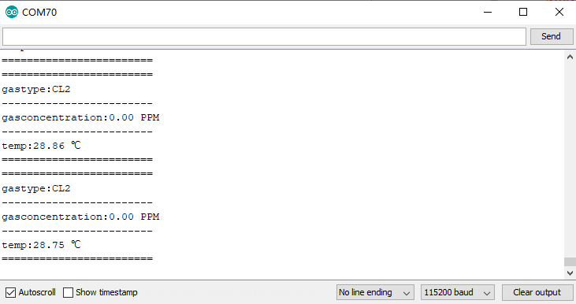

Threshold alarm function

Connection
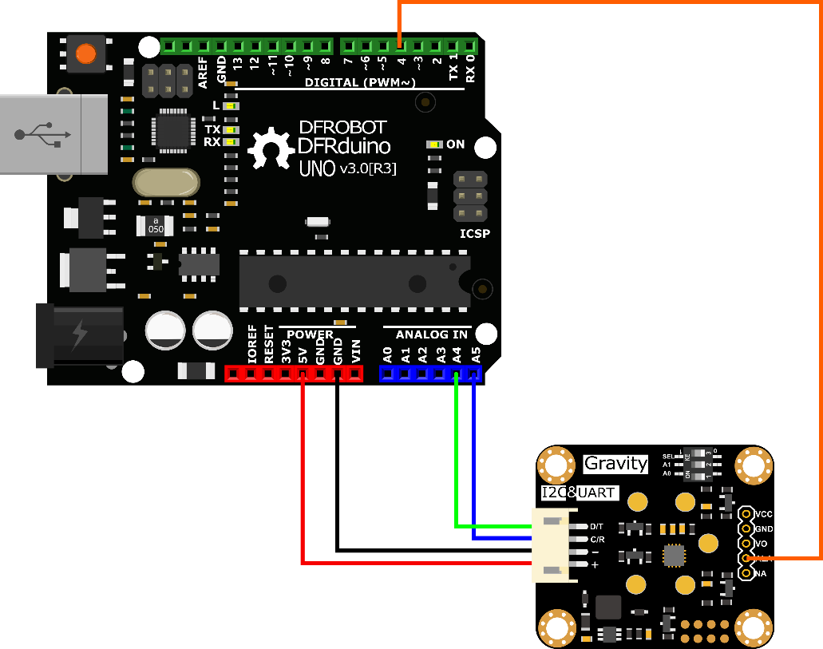
- Sample code
- Connect the module to the Arduino according to the connection diagram above. Of course, you can also use it with Gravity I/O Expansion Board to build the project prototype more conveniently and quickly.
- Set the DIP switch SEL on the sensor to 0, and use I2C communication by default.
- The default I2C address is 0x74. If you need to modify the I2C address,You can configure the hardware I2C address through the DIP switch on the module, or run the code to modify the address group to modify the address. The corresponding relationship between the DIP switch and the I2C address parameter is as follows:
  - ADDRESS_0: 0x74, A0=0, A1=0
  - ADDRESS_1: 0x75, A0=1, A1=0
  - ADDRESS_2: 0x76, A0=0, A1=1
  - ADDRESS_3: 0x77, A0=1, A1=1
- Download and install the DFRobot_GasSensor Library (About how to install the library?)
- Open Arduino IDE and upload the following code to Arduino UNO.
- Open the serial port monitor of Arduino IDE, adjust the baud rate to 115200, and observe the serial port print result.
/*!
* @file setThresholdAlarm.ino
* @brief Set the threshold alarm of the sensor
* @n Experiment method: Connect the sensor communication pin to the main control and burn codes into it.
* @n Communication mode selection, dial switch SEL:0: IIC, 1: UART
*/
#include "DFRobot_MultiGasSensor.h"

//Enabled by default, use IIC communication at this time. Use UART communication when disabled
#define I2C_COMMUNICATION

#ifdef I2C_COMMUNICATION
#define I2C_ADDRESS 0x77
DFRobot_GAS_I2C gas(&Wire ,I2C_ADDRESS);
#else
#if (!defined ARDUINO_ESP32_DEV) && (!defined __SAMD21G18A__)
/**
UNO:pin_2-----RX
pin_3-----TX
*/
SoftwareSerial mySerial(2, 3);
DFRobot_GAS_SoftWareUart gas(&mySerial);
#else
/**
ESP32:IO16-----RX
IO17-----TX
*/
DFRobot_GAS_HardWareUart gas(&Serial2); //ESP32HardwareSerial
#endif
#endif

#define ALA_pin 4

void setup() {

Serial.begin(115200);

while(!gas.begin())
{
Serial.println("NO Deivces !");
delay(1000);
}

while (!gas.changeAcquireMode(gas.PASSIVITY))
{
delay(1000);
}
Serial.println("change acquire mode success!");

while (!gas.setThresholdAlarm(gas.ON, 2, gas.HIGH_THRESHOLD_ALA ,gas.queryGasType()))
{
Serial.println("Failed to open alarm!");
delay(1000);
}
pinMode(ALA_pin,INPUT);
}

void loop() {

Serial.print(gas.queryGasType());
Serial.print(":");
Serial.println(gas.readGasConcentrationPPM());
if (digitalRead(ALA_pin) == 1)
{
Serial.println("warning!!!");
}
else
{
Serial.println("nolmal!!!");
}
delay(200);
}
Copy

Result
-*After uploading the code successfully, open the serial monitor and you can observe the alarm message. *
-ALA outputs low level by default when no alarm is triggered. Modify the HIGH_THRESHOLD_ALA parameter in the gas.setThresholdAlarm function to LOW_THRESHOLD_ALA, then ALA outputs high level when no alarm is triggered
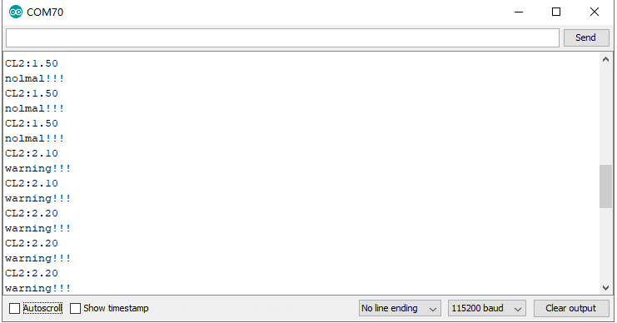

API description
DFR0784 Gravity: Electrochemical Smart Gas Sensor Terminal There are two data reading modes: active upload and passive response. The factory default is active upload mode, and users can adjust them in the code according to their needs.

Mode selection function "changeAcquireMode()"
Modify the parameters in brackets of the "changeAcquireMode()" function to adjust the data sending mode.
"INITIATIVE" is the active upload mode. In the active upload mode, the sensor will automatically upload parameters every 1 second;
"PASSIVITY" is the passive response mode. In the passive response mode, the sensor will feedback the parameters only every time the data reading function is called.
gas.changeAcquireMode(gas.INITIATIVE)
/*
gas.INITIATIVE // Active upload mode
gas.PASSIVITY // Passive response mode
*/
Copy

Set the probe type function "setGasType()"
Set the probe type by the "setGasType()" function.
gas.setGasType(/*Gas type*/gas.O2);
Copy

Read the probe type function "queryGasType()"
Through the "queryGasType()" function, You can get the type of current gas probe.
gas.queryGasType();
Copy
For probe compatible types and corresponding parameters, please refer to the table below.
Gas type | CO | O2 | NH3 | H2S | NO2 | HCL
Detection range | (0-1000)ppm | (0-25)%VOL | (0-100)ppm | (0-100)ppm | (0-20)ppm | (0-10)ppm
Resolution | 1ppm | 0.1%VOL | 1ppm | 1ppm | 0.1ppm | 0.1ppm
V0 voltage output range | (0.6-3)V | (1.5-0)V | (0.6-3)V | (0.6-3)V | (2-0)V | (2-0)V
Response time (T90) | ≤30S | ≤15S | ≤150S | ≤30S | ≤30S | ≤60S

Gas type | H2 | PH3 | SO2 |  | O3 | CL2 | HF
Detection range | (0-1000)ppm | (0-1000)ppm | (0-20)ppm |  | (0-10)ppm | (0-20)ppm | (0-10)ppm
Resolution | 1ppm | 0.1ppm | 0.1ppm |  | 0.1ppm | 0.1ppm | 0.1ppm
V0 voltage output range | (0.6-3)V | (0.6-3)V | (0.6-3)V |  | (2-0)V | (2-0)V | (2-0)V
Response time (T90) | ≤120S | ≤30S | ≤30S |  | ≤120S | ≤60S | ≤60S

Gas concentration reading function "readGasConcentrationPPM()"
The feedback gas concentration value of the gas sensor can be read through the "readGasConcentrationPPM()" function.
gas.readGasConcentrationPPM();
Copy

Temperature reading function "readTempC()"
The onboard temperature sensor data can be read through the "readTempC()" function.
gas.readTempC();
Copy

Voltage reading function "getSensorVoltage()"
The original voltage output V0 of the gas probe can be read through the "getSensorVoltage()" function.
gas.getSensorVoltage();
Copy

Configure temperature compensation function "setTempCompensation()"
You can enable/disable the temperature compensation function through the "setTempCompensation()" function.
gas.setTempCompensation();
/*
gas.ON Turn on
gas.OFF Turn off
*/
Copy

Threshold alarm function "setThresholdAlarm()"
You can configure the threshold alarm information through the "setThresholdAlarm()" function
gas.setThresholdAlarm(gas.ON, 200, gas.LOW_THRESHOLD_ALA ,gas.queryGasType());
/*
gas.ON Turn on
gas.OFF Turn off
200 Set threshold
gas.LOW_THRESHOLD_ALA Jump to low level when alarming
gas.HIGH_THRESHOLD_ALA Jump to high level when alarming
gas.queryGasType() Set alarm gas type
*/
Copy

I2C address group configuration function "changeI2cAddrGroup()"
You can configure the I2C address group code and switch between different address groups through the "changeI2cAddrGroup()" function.
In order to prevent address conflicts when using multiple sensors, we have prepared 8 groups with a total of 23 addresses. If necessary, You can use "change_sensor_iic_addr.ino" in the library file "example",to switch by modifying the group serial number configuration of "changeI2cAddrGroup()". After the serial port information displays "IIC addr change success!", power on again.
gas.changeI2cAddrGroup(i);
/*
i Group number

//Group serial number and DIP switch configuration table
A0 A1Dial level 00 01 10 11
Group number Group address
1 0x60 0x61 0x62 0x63
2 0x64 0x65 0x66 0x67
3 0x68 0x69 0x6A 0x6B
4 0x6C 0x6D 0x6E 0x6F
5 0x70 0x71 0x72 0x73
6（Default address group） 0x74 0x75 0x76 0x77
7 0x78 0x79 0x7A 0x7B
8 0x7C 0x7D 0x7E
*/
Copy

Serial port protocol usage tutorial
Through the UART serial communication protocol, you can connect DFR0784 Gravity: Electrochemical Smart Gas Sensor Terminal to any controller with UART for data reading and sensor configuration. Note: At this time, the SEL end of the DIP switch on the sensor must be placed in the "1" position

Serial port parameter setting
Baud rate | 9600
Data bit | 8 bit
Check bit | 1 bit

Communication protocol description
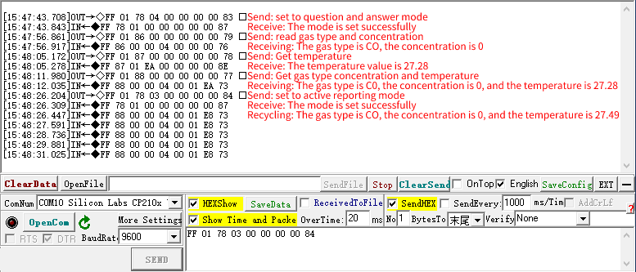

① 0x78——Modify terminal communication mode
The terminal has two communication modes, active uploading and question and answer. The factory default is active uploading mode, and data is sent every 1s.
Send
Byte0 | Byte1 | Byte2 | Byte3 | Byte4 | Byte5 | Byte6 | Byte7 | Byte8
Start bit | addr | Command | Communication mode | -- | -- | -- | -- | Check value
0xFF | 0x01 | 0x78 | Active upload mode: 0x03  Question and answer mode: 0x04 | 0x00 | 0x00 | 0x00 | 0x00 | 0x84  0x83
EXP.FF 01 78 03 00 00 00 00 84 (switch to initiative mode)
EXP.FF 01 78 04 00 00 00 00 83 (switch to passive mode)
Return
Byte0 | Byte1 | Byte2 | Byte3 | Byte4 | Byte5 | Byte6 | Byte7 | Byte8
Start bit | Command | Back to calibration | -- | -- | -- | -- | -- | Check value
0xFF | 0x78 | Success: 0x01  Failure: 0x00 | 0x00 | 0x00 | 0x00 | 0x00 | 0x00 | 0x87  0x88
EXP.FF 78 01 00 00 00 00 00 87

② Initiative mode，Data Format
In the active upload mode, the terminal will return data every 1s. The data format is as follows.
Return
Byte0 | Byte1 | Byte2 | Byte3 | Byte4 | Byte5 | Byte6 | Byte7 | Byte8
Start bit | Command | Gas concentration  high bit | Gas concentration  low bit | Gas type | Decimal places | Temperature value  High | Temperature value  lower | Check value
0xFF | 0x88 | 0x00 | 0x00 | 0x00 | 0x00 | 0x00 | 0x00 | --
Note:
- Gas concentration value = (high gas concentration x 256 + low gas concentration) x resolution
- The decimal place is 0, the resolution is 1; the decimal place is 1, the resolution is 0.1; the decimal place is 2, the resolution is 0.01
- For the calculation method of temperature value, please refer to the sample code below: "Calculation of temperature value"
Gas Type Table
Gas Type | Command | Gas Type | Command
NH3 | 0x02 | SO2 | 0x2B
H2S | 0x03 | NO2 | 0x2C
CO | 0x04 | HCL | 0x2E
O2 | 0x05 | CL2 | 0X31
H2 | 0x06 | HF | 0x33
O3 | 0x2A | PH3 | 0x45

③ 0x86——Passive mode,Read gas concentration data
In the question and answer mode, you need to send commands to read various parameters of the terminal. The method of reading the gas concentration is as follows.
Send
Byte0 | Byte1 | Byte2 | Byte3 | Byte4 | Byte5 | Byte6 | Byte7 | Byte8
Start bit | addr | Command | -- | -- | -- | -- | -- | Check value
0xFF | 0x01 | 0x86 | 0x00 | 0x00 | 0x00 | 0x00 | 0x00 | 0x79
EXP.FF 01 86 00 00 00 00 00 79
Return
Byte0 | Byte1 | Byte2 | Byte3 | Byte4 | Byte5 | Byte6 | Byte7 | Byte8
Start bit | Command | Gas concentration  high bit | Gas concentration  low bit | Gas type | Decimal places | -- | -- | Check value
0xFF | 0x86 | 0x00 | 0x00 | 0x00 | 0x00 | 0x00 | 0x00 | 0x7A
EXP.FF 86 00 00 00 00 00 00 7A
Note:
- Gas concentration value = (high gas concentration x 256 + low gas concentration) x resolution
- The decimal place is 0, the resolution is 1; the decimal place is 1, the resolution is 0.1; the decimal place is 2, the resolution is 0.01

④ 0x87——Passive mode,Read temperature data
In the question and answer mode, you need to read various parameters of the terminal by sending commands. The terminal integrates the thermistor, which can obtain the real-time temperature of the terminal. The way to read the terminal temperature is as follows.
Send
Byte0 | Byte1 | Byte2 | Byte3 | Byte4 | Byte5 | Byte6 | Byte7 | Byte8
Start bit | addr | Command | -- | -- | -- | -- | -- | Check value
0xFF | 0x01 | 0x87 | 0x00 | 0x00 | 0x00 | 0x00 | 0x00 | 0x78
EXP.FF 01 87 00 00 00 00 00 78
Return
Byte0 | Byte1 | Byte2 | Byte3 | Byte4 | Byte5 | Byte6 | Byte7 | Byte8
Start bit | Command | Temperature data  high bit | Temperature data  low bit | -- | -- | -- | -- | Check value
0xFF | 0x87 | 0x00 | 0x00 | 0x00 | 0x00 | 0x00 | 0x00 | 0x79
EXP.FF 87 00 00 00 00 00 00 79
Note:
For the calculation method of temperature value, please refer to the sample code below: "Calculation of temperature value"

⑤ 0x88——Passive mode,Read temperature and gas concentration data
In the question and answer mode, you need to read various parameters of the terminal by sending commands, and the way to read the temperature and gas concentration data of the terminal is as follows.
Send
Byte0 | Byte1 | Byte2 | Byte3 | Byte4 | Byte5 | Byte6 | Byte7 | Byte8
Start bit | addr | Command | -- | -- | -- | -- | -- | Check value
0xFF | 0x01 | 0x88 | 0x00 | 0x00 | 0x00 | 0x00 | 0x00 | 0x77
EXP.FF 01 88 00 00 00 00 00 77
Return
Byte0 | Byte1 | Byte2 | Byte3 | Byte4 | Byte5 | Byte6 | Byte7 | Byte8
Start bit | Command | Gas concentration  high bit | Gas concentration  low bit | Gas type | Decimal places | Temperature value  High | Temperature value  lower | Check value
0xFF | 0x88 | 0x00 | 0x00 | 0x00 | 0x00 | 0x00 | 0x00 | 0x78
EXP. FF 88 00 00 00 00 00 00 78
Note:
- Gas concentration value = (high gas concentration x 256 + low gas concentration) x resolution
- The decimal place is 0, the resolution is 1; the decimal place is 1, the resolution is 0.1; the decimal place is 2, the resolution is 0.01
- For the calculation method of temperature value, please refer to the sample code below: "Calculation of temperature value"

⑥ 0x89——Configure threshold alarm function
The terminal has a threshold alarm function, the alarm threshold and judgment logic can be configured. The configuration method is as follows,After the configuration is successful, the entire system needs to be powered on again to take effect.
Note: When no external controller is connected and only the sensor is used to achieve this function, the sensor must be set to active upload mode after the parameters related to the threshold alarm function are configured.
Send
Byte0 | Byte1 | Byte2 | Byte3 | Byte4 | Byte5 | Byte6 | Byte7 | Byte8
Start bit | Empty | Command | Function switch setting | Alarm concentration threshold  high bit | Alarm concentration threshold  low bit | -- | -- | Check value
0xFF | 0x01 | 0x89 | On: 0x01  Off: 0x00 | 0x00 | 0x00 | 0x00 | 0x00 | 0x71  0x70
EXP. FF 01 89 00 00 05 00 00 71 (turn off the alarm function)
EXP. FF 01 89 01 00 05 00 00 70 (open the alarm function)
Please refer to ⑤ for how to calculate the concentration.
Return
Byte0 | Byte1 | Byte2 | Byte3 | Byte4 | Byte5 | Byte6 | Byte7 | Byte8
Start bit | Command | Return configuration result | Function switch status | Alarm concentration threshold  high bit | Alarm concentration threshold  low bit | -- | -- | Check value
0xFF | 0x89 | Success: 0x01  Failure: 0x00 | On: 0x01  Off: 0x00 | 0x00 | 0x00 | 0x00 | 0x00 | --
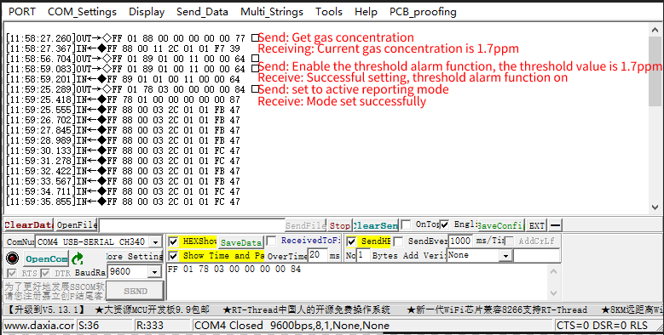
To configure the threshold alarm by code using a controller such as Raspberry Pi, you can use this python code: GAS_ALA.zip

Checksum calculation
Check value = (inverted (byte 1 + byte 2 + ··· ··· + byte 7) + 1
The reference routine is as follows:
/******************************************************************
* Function name: unsigned char FucCheckSum(uchar *i,ucharln)
* Function description: Sum check (reverse the sum of 1\2\3\4\5\6\7 of the sending and receiving protocol + 1)
* Function description: reverse the sum of the array element 1 to the penultimate element and plus 1 (the number of elements must be greater than 2)
******************************************************************/
char data[] = {0xFF,0x01,0x89,0x00,0x00,0x05,0x00,0x00};

unsigned char FucCheckSum(unsigned char *i,unsigned char ln)
{
unsigned char j,tempq=0;
i+=1;
for(j=0;j<(ln-2);j++)
{
tempq+=*i;
i++;
}
tempq=(~tempq)+1;
return(tempq);
}

void setup() {
Serial.begin(115200);
Serial.println(FucCheckSum(data,8),HEX);
}

void loop() {

}
Copy

Calculation of temperature value
byte Temp_H = 0x01;//Temperature data high bit
byte Temp_L = 0xD9;//Temperature data low bit

void setup() {
Serial.begin(115200);
uint16_t temp_ADC = (Temp_H << 8) + Temp_L;
float Vpd3 = 3 * (float)temp_ADC / 1024;
float Rth = Vpd3 * 10000 / (3 - Vpd3);
float Temp = 1 / (1 / (273.15 + 25) + 1 / 3380.13 * log(Rth / 10000)) - 273.15;
Serial.println(Temp);
}

void loop() {

}

