DC5V 4020 Hydraulic Centrifugal Fan with XH2.54-2P 30CM Cable
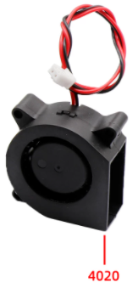
Specification
Voltage: DC 5V
Rated current: 0.19A
Size: 40*40*20MM
Power consumption: 0.95W
Speed: 6000±5%RPM
Noise: 25.3DBA
Weight: 22.6g
Lifespan: 28000 hours 40℃
Bearing structure: hydraulic bearing
Wiring: red wire positive, black wire negative
Temperature range: -10 to +60℃
Storage Humidity: 5 to 95%RH

Dimensional drawings
