SKU：110061363

Short description
Jetson-20-1-H1 is a hand-size edge AI box built with Jetson Xavier NX 8GB module, rich set of IOs, aluminium case, cooling fan, pre-installed JetPack System, ready for your next AI application development and deployment.

PRODUCT DETAILS
Note:
- We will not include a power cord, please choose a suitable form according to your country.
- We will not include a 3V RTC battery (CR1220).

Features
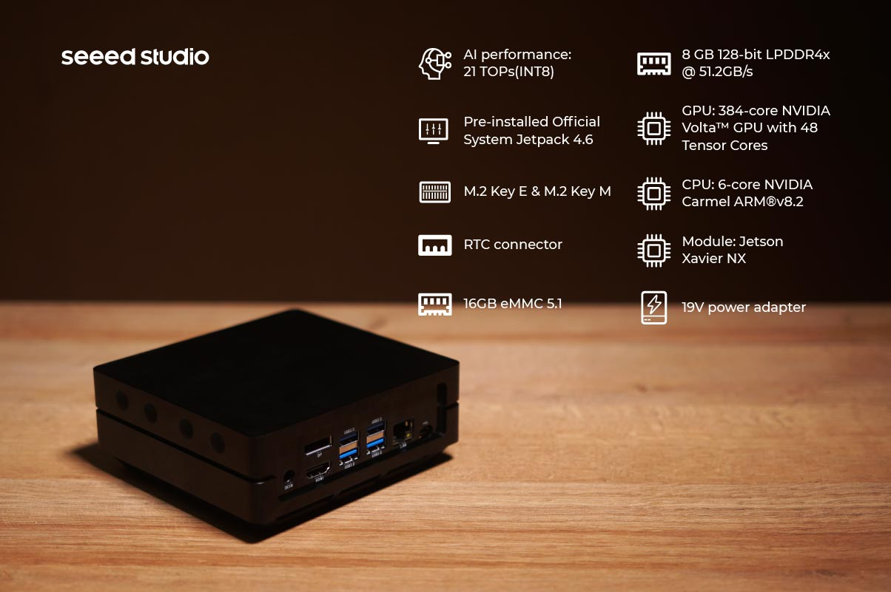

- Hand-size edge AI device with an overall dimension of 130mm*120mm*50mm, fits in everywhere.
- Powered by the 6-core NVIDIA Carmel ARM®v8.2 64-bit CPU 6MB L2 + 4MB L3.
- 384-core NVIDIA Volta™ GPU with 48 Tensor Cores delivers 21 TOPS AI performance.
- Rich peripherals including Gigabit Ethernet port, 4 USB 3.0 Type-A ports, HDMI port and DP ports.
- Pre-installed NVIDIA official JetPack software, ready for cloud native application.
- Able to mount on the wall with mounting holes on the back.
- Support wide range of AI application fast building with our ecosystem partners.
- Support Allxon to enable efficient remote hardware management services.

Note:
- We have already installed JetPack 4.6 system.

Description
reComputer Jetson series are compact edge computers built with NVIDIA advanced AI embedded systems: Jetson-10 (Nano) and Jetson-20 (Xavier NX). With rich extension modules, industrial peripherals, thermal management combined with decades of Seeed’s hardware expertise, reComputer Jetson is ready to help you accelerate and scale the next-gen AI product emerging diverse AI scenarios.
reComputer Jetson is compatible with the entire NVIDIA Jetson software stack, cloud-native workflows, industry-leading AI frameworks, helping deliver seamless AI integration.

Application: For next-gen autonomous machine
With edge AI developers can deploy machine learning models in solving demanding challenges for advanced robotics and autonomous machines in the fields:
Edge AI into the Wild: UAV, Drone, Wildlife protection,Agriculture
Smart City: Traffic,Retail, Healthcare
Industry 4.0:Manufacturing, Logistics, Deliver, Service
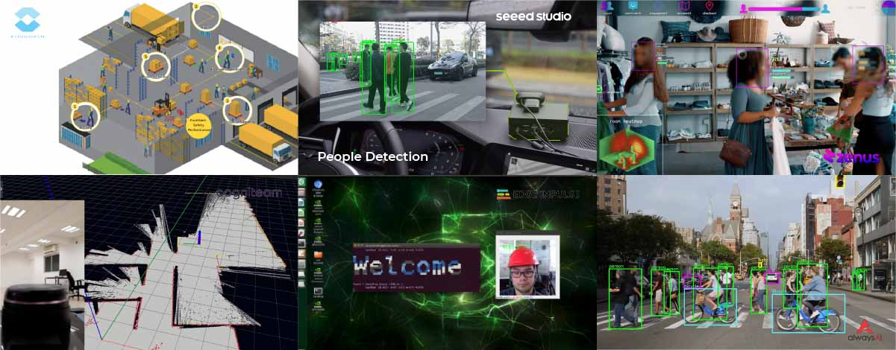

Comparison between jetson-20-1-H1 and Xavier NX dev kit：
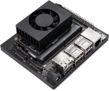 | 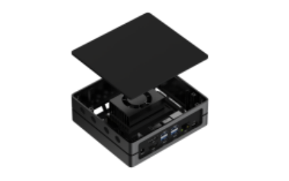
NVIDIA Jetson Xavier NX Developer Kit | reComputer Jetson-20-1-H1
Xavier NX (not production version) | Xavier NX (production version)
21 TOPS
384-core NVIDIA Volta™ GPU
6-core NVIDIA Carmel ARM®v8.2 64-bit CPU 6 MB L2 + 4 MB L3
8 GB 128-bit LPDDR4x @ 51.2GB/s | 8 GB 128-bit LPDDR4x @59.7GB/s
microSD (Card not included) | 16 GB eMMC
2x 4K @ 30 | 6x 1080p @ 60 | 14x 1080p @ 30 (H.265/H.264) | 2x 4K60 | 4x 4K30 | 10x 1080p60 | 22x 1080p30 (H.265)  2x 4K60 | 4x 4K30 | 10x 1080p60 | 20x 108p30 (H.264)
2x 4K @ 60 | 4x 4K @ 30 | 12x 1080p @ 60 | 32x 1080p @ 30 (H.265)  2x 4K @ 30 | 6x 1080p @ 60 | 16x 1080p @ 30 (H.264) | 2x 8K30 | 6x 4K60 | 12x 4K30 | 22x 1080p60 | 44x 1080p30 (H.265)  2x 4K60 | 6x 4K30 | 10x 1080p60 | 22x 1080p30 (H.264)
1*RJ45 Gigabit Ethernet Connector (10/100/1000)
4 * USB 3.1 Type A Connectors;  1 * Micro-USB port for Device mode; | 4 * USB 3.0 Type A Connectors；  1 * Micro-USB port for Device mode;
2*CSI Camera (15 pos, 1mm pitch, MIPI CSI-2 )
1*HDMI Type A+ 1*DP
1* FAN(5V PWM)
1*M.2 Key E(WiFi/BT included) | 1*M.2 Key E
1*M.2 Key M
- | 1*RTC Socket
1* 40-Pin header
DC Jack 19V 90W 4.74A MAX
103 mm x 90.5 mm x 31 mm | 130mm x120mm x 50mm(with case)

Power-efficient AI computer, compact rich I/Os for endless AI possibilities:

reComputer Jetson - 20 comes with Jetson Xavier NX delivers up to 21 TOPS, making it ideal for high-performance compute and AI in embedded and edge systems. You get the performance of 384 NVIDIA CUDA® Cores, 48 Tensor Cores, 6 Carmel ARM CPUs, and two NVIDIA Deep Learning Accelerators (NVDLA) engines. Combined with over 59.7GB/s of memory bandwidth, video encoded and decoded, these features make Jetson Xavier NX the platform of choice to run multiple modern neural networks in parallel and process high-resolution data from multiple sensors simultaneously.

Jetson Xavier NX supports multiple power modes, including low-power modes for battery-operated systems, and delivers up to 14 TOPs for AI applications in as little as 10 W.

Powerful reference carrier board :
Seeed reference carrier board for Jetson-20-1-H1 is a high-performance, interface rich NVIDIA Jetson Xavier NX compatible carrier board, providing HDMI 2.0, Gigabit Ethernet, USB3.0, USB 2.0, M.2 key E wifi / BT, M.2 key M, CSI camera, CAN, GPIO, I2C, I2S, fans, and other rich peripheral interfaces. It has the same functional design and size as the carrier board of NVIDIA® Jetson Xavier™ NX DEVELOPER KIT.
Take advantage of the small form factor, sensor-rich interfaces, and big performance to bring new capability to all your embedded AI and edge systems.

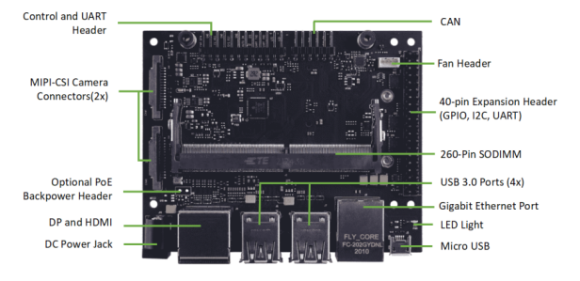
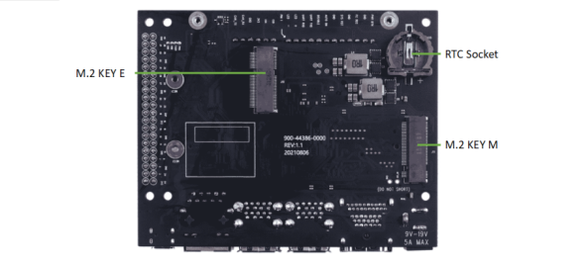

Desktop, Wall Mount, or fit in anywhere
With an overall dimension of 130mm*120mm*50mm, it is only around 1/10 of the size of an ordinary computer case which makes it possible to fit in edge AI scenarios. The back screw holes allow you to hang the product as you need. We also provide other editions case like blue, silver and silver mental, whose stackable structure allows you to stack more middle layers to create rooms very easily.
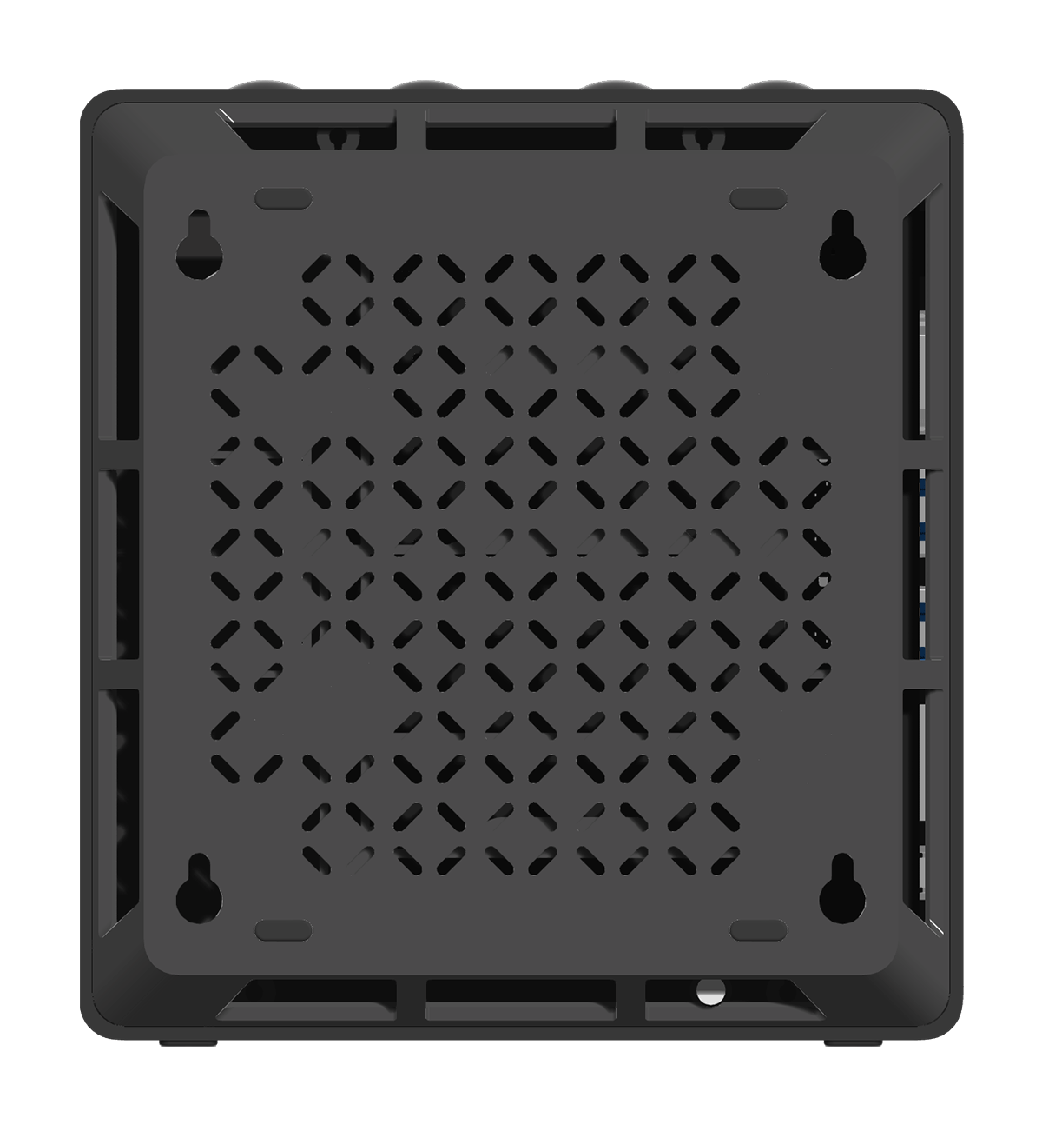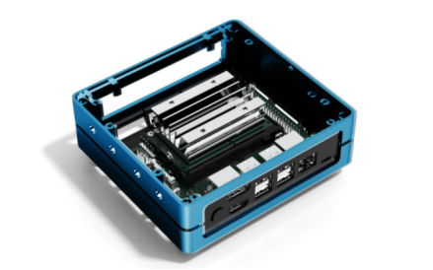

Prebuild system for edge AI integration

All NVIDIA® Jetson™ modules and developer kits are supported by the same software stack, enabling you to develop once and deploy everywhere. Jetson Software is designed to provide end-to-end acceleration for AI applications and accelerate your time to market. We bring the same powerful NVIDIA technologies that power data center and cloud deployments to the edge.
NVIDIA JetPack includes NVIDIA Container Runtime with Docker integration, enabling GPU accelerated containerized applications on Jetson platform. Jetpack also brings support for NVIDIA Triton™ Inference Server to simplify the deployment of AI models at scale.
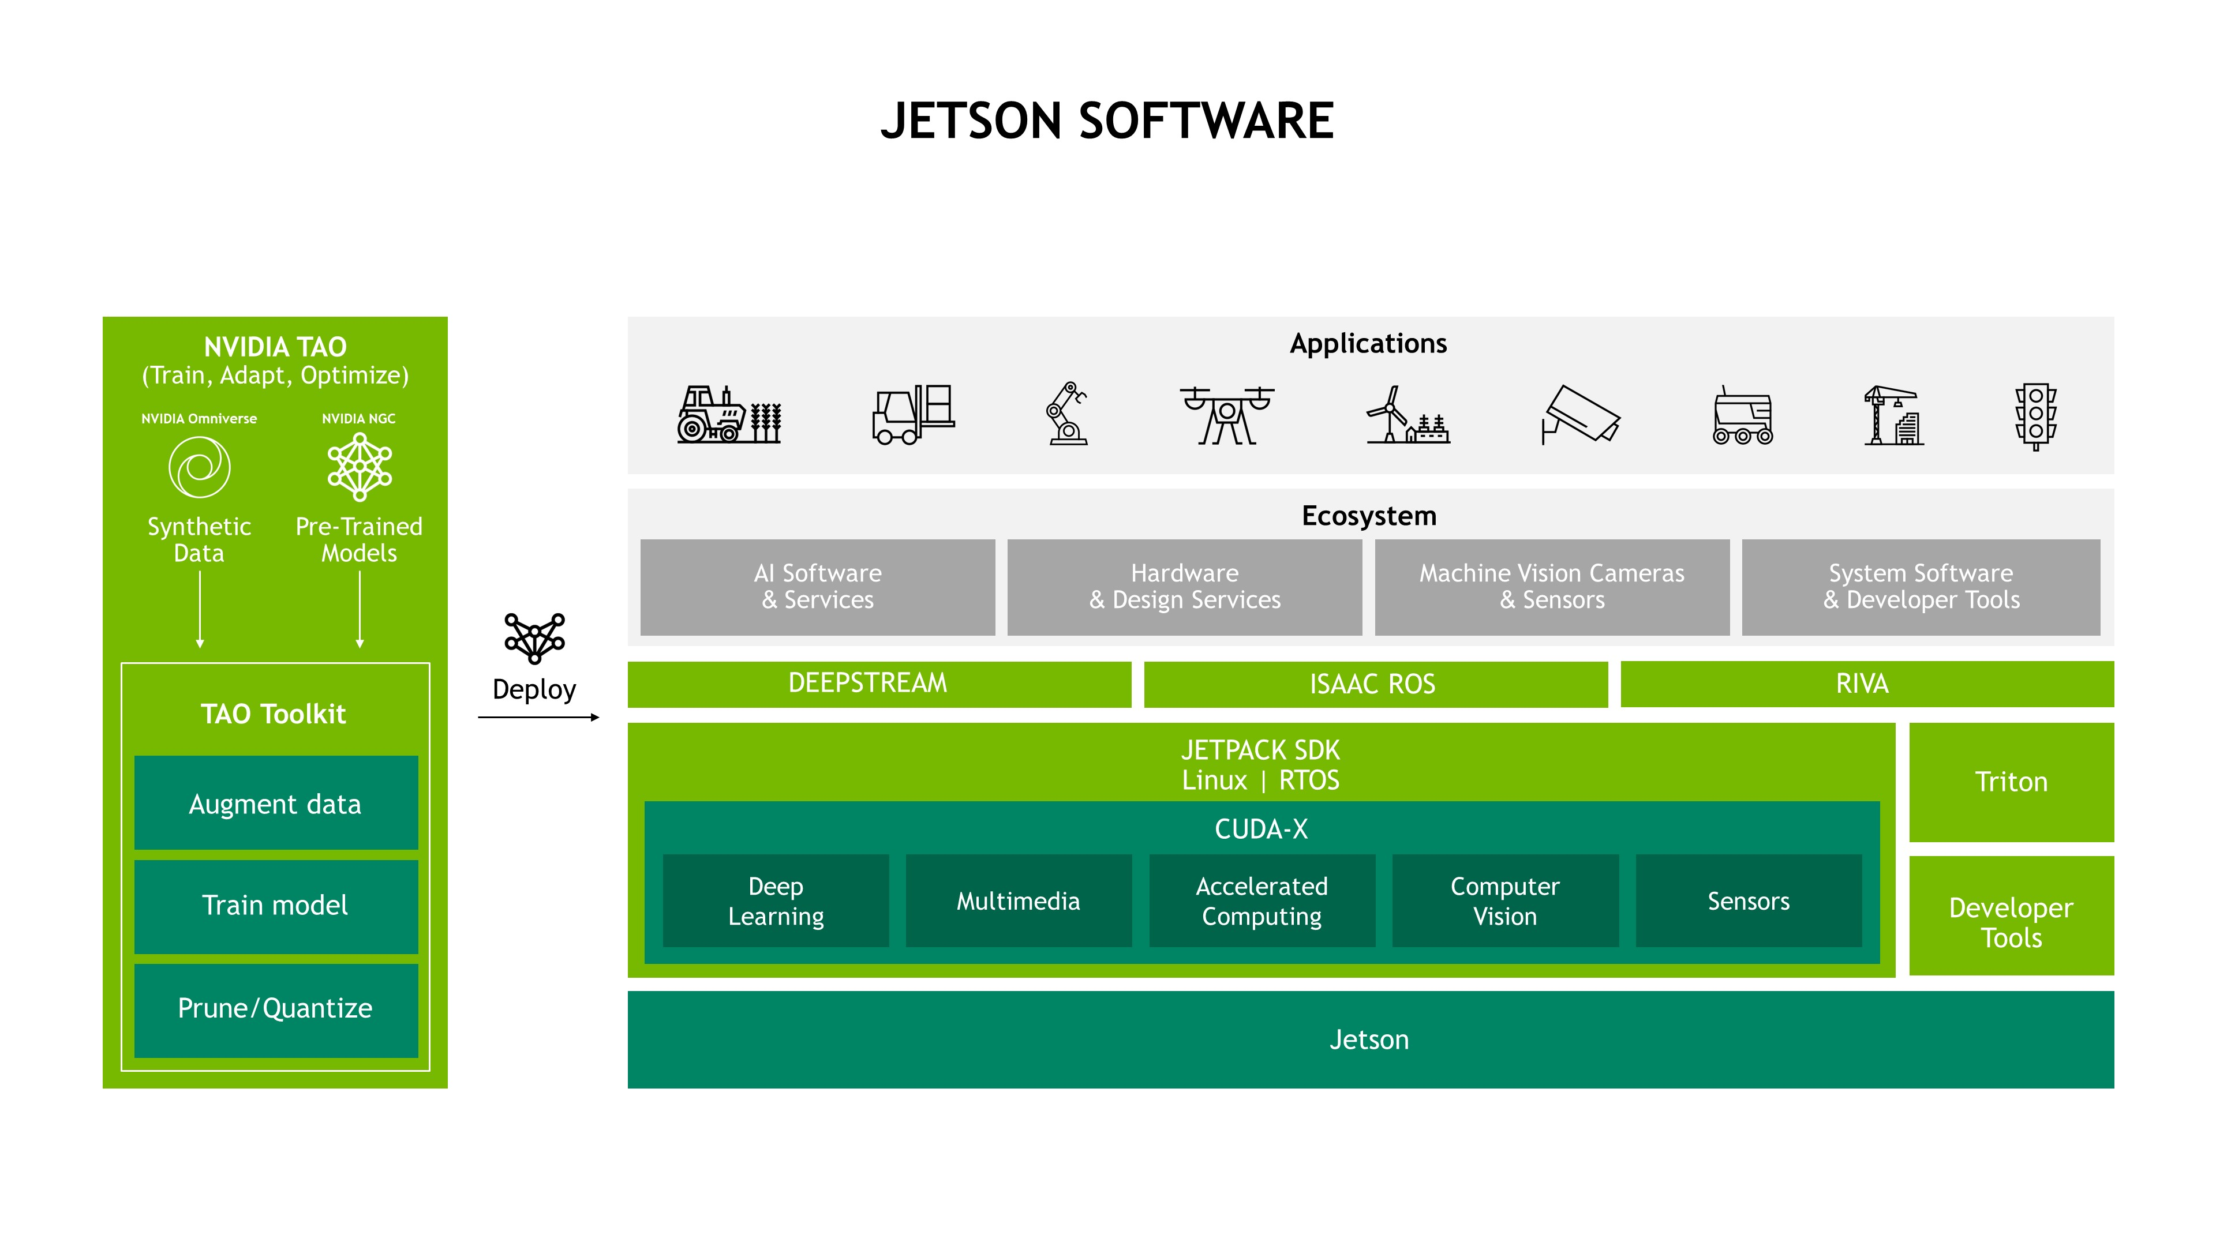

NVIDIA Jetson powered Edge AI platform at Seeed
At Seeed, you will find everything you want to work with NVIDIA Jetson Platform – official NVIDIA Jetson Dev Kits, Seeed-designed carrier boards, and edge devices, as well as accessories.
Seeed will continue working on the Jetson product line and will be ready to combine our partners’ unique technology with Seeed’s hardware expertise for an end-to-end solution.

Work with Seeed Ecosystem
Deploying an AI idea can be faster, flexible, even scalable for everyone. Seeed Jetson Platform targets on helping educators, developers and enterprises deploy ML in the real-world. By consolidating Seeed’s best-in-class hardware, cutting-edge technology from our software partners and all developers from the community, we aim at emerging all kinds of AI scenarios in our open-source platform to faster industries digital transformation. We are looking for partners to join our ecosystem together to deliver solutions to different industries together. Please contact cooperation@seeed.cc for more partnership ecosystem information.

Specifications
Module Technical Specifications
 | Jetson Xavier NX
AI Performance | 21 TOPS
GPU | 384-core NVIDIA Volta™ GPU with 48 Tensor Cores
CPU | 6-core NVIDIA Carmel ARM®v8.2 64-bit CPU 6MB L2 + 4MB L3
Memory | 8 GB 128-bit LPDDR4x 59.7GB/s
Storage | 16 GB eMMC 5.1
Power | 10 W | 15 W | 20 W
PCIe | 1 x1 (PCIe Gen3) + 1 x4 (PCIe Gen4), total 144 GT/s*
CSI Camera | Up to 6 cameras (24 via virtual channels)  14 lanes (3x4 or 6x2) MIPI CSI-2, D-PHY 1.2 (up to 30 Gbps)
Video Encode | 2x 4K60 | 4x 4K30 | 10x 1080p60 | 22x 1080p30 (H.265)  2x 4K60 | 4x 4K30 | 10x 1080p60 | 20x 1080p30 (H.264)
Video Decode | 2x 8K30 | 6x 4K60 | 12x 4K30 | 22x 1080p60 | 44x 1080p30 (H.265)  2x 4K60 | 6x 4K30 | 10x 1080p60 | 22x 1080p30 (H.264)
Display | 2 multi-mode DP 1.4/eDP 1.4/HDMI 2.0
DL Accelerator | 2x NVDLA Engines
Vision Accelerator | 7-Way VLIW Vision Processor
Networking | 10/100/1000 BASE-T Ethernet
Mechanical | 260-pin SO-DIMM connector 69.6 mm x 45 mm
Carrier Board Technical Specifications
Connector | Jetson-20-1-H1 | NVIDIA® Jetson Xavier™ NX DEVELOPER KIT
Jetson module connector | 1*Jetson SODIMM connector, 260-pin | 1*Jetson SODIMM connector, 260-pin
USB 3.0 Type A | 4*USB 3.0 Type-A Connector | 4*USB 3.0 Type-A Connector
USB Micro Type B | 1*USB Micro B, RA Female | 1*USB Micro B, RA Female
Ethernet Port | 1*RJ45 Gigabit Ethernet Connector (10/100/1000) | 1*RJ45 Gigabit Ethernet Connector (10/100/1000)
Display Port | 1*HDMI type A and 1*DP | 1*HDMI type A and 1*DP
CSI Camera Connector | 2*CSI Camera (15 pos, 1mm pitch, MIPI CSI-2 ) | 2*CSI Camera (15 pos, 1mm pitch, MIPI CSI-2 )
M.2 Key E | 1*M.2 Key E Slot (75-pin) 2230 | 1*M.2 Key E Slot (75-pin) 2230
M.2 Key M | 1*M.2 Key M Slot (75-pin) NVME 2280 | 1*M.2 Key M Slot (75-pin) NVME 2280
Multifunctional Port | 2.0 Pitch 40 PIN | 2.0 Pitch 40 PIN
Button Header | 1*Button Header | 1*Button Header
FAN Connector | 1*Picoblade Header | 1*Picoblade Header
CAN | 1*CAN Bus Header (1x4, 2.54mm pitch, RA) | Reserved
RTC | 1*RTC Back-up Coin Cell Socket (CR1220) | Reserved
Power | 1*DC Input Power TE Connector | 1*DC Input Power TE Connector

Part List
1 x Acrylic Cover
1 x Aluminium Frame
1 x Jetson Xavier NX module
1 x Heatsink
1 x Carrier board
1 x 19V/4.74A (MAX 90W) Power Adapter (Power cable not included)

