How To Install
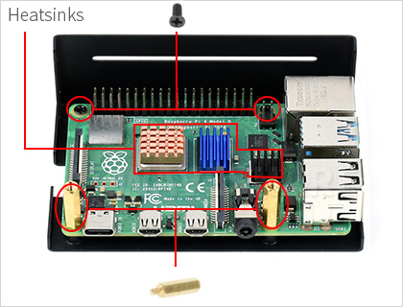
1. Attach heatsinks to the Pi, then put it on the bottom case, and fix it with screws and standoffs

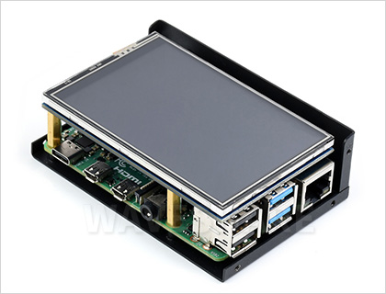
2. Attach the Waveshare 3.5inch display via the Raspberry Pi GPIO header

3. Put on the top lid, make sure the Raspberry Pi connectors and screw holes are aligned

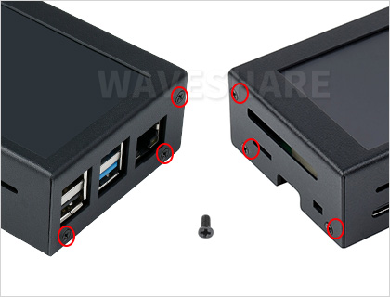
4. Fix the remaining screws

------------------------------------------------------------------------------------
Outline Dimensions




