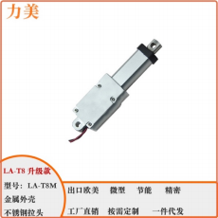
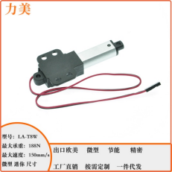

Electric Pushrod LA-T8 (plastic case) & LA-T8M (metal case) & LA-T8W(with wings)
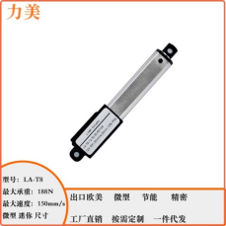
Product Parameter:

Model number | LA-T8 (regular style) & LA-T8M (Metal style) & LA-T8W(with wings) Electric pushrod
Voltage & Power & current | 6VDC/12VDC/24VDC, power: 2.5W working current ≤200mA, plugging current 330mA
Maximum bearing capacity | 188N=18KG= 18kg
Maximum speed | 150 mm per second
Limit switch | Built-in flexible limit switch, power off stop and self-lock
Can it be made to order | Can be customized, and accept OEM
Inner tube material | Aluminum material
Frequency of operation | 10%, up to 2 minutes of continuous work, requiring 18 minutes of rest. (Optimal operating frequency)
Maximum useful life | Up to 5W times (because the actual application situation is different, this number of life is only for reference)
Existing itinerary | 10/17.5/21/25/30/50/75/100/150mm
Ambient temperature | -25 ℃ ~ +60℃
Noise | About 60dB
Warranty period | 1 year, life-long technical support
Authentication | CE RoHS

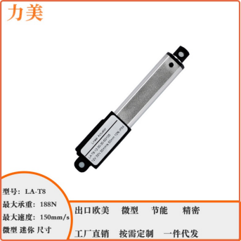
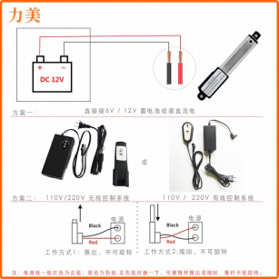

Control mode of push rod:：

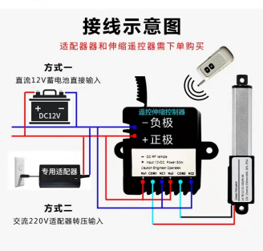

LA-T8: (plastic shell)
Advantages
→ Compact internal structure
→ Simple control mode
→ Low voltage
→ The push and pull forces are equal
→ Easy installation
→ The volume is very small, small installation distance
→ Although the volume is small, but the thrust is relatively large
Where applicable
→ Robot
→ Automation equipment
→ Toys
→ Industrial automation equipment
→ Trash can
→ Vending machines
→ Used for products with limited installation space

Parameters: 10/17.5/21/25/30/50/75/100 stroke all applicable to the following specifications: Voltage :6VDC/ 12VDC/ 24VDC

model | load bearing:  N | no-load speed:  mm/s | Operating frequency:  % | Current：12V | blocking current
LA-T8-A | 188 | 5 | 10%, continuous work for 2 minutes, need to rest for 18 minutes | 200mA | 330mA
LA-T8-B | 128 | 7
LA-T8-C | 96 | 9.5
LA-T8-D | 64 | 15
LA-T8-E | 32 | 30
LA-T8-F | 19.2 | 50
LA-T8-G | 6.4 | 150
Voltage :12VDC/ 24VDC (now only LA-T8 conventional style and LA-T8W style with wings can travel 150mm

model | load bearing:  N | no-load speed:  mm/s | Operating frequency:  % | Current：12V | blocking current
LA-T8-A | 150 | 5 | 10%, continuous work for 2 minutes, need to rest for 18 minutes | 200mA | 330mA
LA-T8-B | 64 | 15
LA-T8-C | 32 | 30
Plastic shell LA-T8 dimensions:
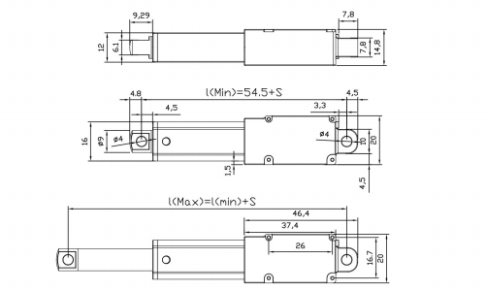

Minimum installation distance Lmin = 54.5mm+ stroke
The minimum mounting distance refers to the hole center distance of the two mounting holes after 100% retraction of the push rod

Maximum installation distance Lmax = minimum installation distance + stroke
The minimum mounting distance refers to the hole center distance of the two mounting holes after the push rod is pushed out 100%

The hole spacing of the installation hole is 4MM. The tolerance of the drawing is ±2mm
Waterproof grade: IP54
1 -- Red power cord -- positive +
2 -- black power cord -- negative-

LA-T8M （metal case） :
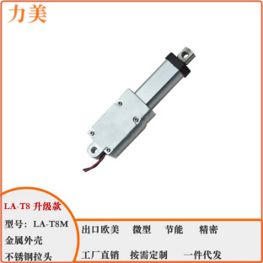

Advantages
→ Compact internal structure
→ Simple control mode
→ Low voltage
→ The push and pull forces are equal
→ Easy installation
→ The volume is very small, small installation distance
→ Although the volume is small, but the thrust is relatively large
Where applicable
→ Robot
→ Automation equipment
→ Toys
→ Industrial automation equipment
→ Trash can
→ Vending machines
→ Used for products with limited installation space

Parameters: 10/17.5/21/25/30/50/75/100 stroke all applicable to the following specifications: Voltage :6VDC/ 12VDC/ 24VDC

model | load bearing:  N | Self-locking force: N | speed:  mm/s | Operating frequency:  % | Current：  12V/6V | blocking current: 12V/ 6V
LA-T8M -A | 188 | 235 | 5 | 10%, continuous work for 2 minutes, need to rest for 18 minutes | 200mA/  400m A | 330mA/  660mA
LA-T8M-B | 128 | 160 | 7
LA-T8M-C | 96 | 120 | 9.5
LA-T8M-D | 64 | 80 | 15
LA-T8M-E | 32 | 40 | 30
LA-T8M-F | 19.2 | 24 | 50
LA-T8M-G | 6.4 | 8 | 150

Metal shell LA-T8M External dimension diagram:
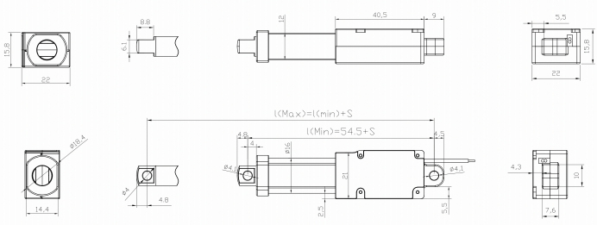
Minimum installation distance Lmin = 54.5mm+ stroke
The minimum mounting distance refers to the hole center distance of the two mounting holes after 100% retraction of the push rod

Maximum installation distance Lmax = minimum installation distance + stroke
The minimum mounting distance refers to the hole center distance of the two mounting holes after the push rod is pushed out 100%

The hole spacing of the installation hole is 4MM. The tolerance of the drawing: ±2mm waterproof grade can reach IP65
1 -- Red power cord -- positive 2 -- black power cord -- negative
Selectable voltage ----- Max voltage ： 6VDC-----7.5VDC 12VDC-----13.5V

LA-T8W （With wings） :
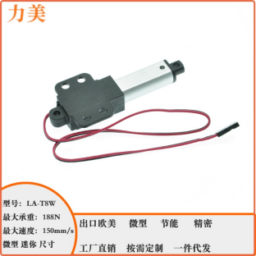
Advantages
→ Compact internal structure
→ Simple control mode
→ Low voltage
→ The push and pull forces are equal
→ Easy installation
→ The volume is very small, small installation distance
→ Although the volume is small, but the thrust is relatively large
Where applicable
→ Robot
→ Automation equipment
→ Toys
→ Industrial automation equipment
→ Trash can
→ Vending machines
→ Used for products with limited installation space

Parameters: 10/17.5/21/25/30/50/75/100 stroke all applicable to the following specifications: Voltage :6VDC/ 12VDC/ 24VDC

model | load bearing:  N | speed:  mm/s | Operating frequency:  % | Current：  12V/6V | blocking current: 12V/ 6V
LA-T8W -A | 188 | 5 | 10%, continuous work for 2 minutes, need to rest for 18 minutes | 200mA | 330mA
LA-T8W-B | 128 | 7
LA-T8W-C | 96 | 9.5
LA-T8W-D | 64 | 15
LA-T8W-E | 32 | 30
LA-T8W-F | 19.2 | 50
LA-T8W-G | 6.4 | 150
参数: 150 行程全部适用以下规格: 电压: 12VDC/ 24VDC

model | load bearing:  N | no-load speed:  mm/s | Operating frequency:  % | Current：12V | blocking current
LA-T8-A | 150 | 5 | 10%, continuous work for 2 minutes, need to rest for 18 minutes | 200mA | 330mA
LA-T8-B | 64 | 15
LA-T8-C | 32 | 30

Dimensions of LA-T8W with wings：

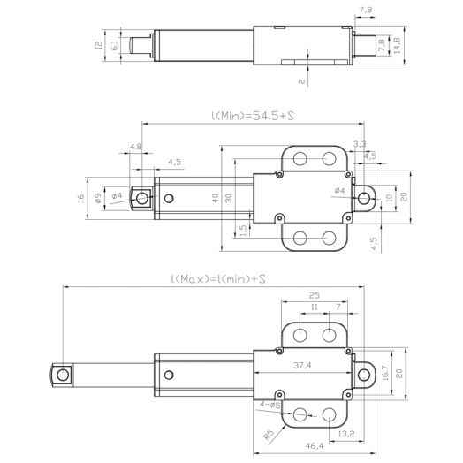

Minimum installation distance Lmin= 54.5mm+ stroke
The minimum mounting distance refers to the hole center distance of the two mounting holes after 100% retraction of the push rod

Maximum installation distance Lmax= minimum installation distance + stroke
The minimum mounting distance refers to the hole center distance of the two mounting holes after the push rod is pushed out 100%
The hole spacing of the installation hole is 4MM. The tolerance of the drawing: ±2mm waterproof grade can reach IP65

1 -- Red power cord -- positive 2 -- black power cord -- negative
Selectable voltage ----- Max voltage ： 6VDC-----7.5VDC 12VDC-----13.5V

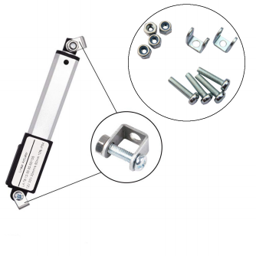
Accessories: Mounting bracket size (purchased separately)

