Single bridge Strain Gauge Sensor Module

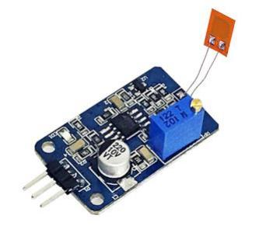

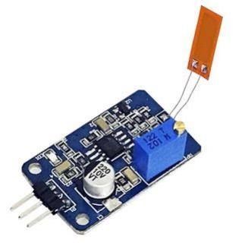

1. Product introduction
There are many types of strain gauges. A general strain gauge is a plastic film called a base
(15~16 um ), a sensitive grid (36 um ) made of thin metal foil is attached , and then covered
A layer of thin film forms a laminated structure.
Attach the strain gauge to the object to be measured so that it expands and contracts along with the strain of the object to be measured . This allows the metal foil inside to lengthen or shorten with strain. Many metals are mechanically Its resistance changes when it stretches or shortens. Strain gauges apply this principle, through The change in resistance is measured to determine the strain. Generally, the sensitive grid of strain gauges uses
For copper-chromium alloys, the resistance change rate is constant and directly proportional to strain.
Attach the strain gauge to the object to be measured so that it bends along with the strain of the object to be measured . This allows the metal foil inside to bend with strain. The resistance of the strain gauge will change when it is bent, and the corresponding output voltage will also change after processing by the conversion module, thus
Measure the bending angle value based on the voltage value.
The strain gauge sensor module converts small resistance changes into voltage signal changes through signal amplification, which can be directly detected by the detection device to measure stress changes. This strain
The chip module can measure bending angle changes in both forward and reverse directions, with high precision and small size.
Ingenious and cost-effective, it is very suitable for use in scientific research, testing, experiments and other occasions.

2. Module introduction and pin definition
Module output voltage range DC 0V~5V , as shown in the figure below, the module description is as follows:

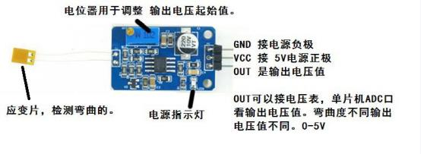

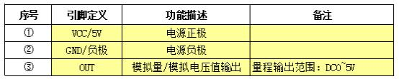

3. Technical parameters of strain gauges

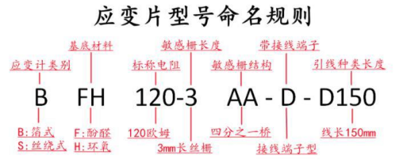

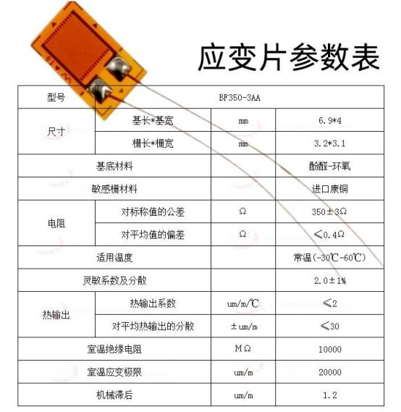

4. Technical indicators of sensor module
1. Module technical parameters
Supply voltage: 5V
Analog output voltage range: DC0V~5V
Initial voltage adjustment potentiometer resistance: 1KΩ
Module size: long 32mm * Width 20mm* height 13.5mm
Hole specification: M2

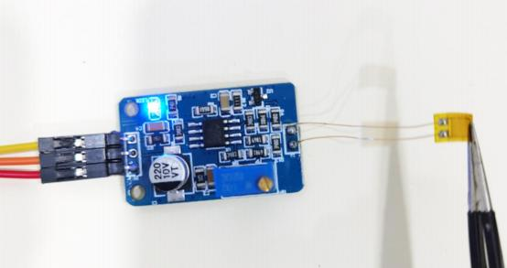

2. How to use the sensor
As the bending angle increases, the deformation amount of the strain gauge will increase accordingly, and the corresponding strain The resistance of the strain gauge will also change, and then the tiny resistance changes will be converted into Replace it with a voltage change to measure the bending angle. How to use strain gauges and modules
It is recommended to follow the steps below.

( 1 ) Connect the strain gauge and strain gauge module and supply 5V voltage.

( 2 ) Adjust the zero point calibration potentiometer with the strain gauge set horizontally to make the AO output
The voltage is around 0V .

( 3 ) Paste the strain gauge and measure. (The voltage value can be measured by a DC voltmeter, It can also be collected through a microcontroller; the forward bending value increases and the reverse bending value decreases.
Small)

3 , module calibration example
( 1 ) Adjust the zero point calibration potentiometer with the strain gauge set horizontally to make the AO output
The voltage is 2V ;

( 2 ) Bending the strain gauge to 90 °, record the output voltage value of AO as 3V ; bending strain The output voltage value of the recorded AO is 1V when sliced to -90 ° . (The microcontroller can be used to collect negative voltage
24 -bit differential ADC conversion chip CS 1237 , see sample code)

( 3 ) Two points determine a straight line to determine the linear relationship: y=90x - 180 ; When the AO output voltage value is 2.5 V , the current bending angle is calculated to be 45°; When the AO output voltage is 1.3V
The bending angle is -63 °.

Precautions
( 1 ) Due to individual differences in sensors, the zero point and the maximum value need to be checked when using them for the first time.
Large value calibration.

( 2 ) Avoid excessive external force operation and damage to the strain gauge.

( ; ) The strain gauge is used with a clip or glued horizontally on the surface of the object (sticky
Please refer to the pasting manual for the pasting method)

*How to convert the analog quantity output by the strain gauge module into strain value?
The output analog value of the strain gauge module can be converted to a strain gauge by using the strain sensitivity coefficient. variable value. The strain sensitivity coefficient is a characteristic parameter of the strain gauge module and represents the unit strain.
The output voltage change corresponding to the value. The strain sensitivity coefficient is usually expressed in units of V/strain.
Bit. Therefore, dividing the output voltage value of the strain gauge module by the strain sensitivity coefficient, we can get
to the strain value.
For example,
If the output voltage value of the strain gauge module is 2.5V,
Strain sensitivity coefficient is 2.0 mV / με ,
Then the strain value is 2.5V/(2.0 mV / με )=1250 με
Therefore, the output analog value of the strain gauge module can be converted into the strain gauge through the strain sensitivity coefficient.
variable value.
It should be noted that the output voltage of the strain gauge module may be affected by environmental factors such as temperature and humidity. are affected by environmental factors, so calibration and correction are required when performing conversion. In addition, the object Parameters such as the geometric shape and the elastic modulus of the material will also affect the conversion results and need to be further refined.
Make reasonable choices and calculations.

