Waveshare Rail-Mount Serial Server, RS485 to WIFI/Ethernet Module, Modbus MQTT Gateway

SKU: 1323455
Features At A Glance:
This is a RS485 device data acquisitor / IoT gateway designed for industrial environment. It combines multi functions in one, including serial server, Modbus gateway, MQTT gateway, RS485 to HTTPD Client, etc. With RS485, WIFI and Ethernet ports, the module can realize functions such as serial to WIFI, serial to Ethernet, Ethernet to WIFI and so on. Using screw terminals for power input, it supports 5~36V wide range power supply. Rail-mount V0 flame-retardant case design, small in size, easy to install. It is suitable for applications like data acquisition, IoT gateway, safety & security IoT, and intelligent instrument monitoring...
-----------------------------------------------------------------------------------------------------------
Specifications:
OUTLINE
Communication interface | RS485, screw terminal
Power supply | 5 ~ 36V DC, screw terminal
Case | PC + ABS, V0 flame retardant grade
Dimensions | L × W × H: 109.66 × 28 × 64.71 mm
COMMUNICATION
Ethernet | 10 / 100M auto-negotiation RJ45 connector
WIFI | 802.11b/g/n compliant
Serial port | RS485 interface (Anti-surge, Lightningproof, Over-current protection)
WIRELESS SPECIFICATION
Frequency Band | 2.412 ~ 2.484 GHz
Wireless network | Station / AP / AP+Station Mode
Security mechanism | WPA-PSK / WPA2-PSK
Encryption type | TKIP / AES
Transmitting power | 802.11b: +19dBm (Max.@11Mbps)  802.11g: +18dBm (Max.@54Mbps)  802.11n: +17dBm (Max.@HT20, MCS7); +17dBm (Max.@HT40, MCS7)
Receiving sensitivity | 802.11b: -89dBm (@11Mbps)  802.11g: -81dBm (@54Mbps)  802.11n: -73dBm (@HT20, MCS7); -71dBm (@HT40, MCS7)
SERIAL SPECIFICATION
Baudrate | 300 ~ 460800 bps
Parity bit | none, odd, even, mark, space
Data bit | 5 ~ 9 bits
Flow control | N/A
SOFTWARE
Protocol | TCP / UDP / ARP / ICMP / DHCP / DNS / HTTP / MQTT
Configuration | host, web browser, serial AT command
Communication method | TCP/IP direct communication, VCOM
Operating mode | Transparent transmission, serial command, HTTPD Client, Modbus TCP to Modbus RTU
ENVIRONMENT REQUIREMENT
Operating temperature | -40℃ ~ 85℃
Storage temperature | -45℃ ~ 125℃
Humidity range | 5% ~ 95% relative humidity

-----------------------------------------------------------------------------------------------------------------------------------------------------------------------------------------------------------------------------------------

RS 485 to wifi/ethernet module
Railmount RS 485 Serial Server , Modbus Gateway, MQTT Gateway
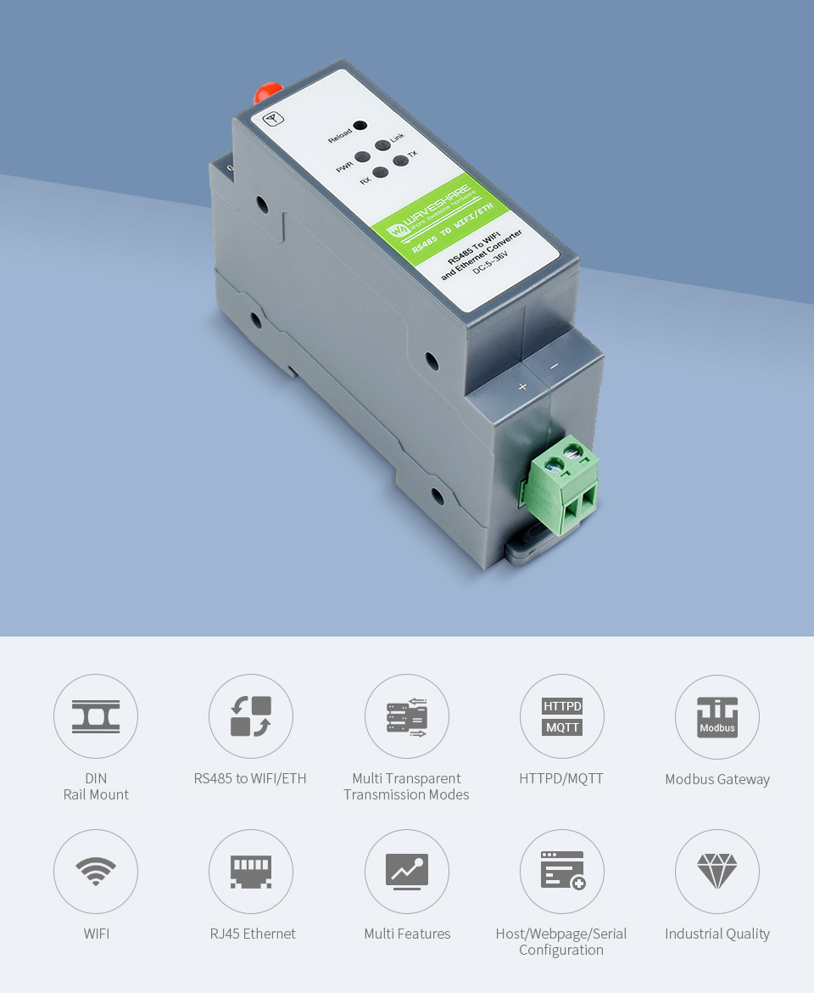

Primary Function:
Support RS485 To WIFI, RS485 To Ethernet, Ethernet To WIFI, Etc.
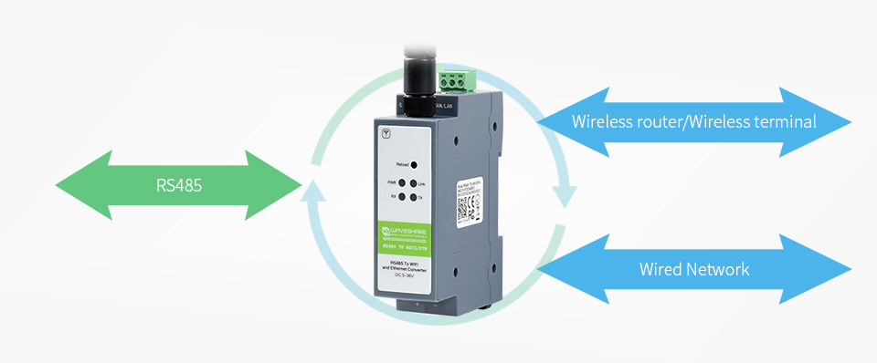

Rail-Mount Serial Server
Industrial Rail-Mount Support, Easy To Install, Compact Size, Cost-Effective
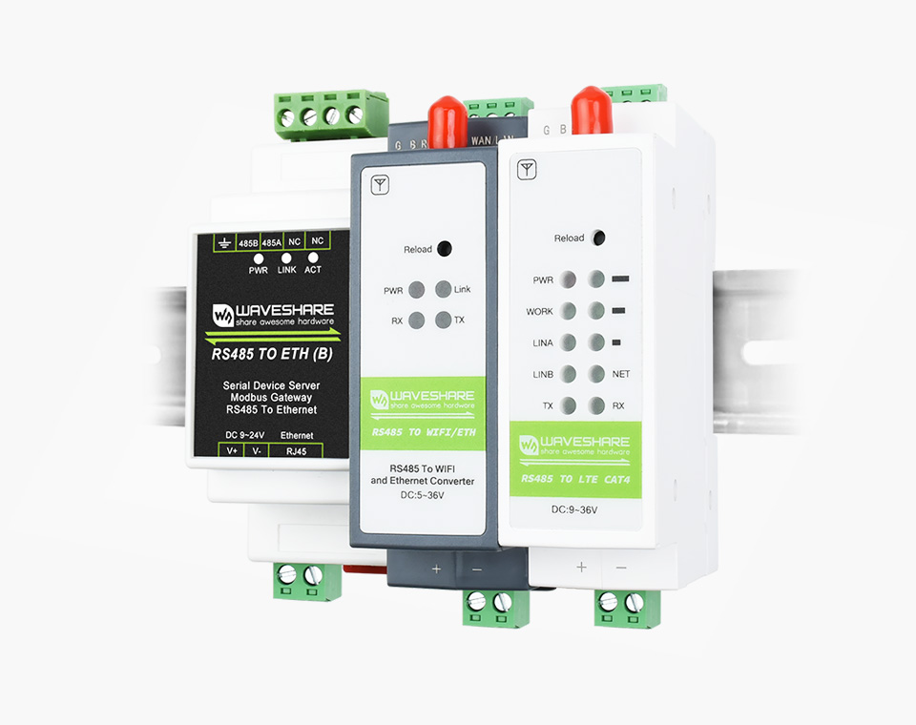
Function Block Diagram
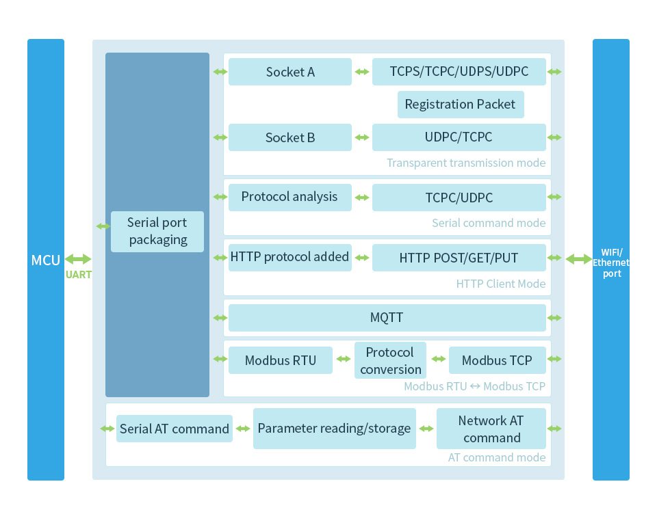
Support Transparent Transmission Mode
Supports TCP Server / TCP Client / UDP Server / UDP Client
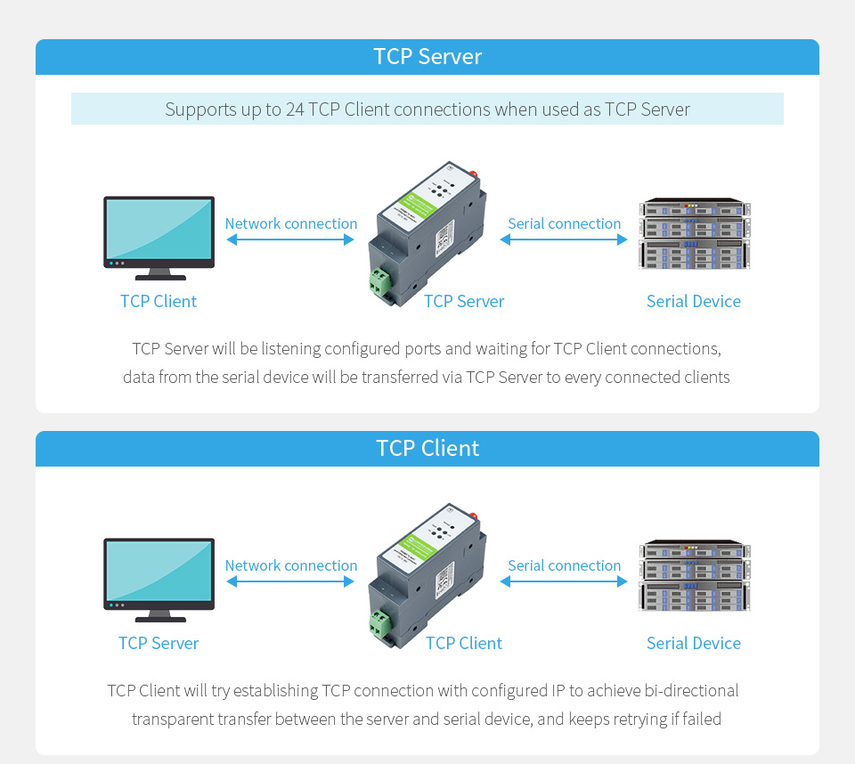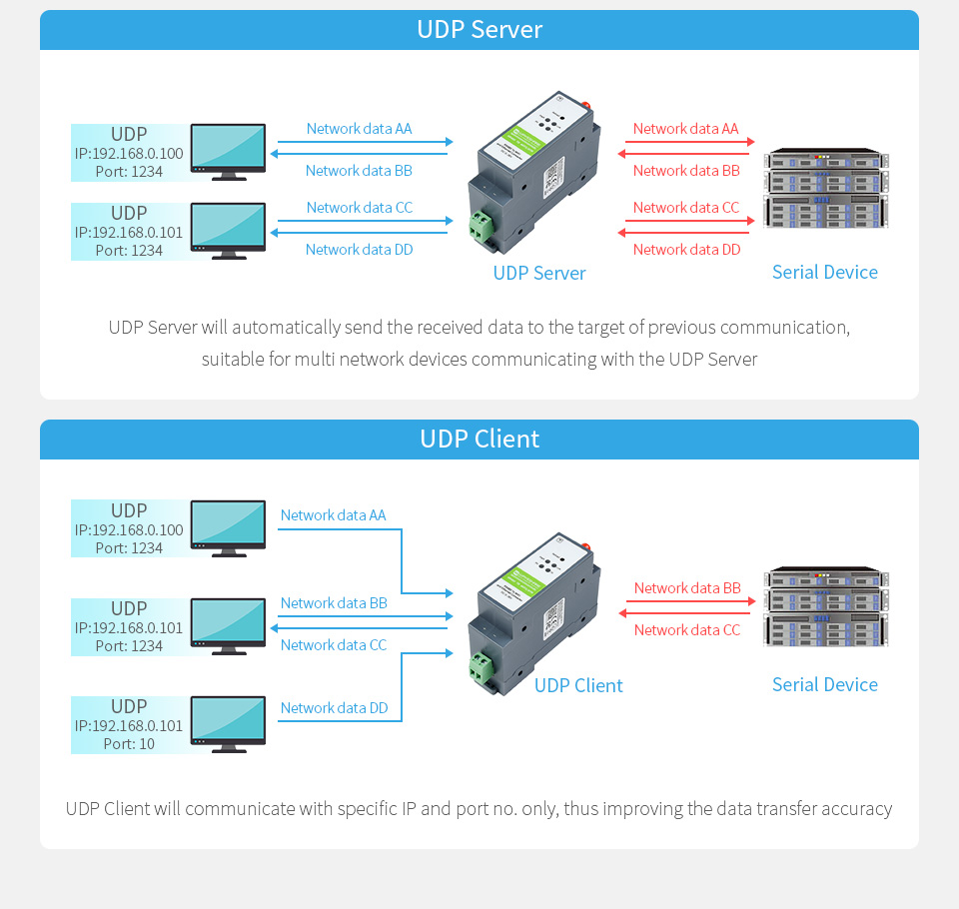
Serial Command Mode
The user sends data to the server according to the protocol
Send data to different servers without restarting
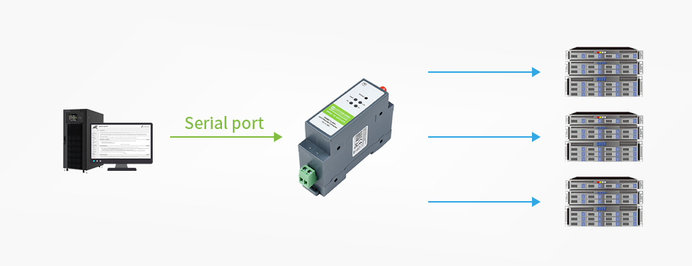
Support HTTPD Client Mode
After the user has set the HTTP header through AT commands or web page, the module can send data to the HTTP server, or obtain data from the HTTP server
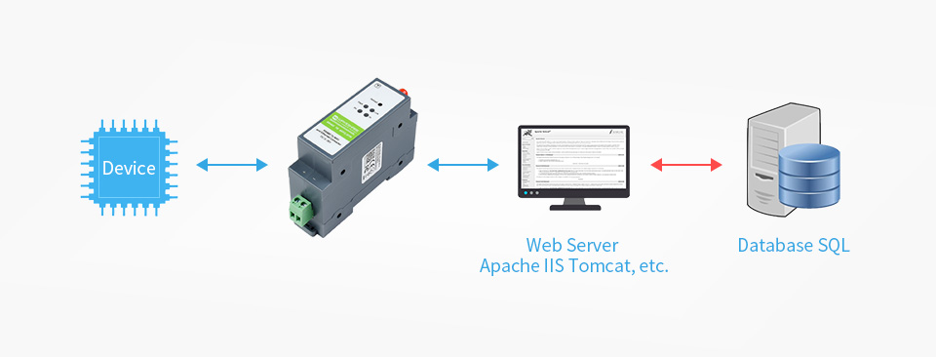
Support MQTT Function
Devices can subscribe to other MQTT client messages, and can publish topic information to the server. Supports subscription of 6 messages and publication of 6 topics, wider range of use and more applicable scenarios. Users can view device-related information through terminal devices or cloud platforms.
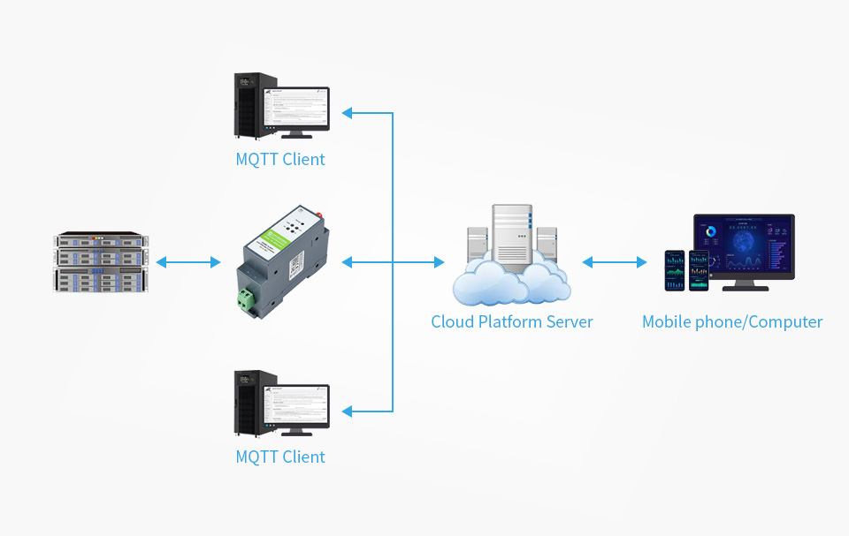
Modbus Gateway Support
Support Modbus TCP And Modbus RTU Interconversion Mode
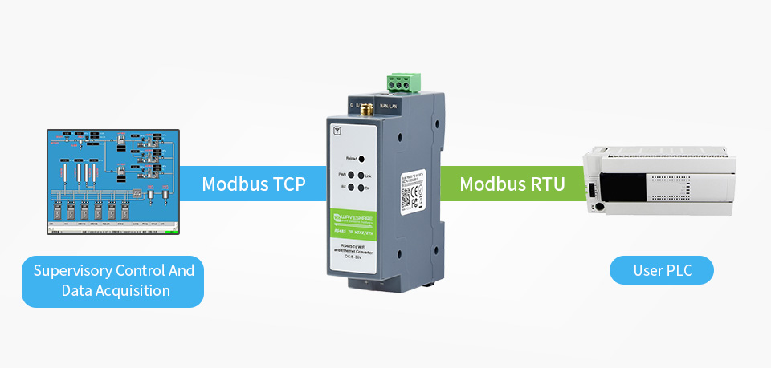
AT Command Mode
The user can query the current status of the module, or set related parameters, by sending AT commands
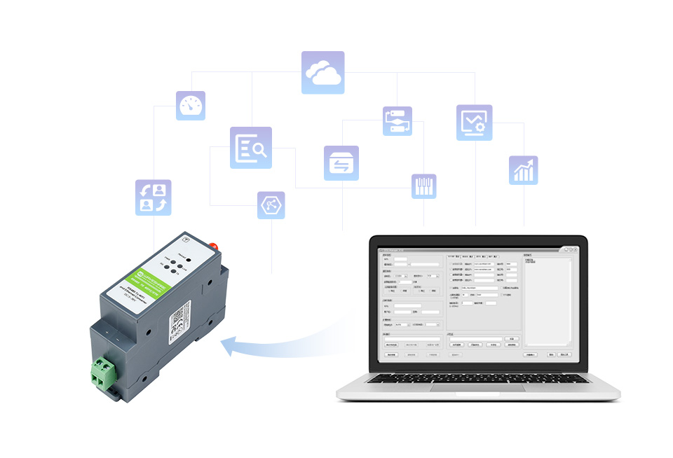

Features
Multi Configuration Methods
Supports muliti configuration methods such as hosts, Web Browser and serial port Configuration
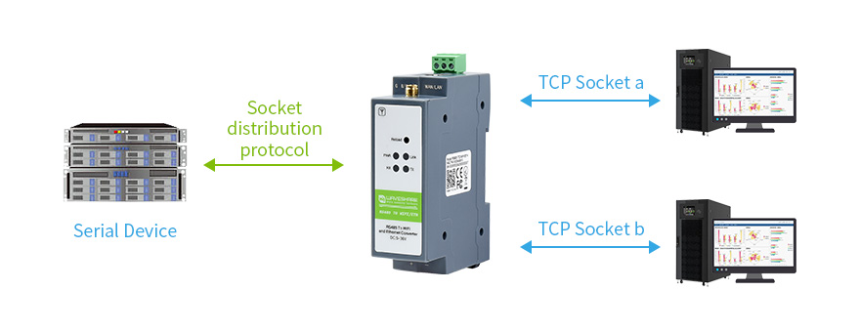
Socket Distribution Protocol
In the transparent transmission mode, the serial device can send data to the specified Socket link; the network data of each Socket is sent to the serial device through the serial port.
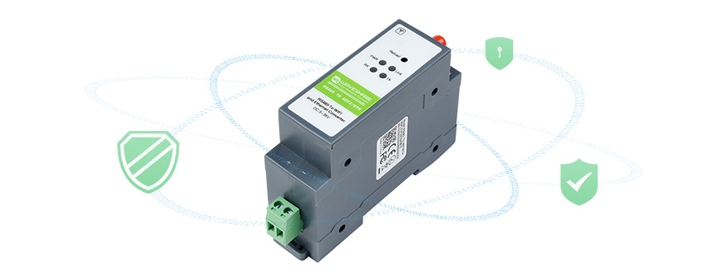
Hardware Protection
ESD Level 4 Static Protection, Level 3 Surge Protection, EFT Level 3 Electrical Fast Transient/Burst Protection.
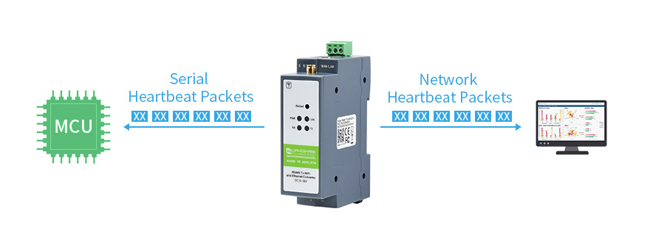
Customized registration packets, heartbeat packets
The registration package is used to identify the device information to the server, so that the server can identify the device.
--------------------------------------------------------------------------------------------------------------------
Interface Introduction
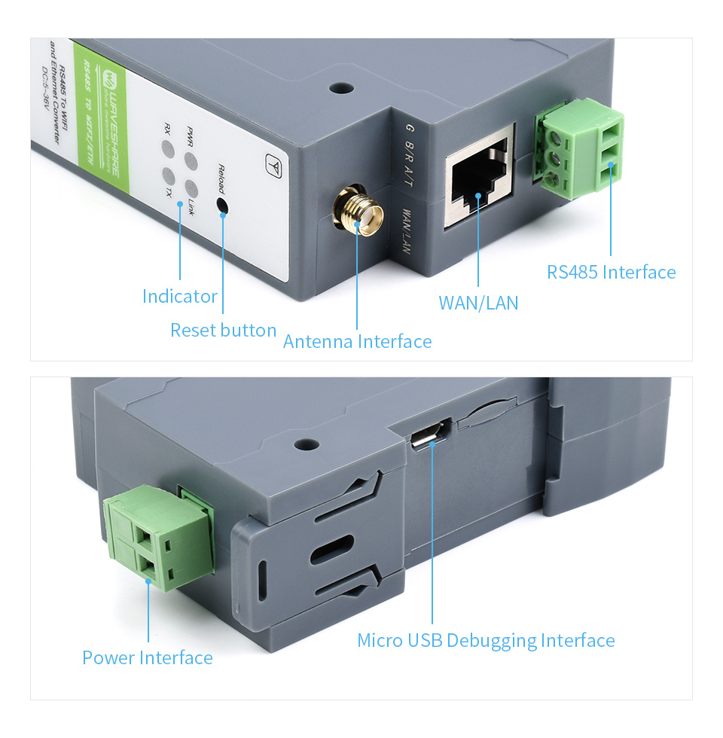

Outline Dimensions




