HRB8825 Stepper Motor HAT For Raspberry Pi, Drives Two Stepper Motors, Up To 1/32 Microstepping
SKU: 22311
Part Number: Stepper Motor HAT (B)
Brand: Waveshare
$14.99 INCREASEDECREASEADD TO CART
$14.192+
$13.793+
$13.634+
Related Products:
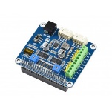
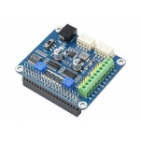
Share:
0

DESCRIPTION
PACKAGE CONTENT
HRB8825 Stepper Motor HAT For Raspberry Pi, Drives Two Stepper Motors, Up To 1/32 Microstepping
Stepper Motor HAT (B)
Alternative Solution Of Stepper Motor HAT,
Drives Two Stepper Motors, Up To 1/32 Microstepping
For 3D Printer, Sculpturing machine, Mechanical arm...
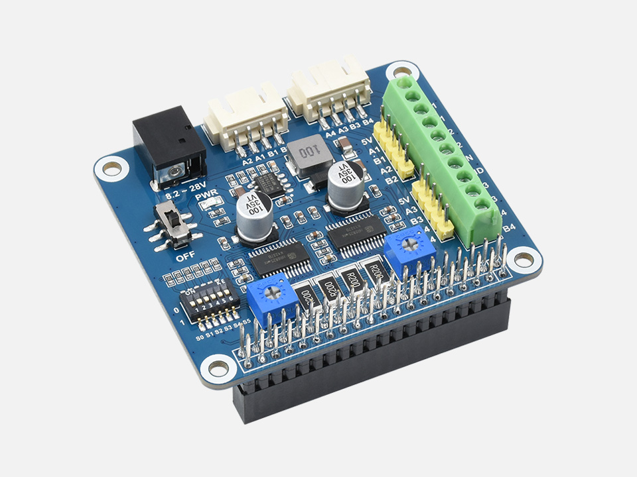
Features At A Glance
- Standard Raspberry Pi 40PIN GPIO extension header, supports Raspberry Pi series boards, Jetson Nano
- Onboard dual HR8825 motor controller IC with built-in microstepping indexer, drives two stepper motors, easy to use
- 6 available microstepping modes, configured with the DIP switches: full-step, half-step, 1/4-step, 1/8-step, 1/16-step, and 1/32-step
- Adjustable motor drive current via potentiometer, maximum 2.5A current output
- Protection features: Overcurrent Protection (OCP), Thermal Shutdown (TSD), VM Undervoltage Lockout (UVLO)
- Integrates 5V regulator, allows providing power to Raspberry Pi
- Onboard multi connector options for stepper motors in different specifications
- Comes with development resources and manual (examples in BCM2835, wiringPi, and python)
Specifications
MOTOR CONTROLLER | HR8825
MOTOR DRIVE VOLTAGE | 8.2V~28V
MOTOR DRIVE CURRENT | 2.5A
LOGIC VOLTAGE | 3.3V
MOUNTING HOLE SIZE | 3.0mm
DIMENSION | 65 × 56mm

Raspberry Pi 40PIN GPIO Compatibility
Designed For Raspberry Pi Boards / Jetson Nano
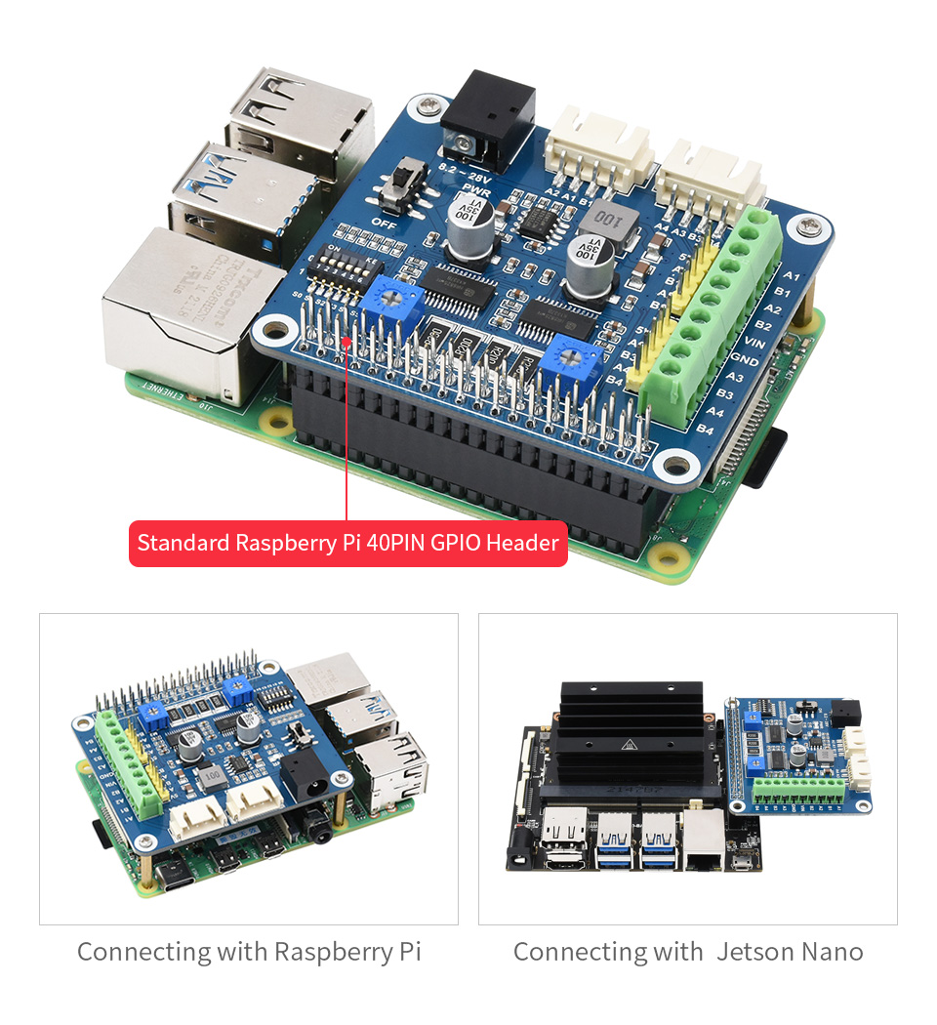
Onboard 2-Ch HR8825 Motor Driver Chip
Built-In Converter For Easy Control, Can Drive Two Stepper Motors
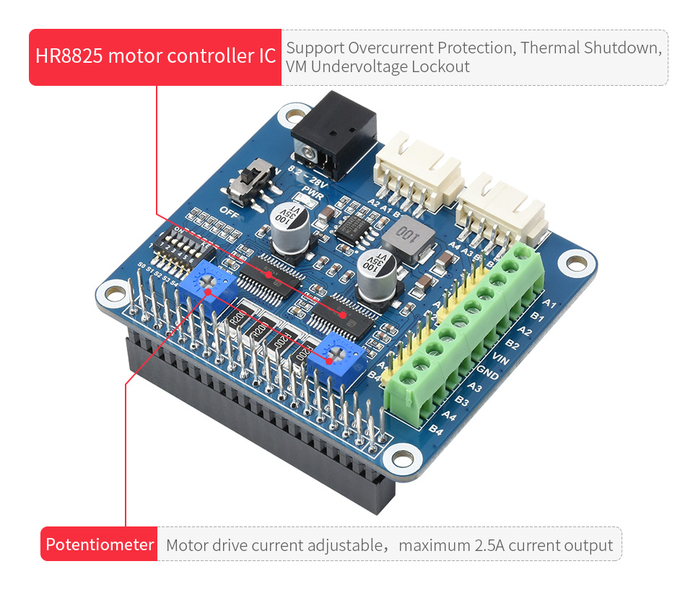
6 Available Microstepping Modes
Configured Via The DIP Switches:
Full-Step, Half-Step, 1/4-Step, 1/8-Step, 1/16-Step, And 1/32-Step
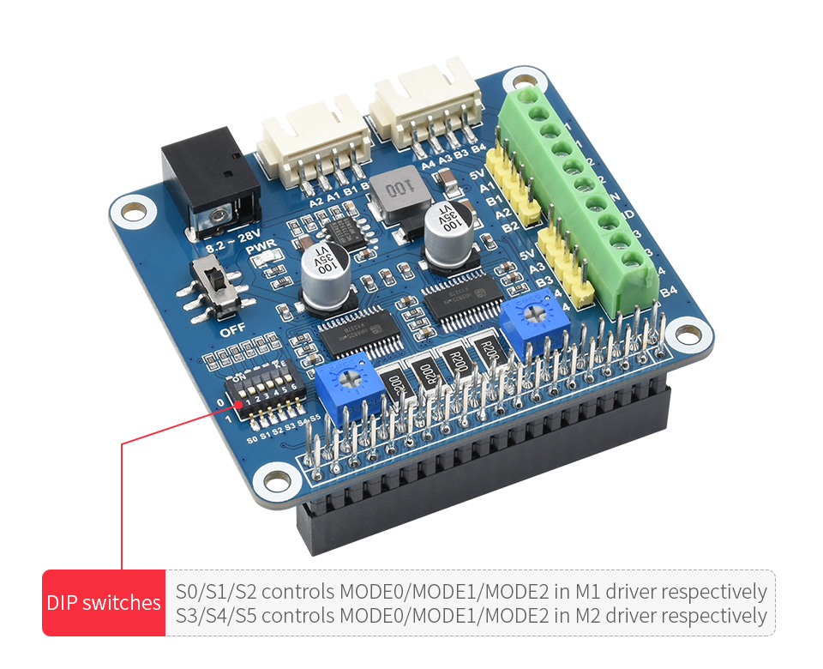
MODE2 | MODE1 | MODE0 | MOTOR MICROSTEPPING SETTING
0 | 0 | 0 | full-step
0 | 0 | 1 | half-step
0 | 1 | 0 | 1/4-step
0 | 1 | 1 | 1/8-step
1 | 0 | 0 | 1/16-step
1 | 0 | 1 | 1/32-step
1 | 1 | 0 | 1/32-step
1 | 1 | 1 | 1/32-step

Onboard Different Stepper Motor Interfaces
Easy Access To Stepper Motors In Different Specifications
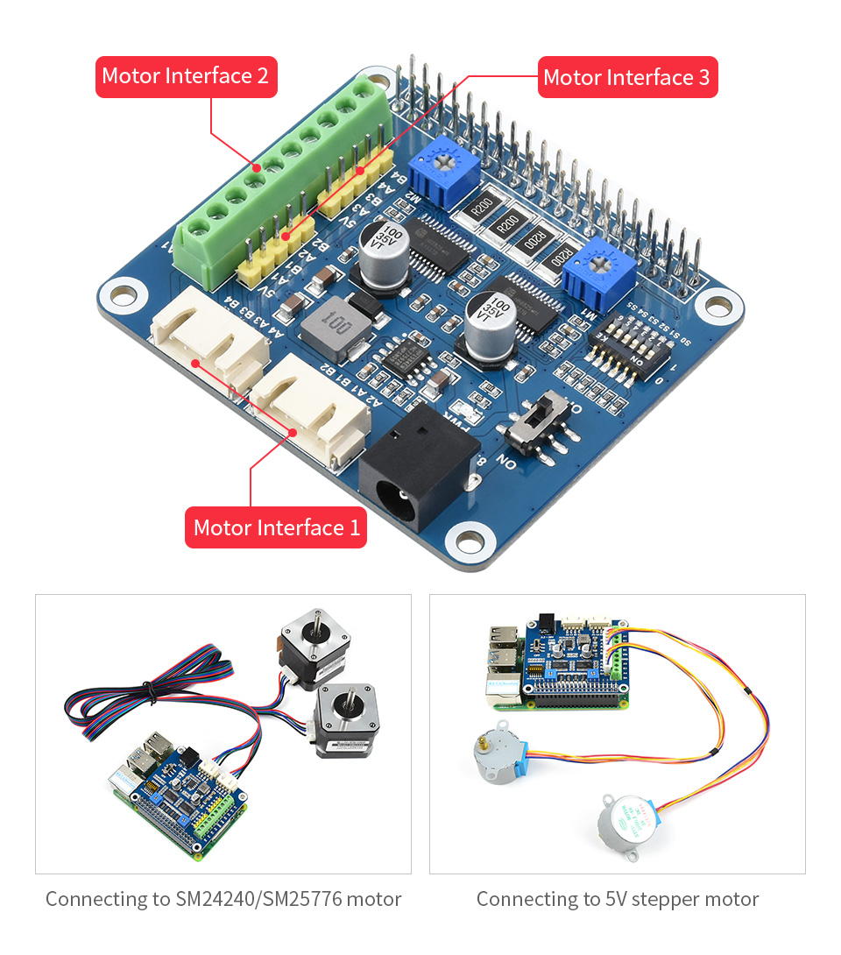
PIN | MOTOR INTERFACE DESCRIPTION
VIN | 8.2~28V Power Input
5V | 5V Power
GND | Ground
A1 | Output 1 terminal of bipolar stepper motor M1 winding A
A2 | Output 2 terminal of bipolar stepper motor M1 winding A
B1 | Output 1 erminal of bipolar stepper motor M1 winding B
B2 | Output 2 terminal of bipolar stepper motor M1 winding B
A3 | Output 1 terminal of bipolar stepper motor M2 winding A
A4 | Output 2 terminal of bipolar stepper motor M2 winding A
B3 | Output 1 terminal of bipolar stepper motor M2 winding B
B4 | Output 2 terminal of bipolar stepper motor M2 winding B
Application Examples
Easy Access To Stepper Motors In Different Specifications
for reference only, Raspberry Pi and stepper motors in the picture are NOT included.
What's On Board
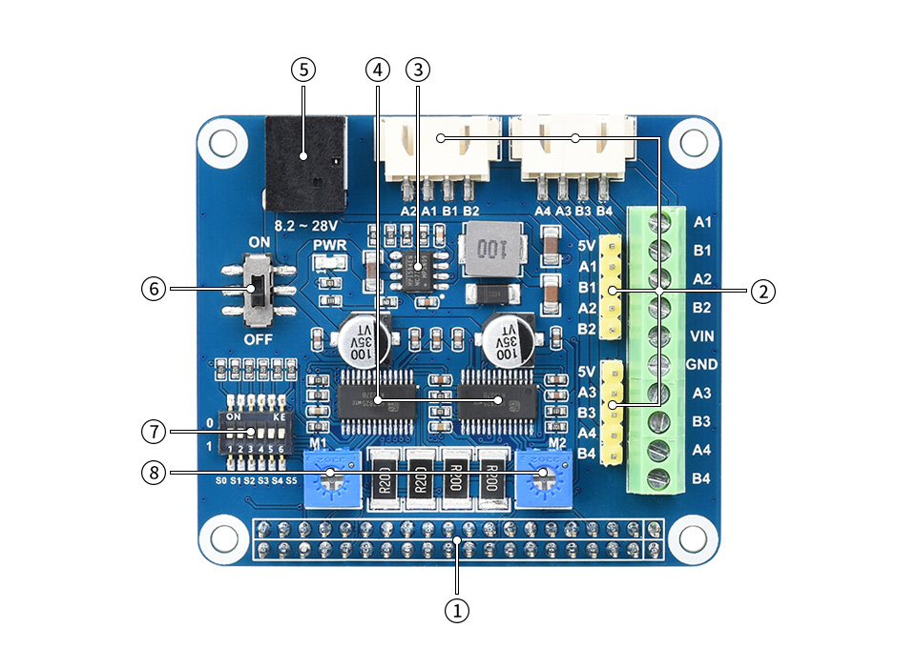
- Raspberry Pi GPIO interface
Can be connected to various Raspberry Pi HATs
- Motor interface
Three different specifications of the motor interface, easy to use
- MP1482 power chip
External power supply can be converted into 5V voltage to power the Raspberry Pi
- HR8825 motor driver chip
Can drive two stepper motors

- External power supply interface
8.2V ~ 28V DC power input
- Motor power switch
You can choose whether the module supplies power to the Raspberry Pi
- DIP switch
For setting 6 different step resolutions
- Potentiometer
Adjustable motor drive current
Pin Definition
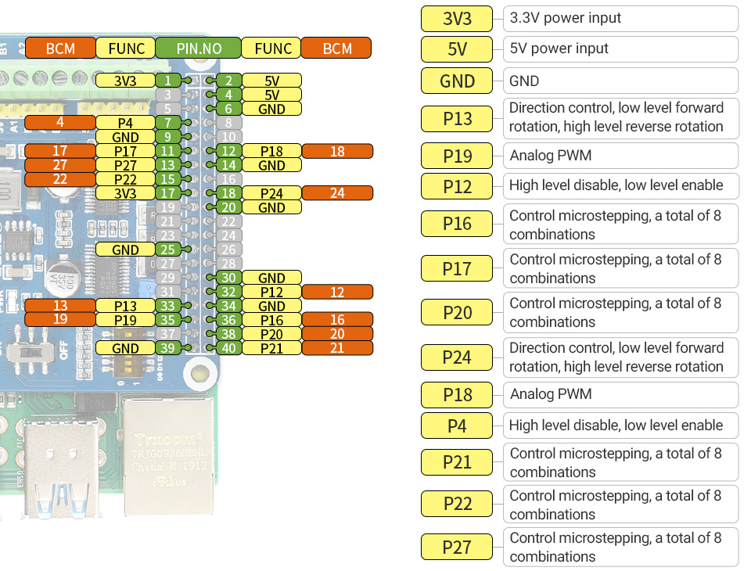
Outline Dimensions
