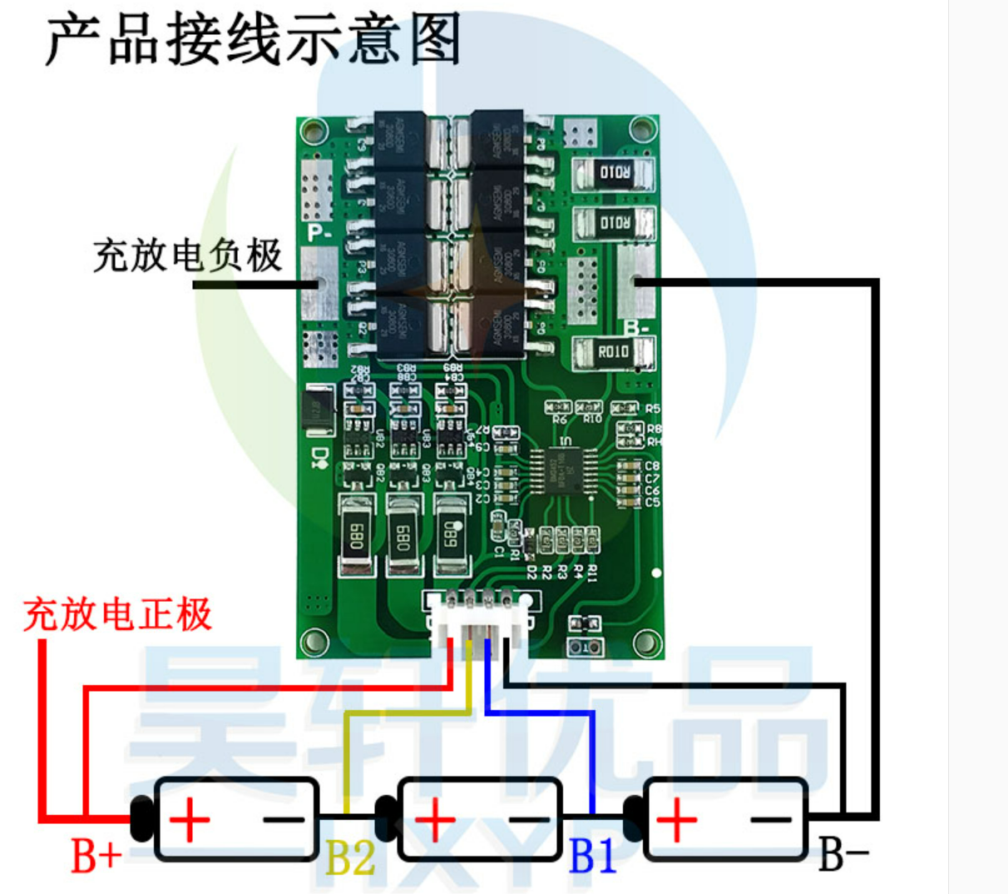

Charge and discharge positive electrode

Charge and discharge negative electrode