Quickly get started with XIAO ESP32C3

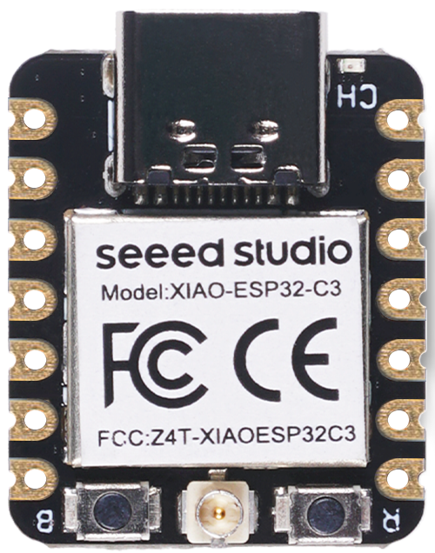
Introduction
Seeed Studio XIAO ESP32C3 is an IoT mini development board based on the Espressif ESP32-C3 WiFi/Bluetooth dual-mode chip. ESP32-C3 is a 32-bit RISC-V CPU, which includes an FPU (Floating Point Unit) for 32-bit single-precision arithmetic with powerful computing power. It has excellent radio frequency performance, supporting IEEE 802.11 b/g/n WiFi, and Bluetooth 5 (LE) protocols. This board comes included with an external antenna to increase the signal strength for your wireless applications. It also has a small and exquisite form-factor combined with a single-sided surface-mountable design.
It is equipped with rich interfaces and has 11 digital I/O that can be used as PWM pins and 4 analog I/O that can be used as ADC pins. It supports four serial interfaces such as UART, I2C, SPI and I2S. There is also a small reset button and a bootloader mode button on the board. XIAO ESP32C3 is fully compatible with the Grove Shield for Seeeduino XIAO and Seeeduino XIAO Expansion board except for the Seeeduino XIAO Expansion board, the SWD spring contacts on the board will not be compatible.
With regard to the features highlighted above, XIAO ESP32C3 is positioned as a high-performance, low-power, cost-effective IoT mini development board, suitable for low-power IoT applications and wireless wearable applications.

Features
- Powerful CPU: ESP32-C3, 32­bit RISC­-V single­core processor that operates at up to 160 MHz
- Complete Wi­Fi subsystem: Complies with IEEE 802.11b/g/n protocol and supports Station mode, SoftAP mode, SoftAP + Station mode, and promiscuous mode
- Bluetooth LE subsystem: Supports features of Bluetooth 5 and Bluetooth mesh
- Ultra-Low Power: Deep sleep power consumption is about 43μA
- Better RF performance: External RF antenna included
- Battery charging chip: Supports lithium battery charge and discharge management
- Rich on-chip resources: 400KB of SRAM, and 4MB of on-board flash memory
- Ultra small size: As small as a thumb(20x17.5mm) XIAO series classic form-factor for wearable devices and small projects
- Reliable security features: Cryptographic hardware accelerators that support AES-128/256, Hash, RSA, HMAC, digital signature and secure boot
- Rich interfaces: 1xI2C, 1xSPI, 1xI2S, 2xUART, 11xGPIO(PWM), 4xADC, 1xJTAG bonding pad interface
- Single-sided components, surface mounting design

Specifications comparison

Item | Seeed Studio XIAO ESP32C3 | Seeeduino XIAO | Seeed XIAO RP2040 | Seeed XIAO BLE | Seeed XIAO BLE Sense
Processor | ESP32-C3 32-bit RISC-V @160MHz | SAMD21 M0+@48MHz | RP2040 Dual-core M0+@133Mhz | nRF52840 M4F@64MHz | nRF52840 M4F@64MHz
Wireless Connectivity | WiFi and Bluetooth 5 (LE) | N/A | N/A | Bluetooth 5.0/BLE/NFC | Bluetooth 5.0/BLE/NFC
Memory | 400KB SRAM, 4MB onboard Flash | 32KB SRAM 256KB FLASH | 264KB SRAM 2MB onboard Flash | 256KB RAM, 1MB Flash 2MB onboard Flash | 256KB RAM,1MB Flash 2MB onboard Flash
Built-in Sensors | N/A | N/A | N/A | N/A | 6 DOF IMU (LSM6DS3TR-C), PDM Microphone
Interfaces | I2C/UART/SPI/I2S | I2C/UART/SPI | I2C/UART/SPI | I2C/UART/SPI | I2C/UART/SPI
PWM/Analog Pins | 11/4 | 11/11 | 11/4 | 11/6 | 11/6
Onboard Buttons | Reset/ Boot Button | N/A | Reset/ Boot Button | Reset Button | Reset Button
Onboard LEDs | Charge LED | N/A | Full-color RGB/ 3-in-one LED | 3-in-one LED/ Charge LED | 3-in-one LED/ Charge LED
Battery Charge Chip | Built-in | N/A | N/A | BQ25101 | BQ25101

Pinout diagram
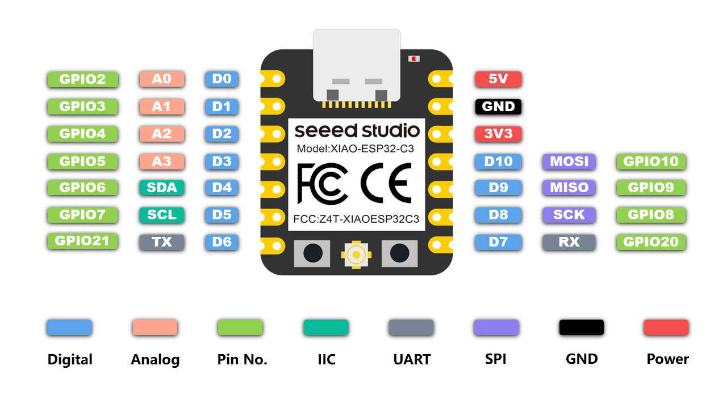

Component overview
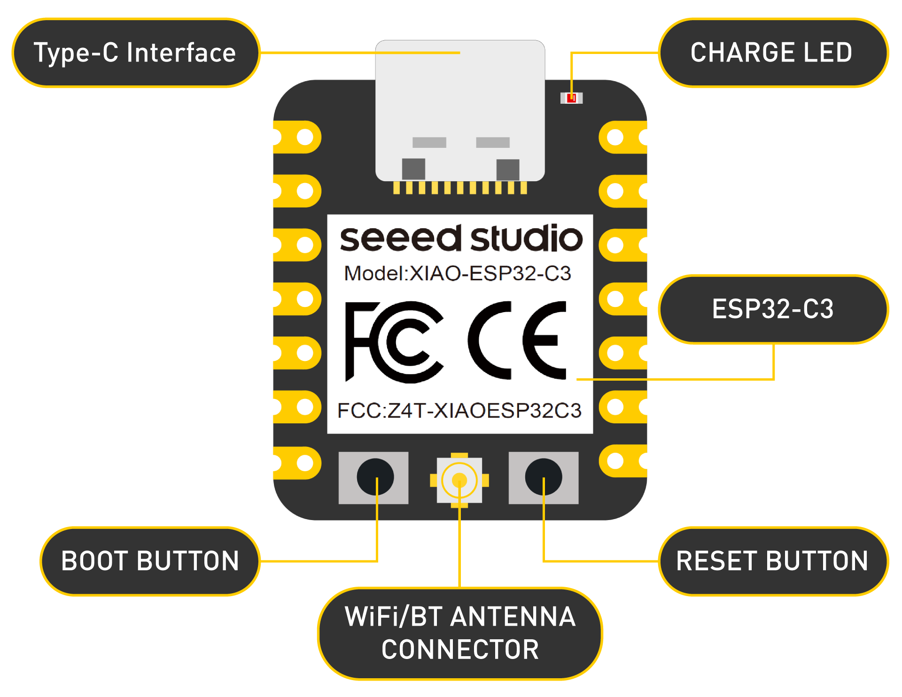

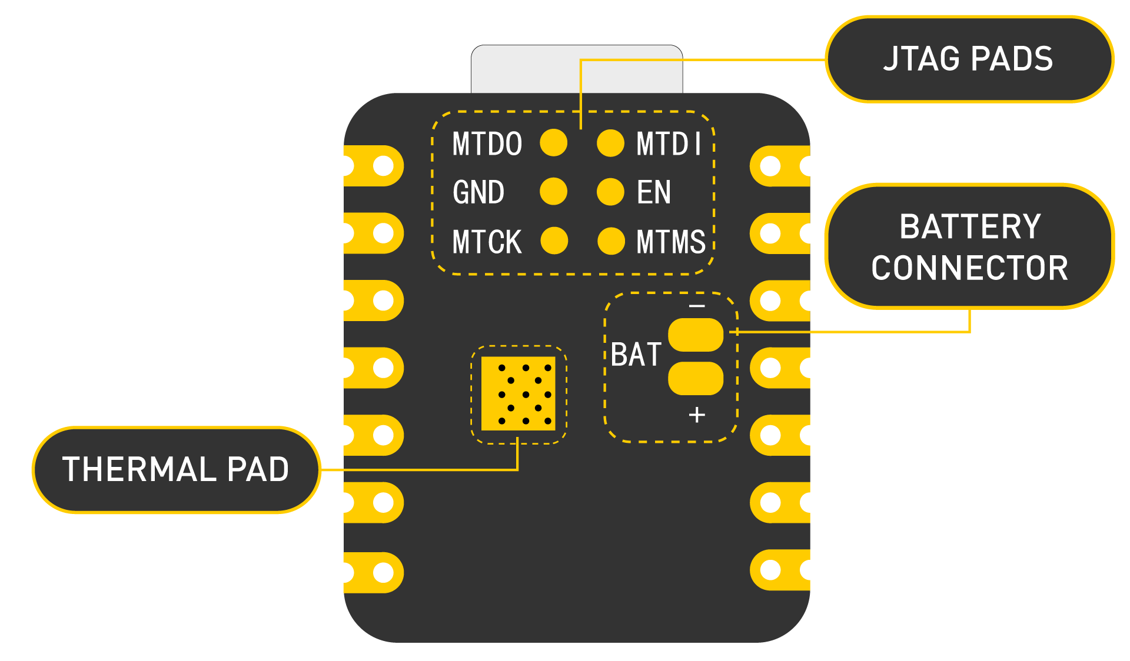

Power Pins
- 5V - This is 5v out from the USB port. You can also use this as a voltage input but you must have some sort of diode (schottky, signal, power) between your external power source and this pin with anode to battery, cathode to 5V pin.
- 3V3 - This is the regulated output from the onboard regulator. You can draw 700mA
- GND - Power/data/signal ground

Getting started

First, we are going to connect XIAO ESP32C3 to the computer, connect an LED to the board and upload a simple code from Arduino IDE to check whether the board is functioning well by blinking the connected LED.

Hardware setup
You need to prepare the following:
- 1 x Seeed Studio XIAO ESP32C3
- 1 x Computer
- 1 x USB Type-C cable

- Step 1. Connect XIAO ESP32C3 to your computer via a USB Type-C cable.
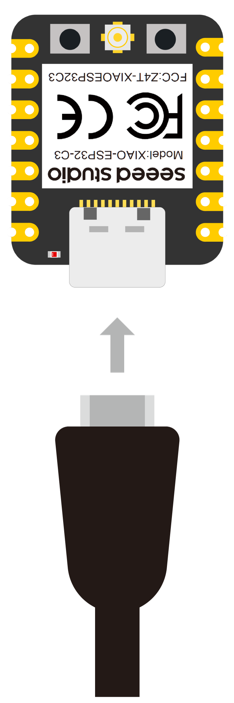
- Step 2. Connect an LED to D10 pin as follows
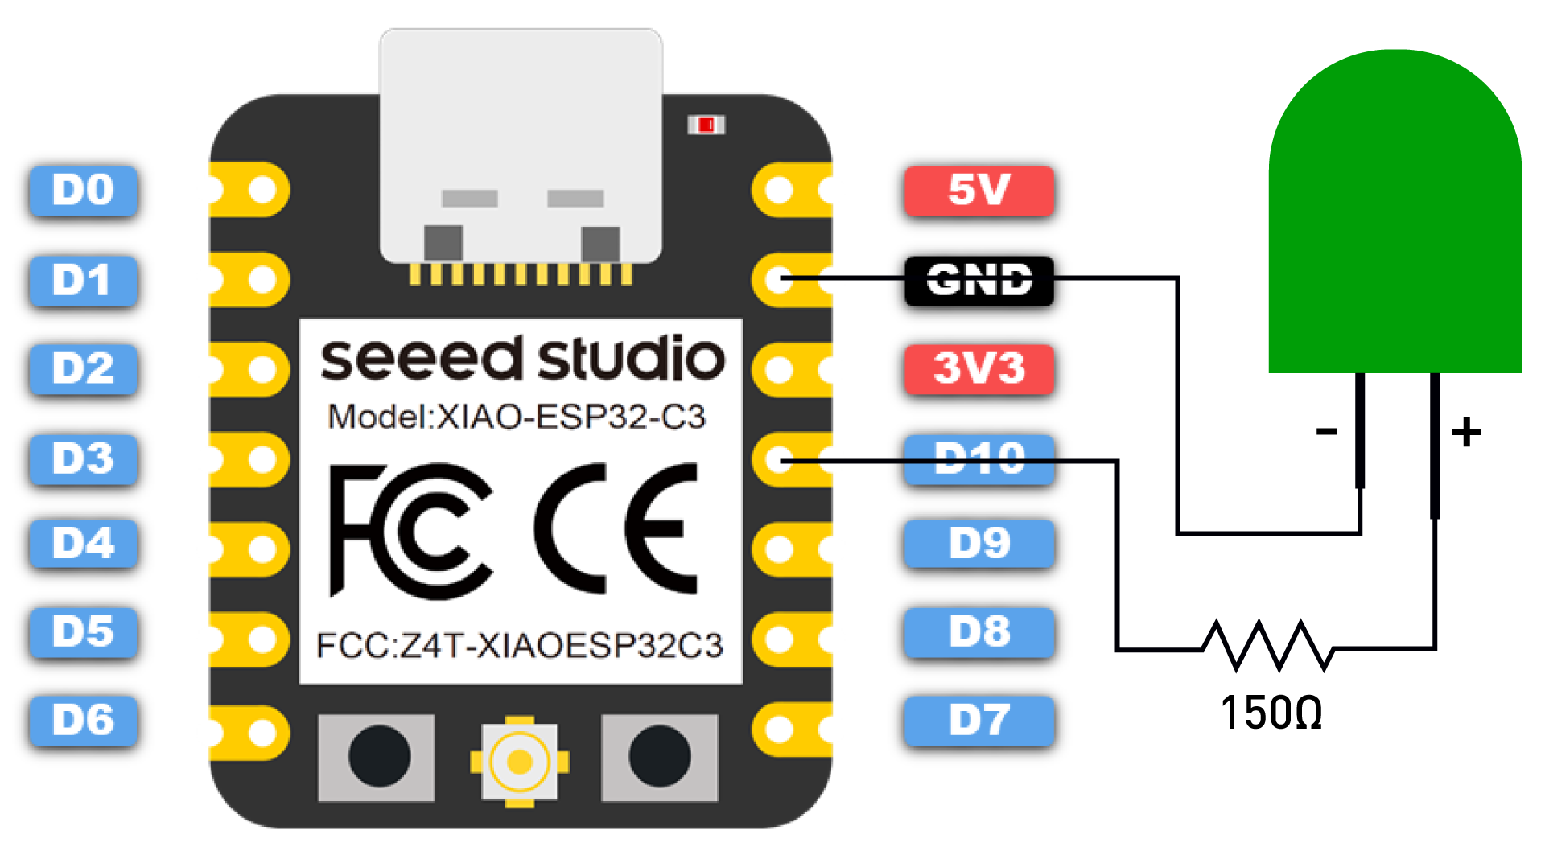
Note: Make sure to connect a resistor (about 150Ω) in series to limit the current through the LED and to prevent excess current that can burn out the LED

Software setup
- Step 1. Download and Install the latest version of Arduino IDE according to your operating system.
- Step 2. Launch the Arduino application
- Step 3. Add ESP32 board package to your Arduino IDE
Navigate to File > Preferences, and fill "Additional Boards Manager URLs" with the url below:
https://raw.githubusercontent.com/espressif/arduino-esp32/gh-pages/package_esp32_dev_index.json

After that click on OK.
Navigate to Tools > Board > Boards Manager..., type the keyword "esp32" in the search box, select the latest version of ****esp32****, and install it.

- Step 4. Select your board and port
Board
Navigate to Tools > Board > ESP32 Arduino and select "XIAO_ESP32C3". The list of board is a little long and you need to roll to the buttom to reach it.

Port
Navigate to Tools > Port and select the serial port name of the connected XIAO ESP32C3.
This is likely to be COM3 or higher (COM1 and COM2 are usually reserved for hardware serial ports).

Blink the LED
- Step 1. Copy the below code to Arduino IDE
// define led according to pin diagram
int led = D10;

void setup() {
// initialize digital pin led as an output
pinMode(led, OUTPUT);
}

void loop() {
digitalWrite(led, HIGH); // turn the LED on
delay(1000); // wait for a second
digitalWrite(led, LOW); // turn the LED off
delay(1000); // wait for a second
}

- Step 2. Click the Upload button to upload the code to the board

Once uploaded, you will see the connected LED blinking with a 1-second delay between each blink. This means the connection is successful and now you can explore more projects with XIAO ESP32C3!

=====================================================================
Additional Info:

Battery Usage
The XIAO ESP32C3 is capable of using a 3.7V lithium battery as the power supply input. You can refer to the following diagram for the wiring method.

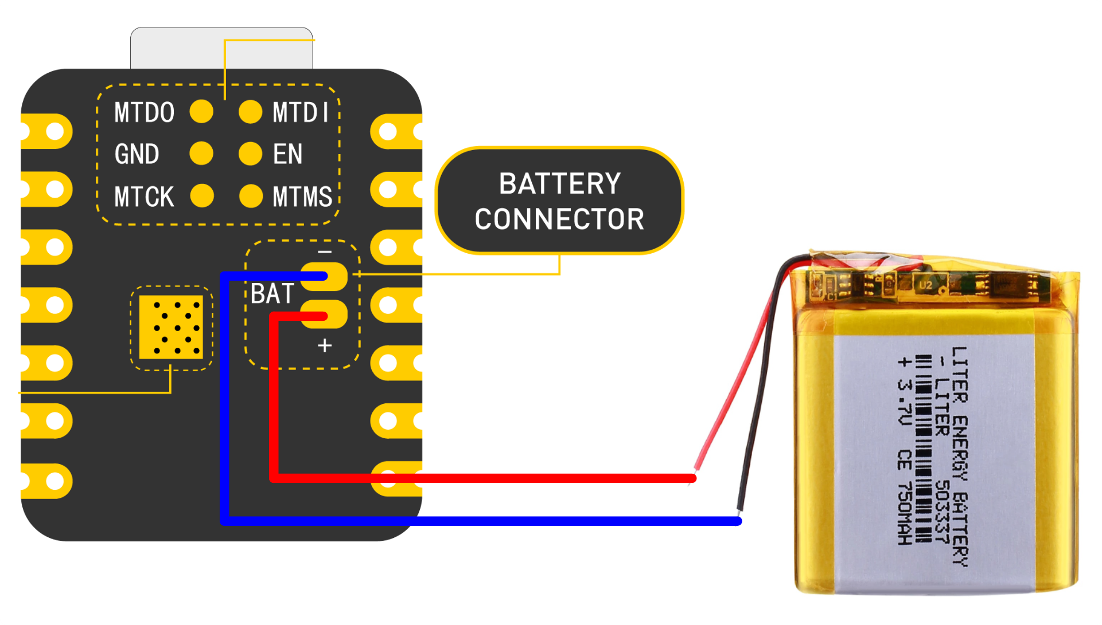
Attention
Please be careful not to short-circuit the positive and negative terminals and burn the battery and equipment when soldering.
Instructions on the use of batteries
- Please use qualified batteries that meet the specifications.
- XIAO can be connected to your computer device via data cable while using the battery, rest assured that XIAO has a built-in circuit protection chip, which is safe.
- The XIAO ESP32C3 will not have any LED on when it is battery powered (unless you have written a specific program), please do not judge whether the XIAO ESP32C3 is working or not by the condition of the LED, please judge it reasonably by your program.
- Sorry, we currently have no way to help you check the remaining battery level through software (because there are no more chip pins available), you need to charge the battery regularly or use a multimeter to check the battery level.

Check the battery voltage
Due to the limitation of the number of pins in the ESP32C3, engineers had no extra pins to allocate to the battery for voltage measurement in order to ensure that the XIAO ESP32C3 has the same number of GPIOs as the other XIAO series available.
But if you prefer to use a separate pin for battery voltage measurement, you can refer to the genius operation of msfujino. We would also like to give a special thanks to msfujino for all the experience and efforts shared for the XIAO ESP32C3. The basic operating idea is: The battery voltage was divided by ½ with 200k and connected to the A0 port so that the voltage could be monitored.

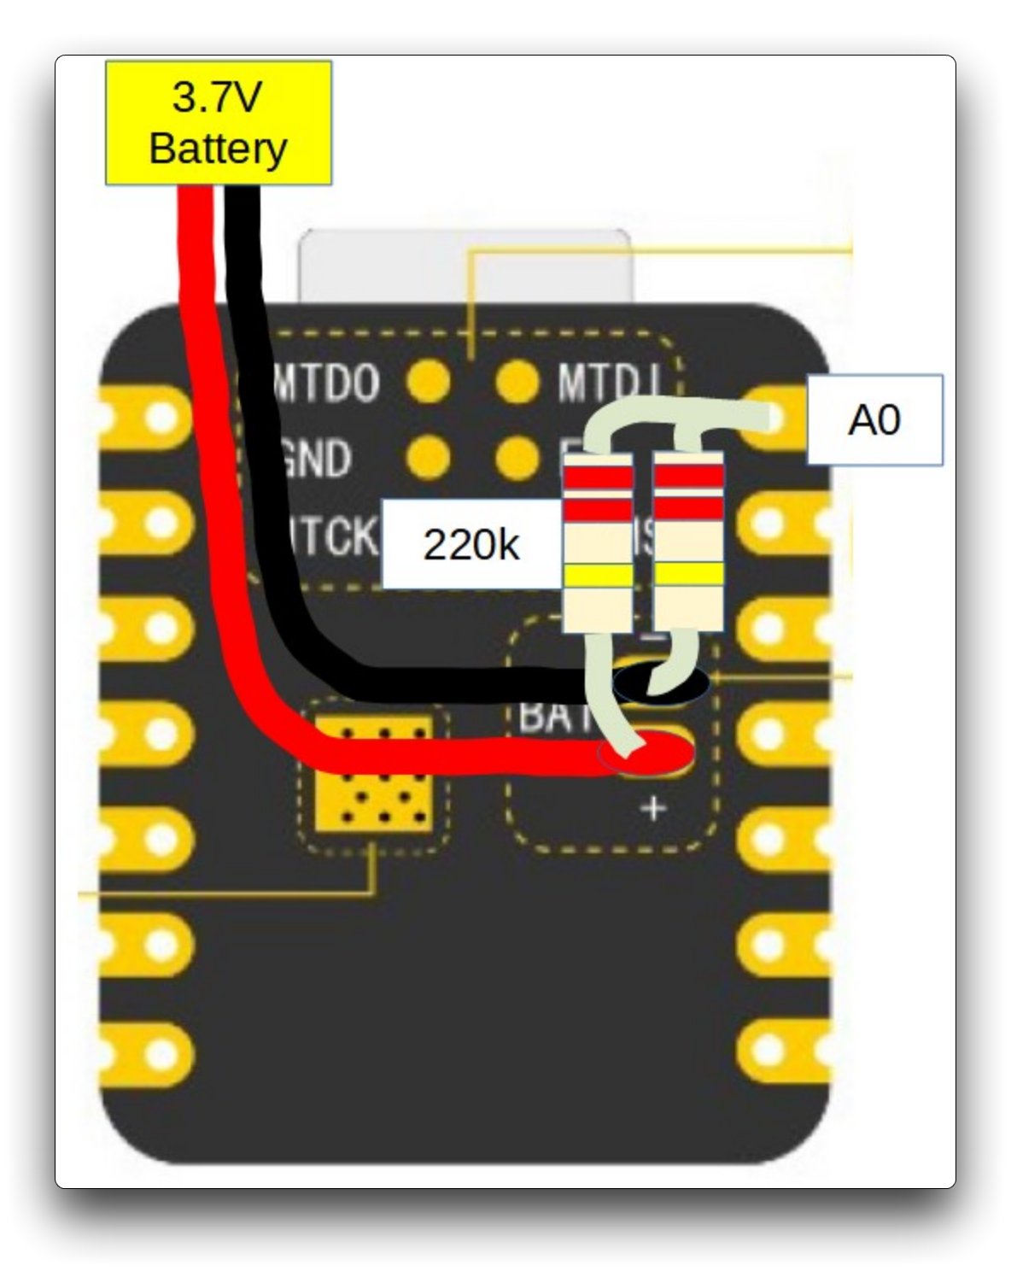
The datasheet says nominally 2500mV full scale AD conversion, but there is a large variation from chip to chip, actually ±10%. My chip was 2700mV full scale.
Fortunately, the calibrated correction value for each chip is written in the fuse area, and by using the function alalogReadMilliVolts(), I can read the corrected voltage value without doing anything special.
The result of AD conversion and the voltage measured by the multimeter agree well with each other with an error of about 5 mV, which is not a problem in practical use.
In addition, during communication in particular, spike-like errors occurred, which had to be averaged out 16 times to remove them.
The following is the procedure to test the battery voltage.
Program:
void setup() {
Serial.begin(115200);
pinMode(A0, INPUT); // ADC
}
void loop() {
uint32_t Vbatt = 0;
for(int i = 0; i < 16; i++) {
Vbatt = Vbatt + analogReadMilliVolts(A0); // ADC with correction
}

float Vbattf = 2 * Vbatt / 16 / 1000.0; // attenuation ratio 1/2, mV --> V
Serial.println(Vbattf, 3);
delay(1000);
}

==========================================================================================================================================

